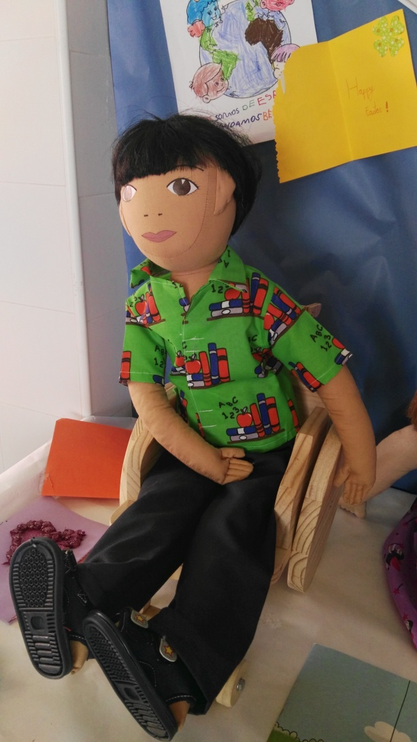
Name: Paco

Family: He lives with his parents and his brother in a new house. They used to live in Rioja, Paco prefers this place where his granddad still lives.

Cultural background: Paco is 4 years old. He was born in Rioja, a small village near Almería. His father is Spanish and her mother is from Argentina where his grandparents live. He uses skype to phone them twice or three times a week. He speaks Spanish and he's starting learning English in his new school. His father is a farmer who grows oranges in Rioja and his mother is a cook.

Where he lives: Paco's family moved to a new house in Almería some months ago. It's a big ground floor house. There are not stairs, and there are big rooms and wide corridors, so he can move on his own with his wheel chair. And …. he doesn’t have to share his bedroom. He has his own one.

Likes/dislikes / difficulties: Paco is very happy at the school because he loves learning new things, there are a lot of beautiful books, puzzles and toys to play. He likes specially the activities on the worksheets for colouring and matching. He's sad because is new at school and he doesn't have many friends. He likes basketball even if he can't play and he loves watching the "Paw Patrol" on TV. Three times at week he goes swimming, he really enjoys doing this physical activity.

Food she likes, dislikes: He loves the oranges that his dad grows and he usually have the food that his mum cooks, everything is delicious! He loves specially fruit and veggies. He eats a lot so he's strong and healthy.
Fears: He is afraid of monster and trucks. Doctors and nurses make him feel scared, and he doesn't want to go to the hospital

Physical peculiarities: Paco is 4 years old, he has dark short hair and black eyes. He is tall and slim. He has strong arms but he can't move his legs, so he can't walk or run. He has to move in a wheelchair and can't use the same desk and chairs than his mates in the classroom.
Recent history: Paco's family moved to Almería because his mother job. He had to change the school and he feels alone. His mates are shocked about his wheelchair, some of them are affraid and aren't able to move it. Every weekend he goes to the village of Rioja, where he used to live. There, he meets his grandad, cousins and friends. He misses all of them.

