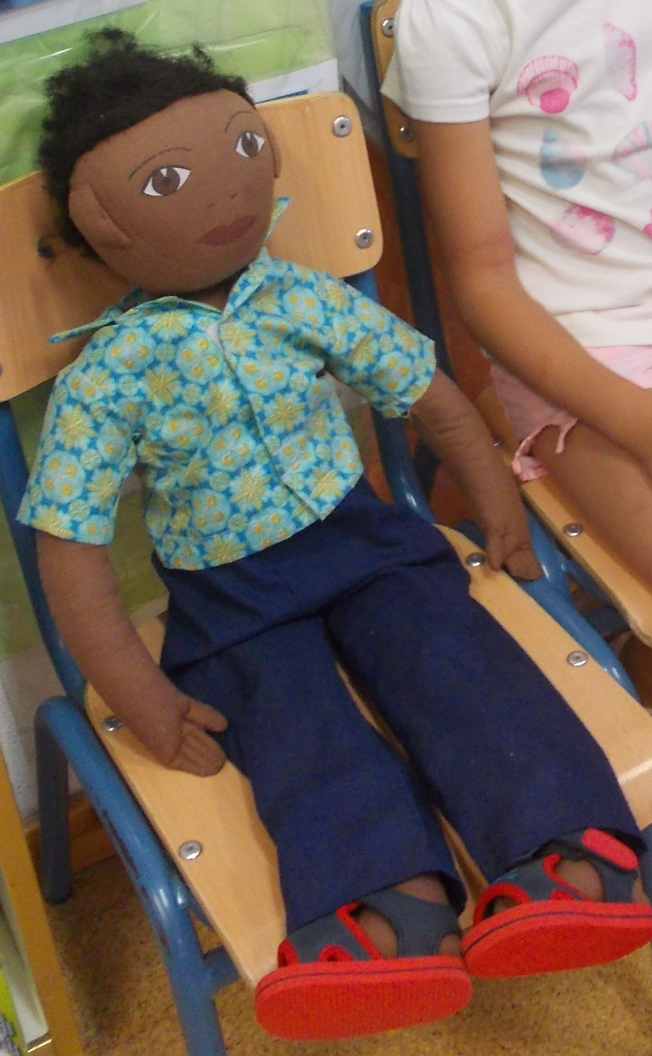
Name: Ramón

Family: His family is not in Spain at this moment. He has got 8 siblings who live with their parents in Senegal. Ramón has just arrived in Spain and he is new at school.

Cultural background: Ramón is 6 years old. He was born in Senegal and he has done a long journey from his country to Spain: he has crossed the desert and then the Mediterranean Sea by boat. He has traveled with other immigrants from his country, but not with his family. He can't speak Spanish very well and he has problems for communicating, but he understand almost everything and he's very interested in learning so he repeats every words he listens. He did not bring any luggage, so he has nothing more than the clothes he has on.

Where he lives: Ramon lives in a boarding school with other children who has not family. The best in the boarding school is that there is a lot of delicious food and some adult people who really love him and make his life easy.

Likes/dislikes / difficulties: Although he can't speak Spanish he likes going to school and being in class with other children. He enjoys doing all the school activities and he wants to learn to read and write so he can send letters to his house.
Because his communication problems is why in the play ground sometimes he feels lonely and he has not friends to play with. He gets very sad when some boys and girls do not want to play with him because he has got very dark skin (it is brown) and black curly hair.

Food he likes, dislikes: Ramon loves to eat sandwiches and hamburgers, he also likes chocolate milkshakes and all types of fruit. He usually has lunch at school and he's always the first in finishing.

Fears: He is afraid to be alone, he always likes to have someone closer to him even if he does not talk and he always sleeps with his teddy bear. This teddy bear was the first thing he had when he arrived in Almería. However he is ashamed his classmates know about that.

Physical peculiarities: Ramón is 6 years old, he has he has got very dark skin (it is brown) and black curly hair. He is the tallest in the class and he's also really slim. He did not bring any luggage, so he had nothing more than the clothes he had on. He has to use clothes that people in the boarding school lend him.
Recent history: Ramón travelled to Almería because he wanted to help his poor family so he was hided with other travellers, but here he realised that he is too young to work, his family doesn't know about him and he's is worried. He misses all of them a lot. He would like to have a mobil phone to call his family.

