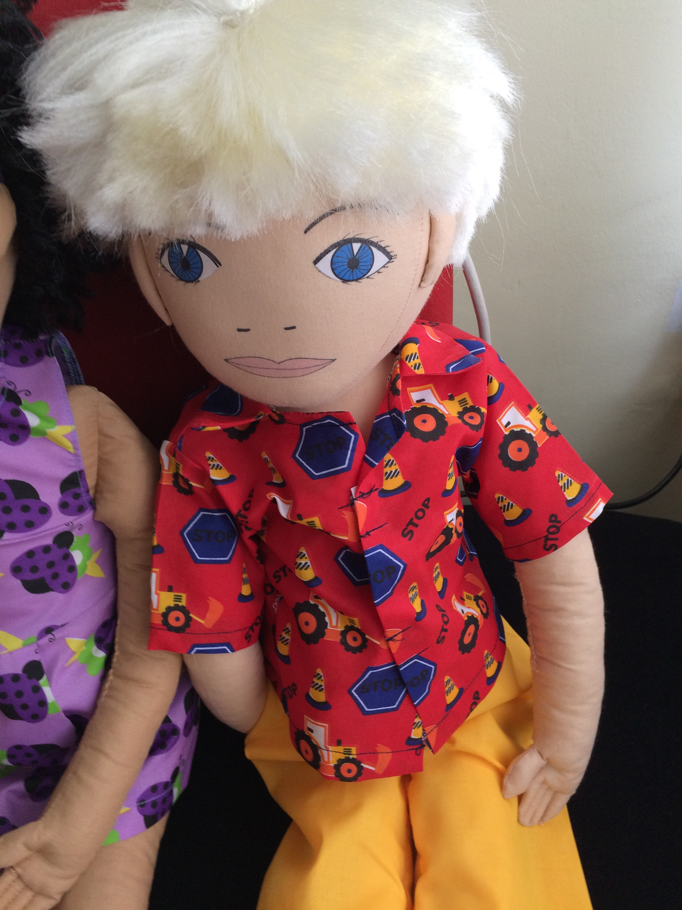
Name: Kristjan
Family: Kristjan lives with his mother and father. He has 2 years older sister.
Cultural background: Kristjan is born in Estonia. He speaks estonian language.
Where he lives: Kristjan lives in a rental apartement in a big apartement building in the city centre of Tallinn.
Likes/dislikes/is difficult: Kristjanile likes sport activities. He likes to participate in sport competitions. Kristjan goes to training every day. He goes to swimming, athleticks and judo. He likes when he does very good in competitions and he recieves a medal. His family is then very proud about him. Kristjan also likes to training camps, because he want’s to be someday a proffessional athlete and compete in olympic games. Kristjan likes to watch sport from TV with his father.
Kristjan does not like books, reading, board games and puzzles. He gets bored of them quickli. It is difficult for him to spend a lot of time behind a table.
Food he likes/dislikes: Kristjan eats everything. His favourite food is chicken soup and minced meat sauce. Kristjan does not like spicy dishes.
Fears: There are no fears. Kristjan is very brave in everything.
Physical peculiarity: Kristjan is very athletic, hei s very strong and physically very well developed. He runs very fast.
Recent history: Kristjan is very good at communication and h ehas very many friends in kindergarten. All children want to be his friends and to play with him. Lately Kristjan feels a little sad. In kindergarten there has been problems that some boys tell Kristjan to choose who he wants to play together with. But Kristjan does not want to choose, he wants to play with everyone. Kristjan is also sad beacuse his father has to be sometimes a week away from home because he drives a truck in Europe. Kristjan really misses his father a lot.
Kristjan is very excited that the family soon moves to private house and then he has a opportunity to play outside and he will have his own room.

