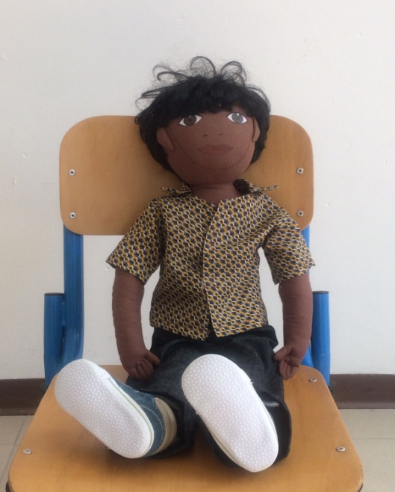
Assad
Family: Assad lives in Italy with the whole family
Life: Assad was born in Tunisia of Tunisian parents. They arrived two years ago. They are Muslim and follow the Muslim religion
His mother speaks only Arabic, his father speaks a little Italian, he and his sister speak French and a bit of Italian.
They do not eat pork and his mother wears the chador
Where he lives: he lives in a house near the school with other Arabs. He attends children school. His sister attends primary school.
What he likes and does not like: He likes to go to the children school because there are other friends who speak like him.
He does not like NOT TO UNDERSTAND WHAT THE TEACHERS SAY AT SCHOOL AND ITALIAN CHILDREN
Food: For Assad likes to eat chicken and various vegetable salads. He likes sweets and dried fruit. He does not like fish.
He does not eat pasta. Assad does not like to eat at school because the food is very different from the plates he is used to and what they prepare at home. He does not like soup, omelet and pizza.
Fear: Assad is afraid of the dark and loud noises. He sleeps in the same room as the mother.
He has got a very dark skin, his hair is black and curly, his eyes are large and black. He is 4 years old.
Current life: His father was an architect in Tunisia, his mother a teacher of history. They came to Italy because in their country there was no work. Now the father is a bricklayer and his mother a housewife. They do not have much money and are helped by associations for immigrants. He suffers because he feels different from other children.
Many times he plays on the sidelines with Mohamed, another Arab child who goes to the children school.

Teachers do not care about trying to integrate Assad.

Questions:
What should we do not to make Assad cry?
Do you have any suggestions?
Do you want to play with him?

Answers:
Teacher, let him come to school with his sister, who is in the other class
We could play his games
We could ask the lady of the canteen to cook Arabic food
We could give him new clothes

