PALEKASTRO SCHOOL

POLAND

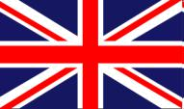
POLAND

POLSKA
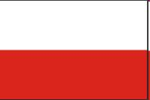

THE CAPITAL CITY OF POLAND:

WARSAW
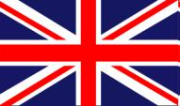

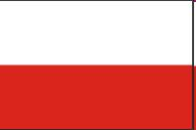 WARSZAWA

THE OFFICIAL FLAG OF THE REPUBLIC OF POLAND

THE MEANING OF COLOURS ON THE FLAG:


WHITE: PURITY, MORALITY AND GOODNESS

RED:* BRAVERY, HEROISM

*THE MEANING WAS ADDED AFTER MANY WARS POLAND HAS FOUGHT. THE ORIGINAL ANCIENT MEANING OF RED WAS NOBILITY AND DIGNITY (RED PAINT USED TO BE VERY EXPENSIVE AND USED ONLY BY RICH PEOPLE)

HOW BIG IS POLAND?

- IT HAS 322 575 sqkm

- IT IS THE 69TH BIGGEST COUNTRY IN THE WORLD

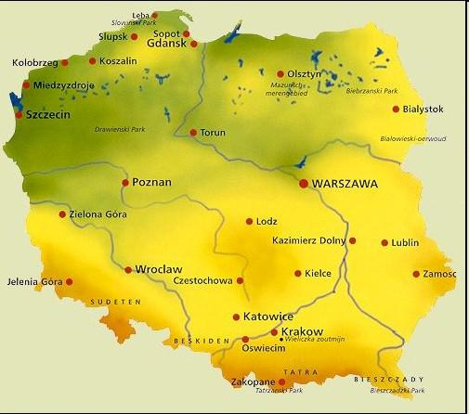
WHERE IS POLAND?
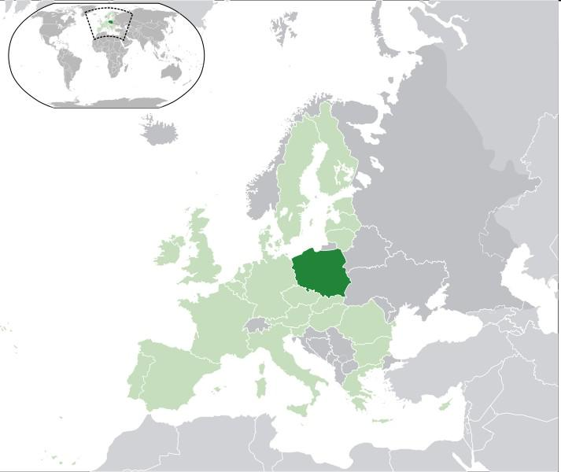

IT’S IN CENTRAL

EUROPE

AT THE BALTIC SEA
POLAND’S NEIGHBOURING COUNTRIES:

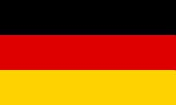
• GERMANY
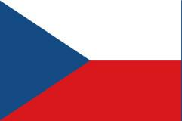

• CZECH REPUBLIC

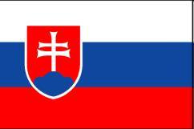
• SLOVAKIA

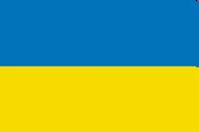
• UKRAINE

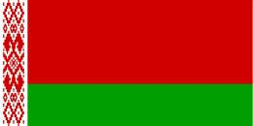
• BELARUS

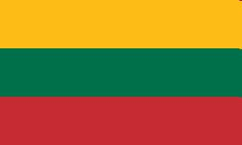
• LITHUANIA
POLAND IS DIVIDED INTO 16 REGIONS CALLED VOIVODSHIPS*:
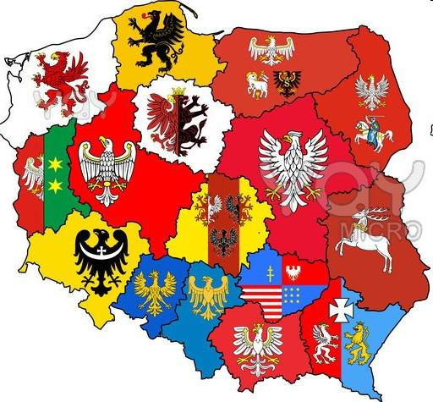

*EACH VIOVODSHIP

HAS ITS OWN

COAT OF ARMS
TRADITIONAL POLISH FOOD:
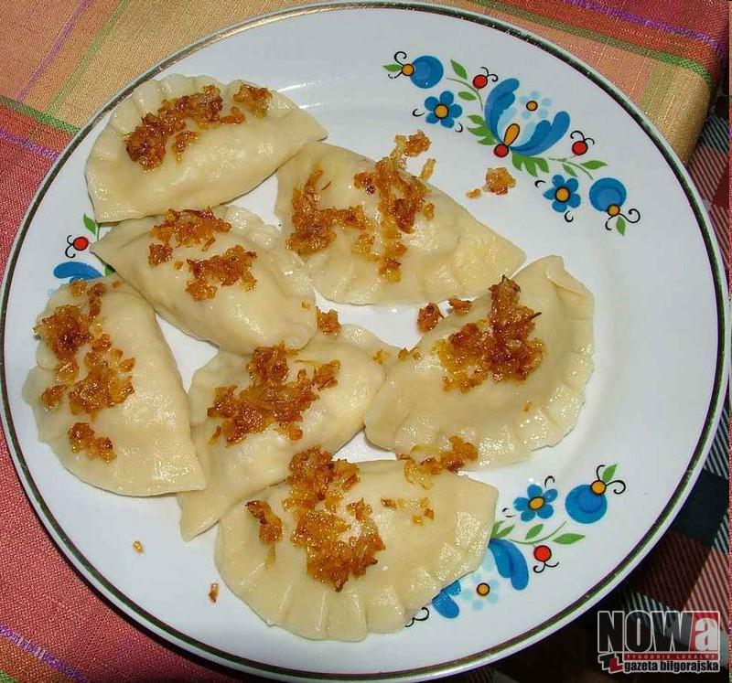

PIEROGI

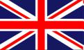 DUMPLINGS
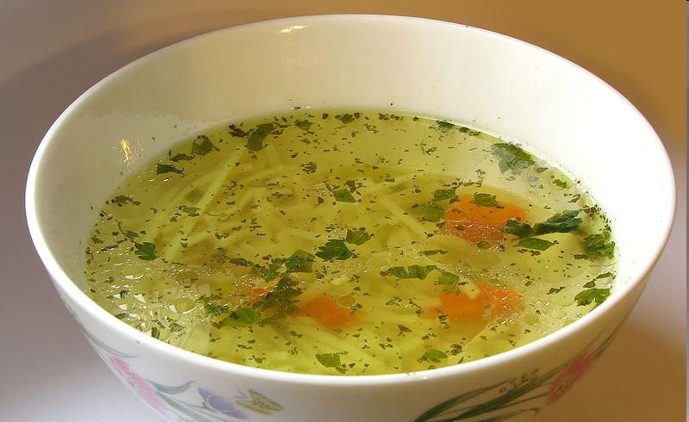

ROSÓŁ

CHICKEN SOUP
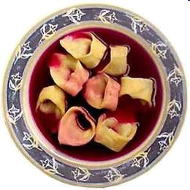
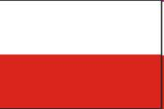 BARSZCZ Z USZKAMI

BEETROOT SOUP WITH
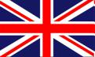
MUSHROOM DUMPLINGS
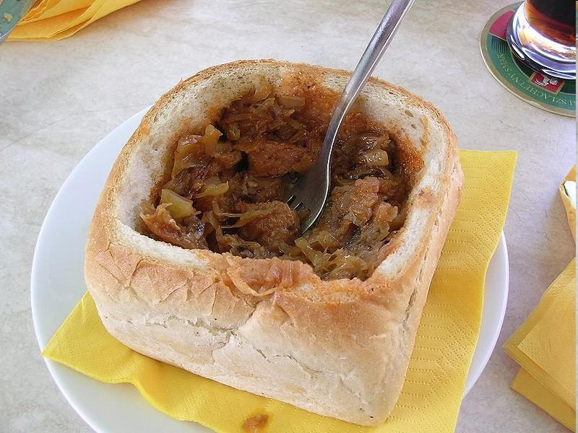

BIGOS

CABBAGE AND MEAT STEW

TRADITIONAL POLISH FESTIVALS
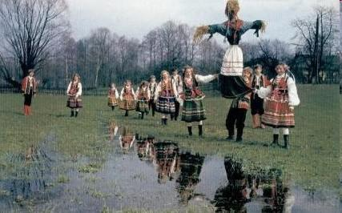
21ST MARCH

FIRST DAY OF SPRING

DROWNING OF ‘MARZANNA’

A DOLL MADE OF STRAW WHICH IS A SYMBOL OF WINTER
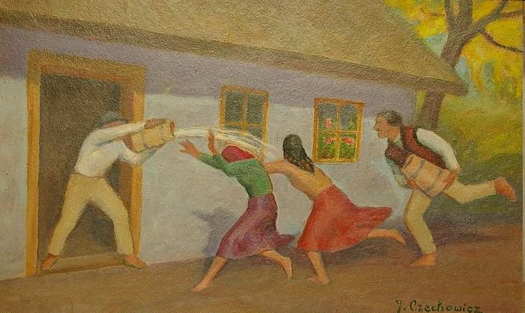

EASTER TIME

EASTER MONDAY ŚMIGUS DYNGUS

WHEN BOYS

POUR WATER ON GIRLS
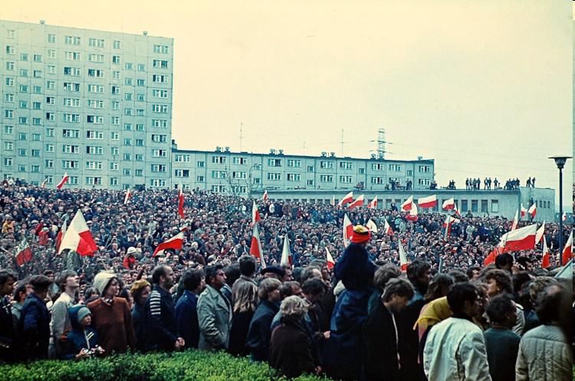
1ST MAY –

DAY OF LABOUR

PEOPLE WITH POLISH FLAGS DURING CELEBRATIONS
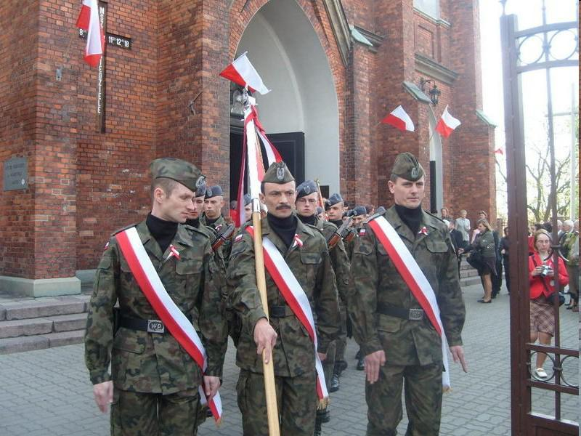

3RD MAY –

DAY OF CONSTITUTION

OFFICIAL MASS WITH PARTICIPATION OF POLISH ARMY

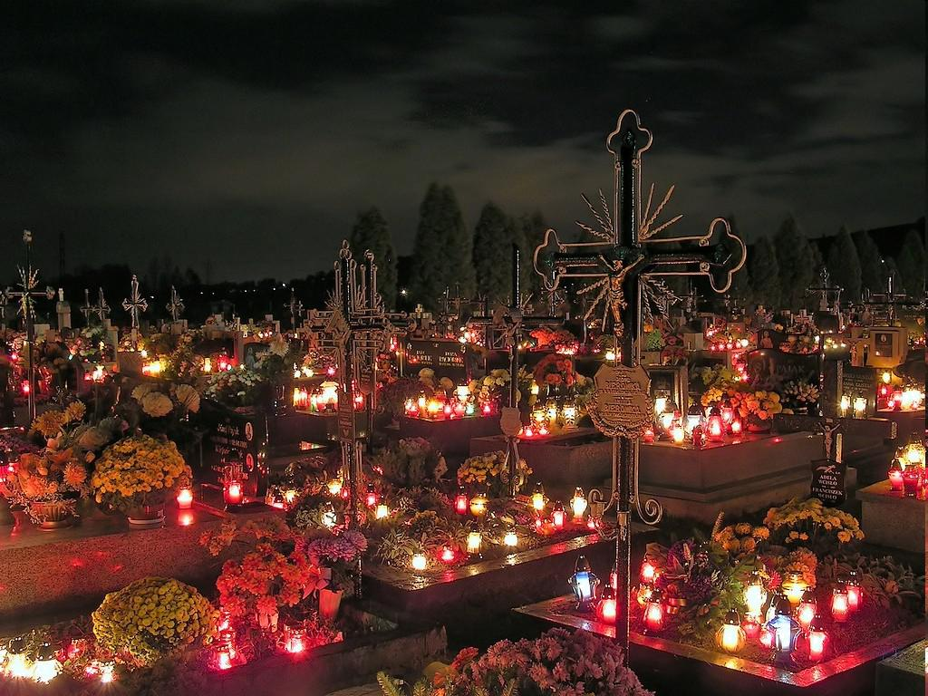
1ST NOVEMBER ALL SAINTS DAY

PEOPLE LIGHT CANDLES

ON GRAVES AND PRAY TOGETHER ON CEMENTARIES
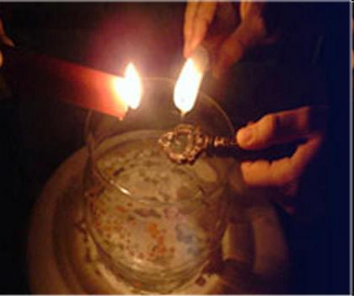

30TH NOVEMBER ST. ANDREW’S DAY

ANDRZEJKI

PEOPLE POUR WAX THROUGH KEY HOLES AND PREDICT FUTURE FROM WAX FIGURES

4TH DECEMBER

ST. BARBARA DAY – TRADITIONAL DAY OF COAL MINERS
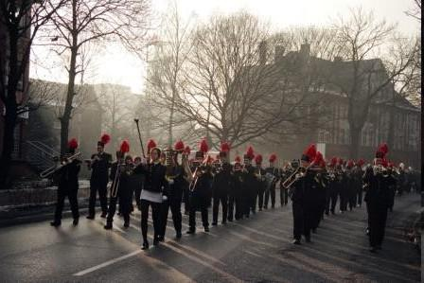

ORCHESTRA OF COAL MINERS

IN TRADITIONAL CLOTHES

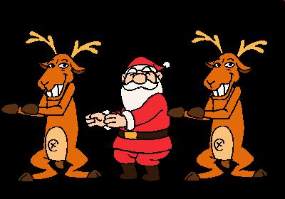
6TH DECEMBER SANTA CLAUS DAY
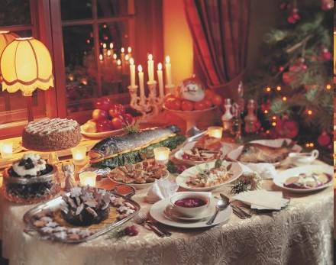

24TH DECEMBER CHRISTMAS EVE

WIGILIA

TRADITIONAL CHRISTMAS EVE SUPPER CONSISTING OF 12 DISHES

FAMOUS CITIES OF POLAND
WARSZAWA

FACTS:

- Situated on both sides of main Polish river
Wisła ( Vistula )
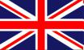

- Polish government headquraters

- Completely destroyed during World War II and rebuilt after the war
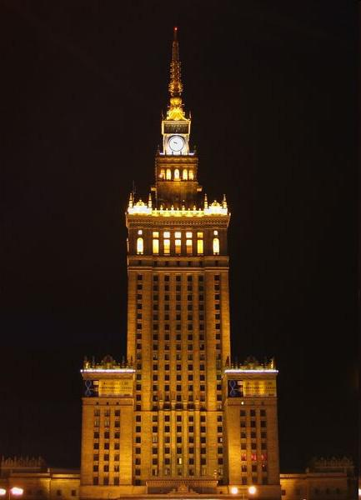
PALACE OF CULTURE AND SCIENCE
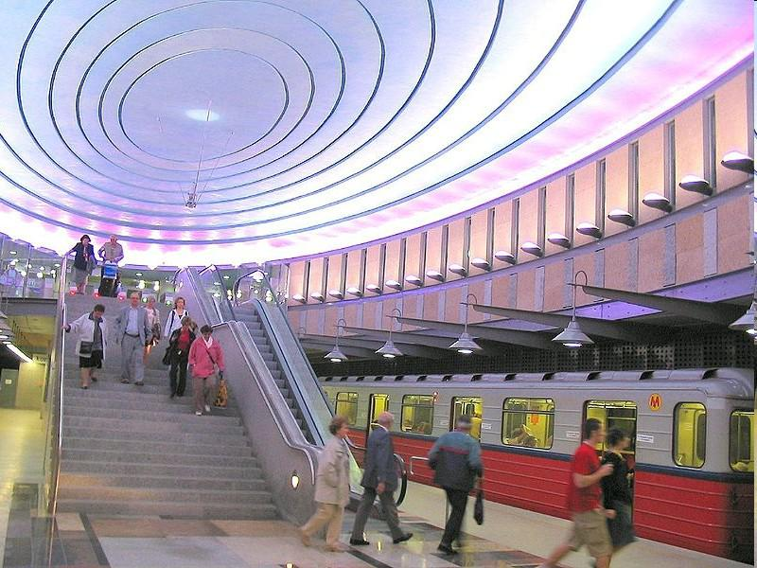

METRO STATION

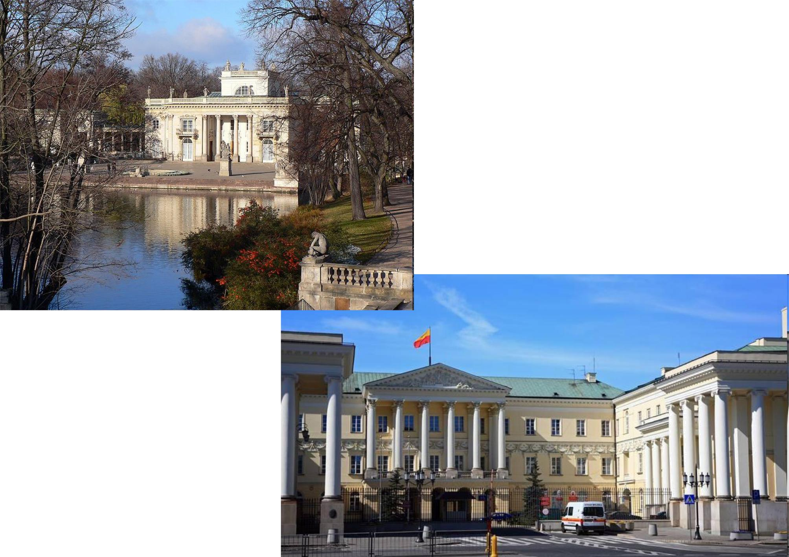
PALACE ON WATER

GOVERNMENT HEADQUARTERS

WROCŁAW

FACTS:

- Selected European Capital of Culture 2016

- Situated on both sides of the second biggest Polish river: Odra

- One of the biggest and oldest cities in Poland
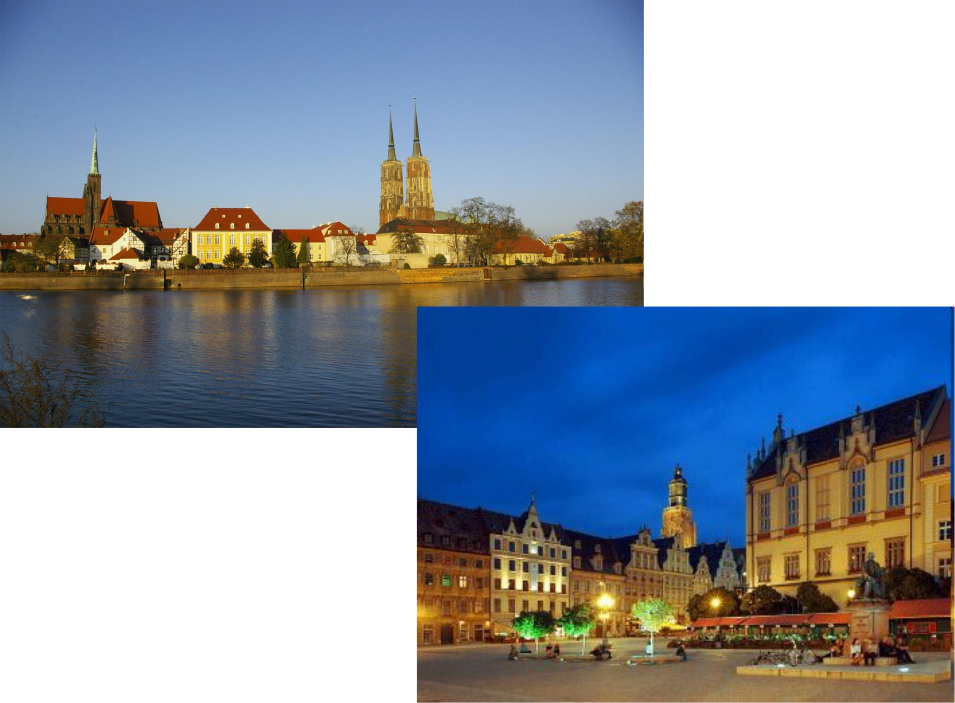
OLD CITY VIEW

MAIN SQUARE

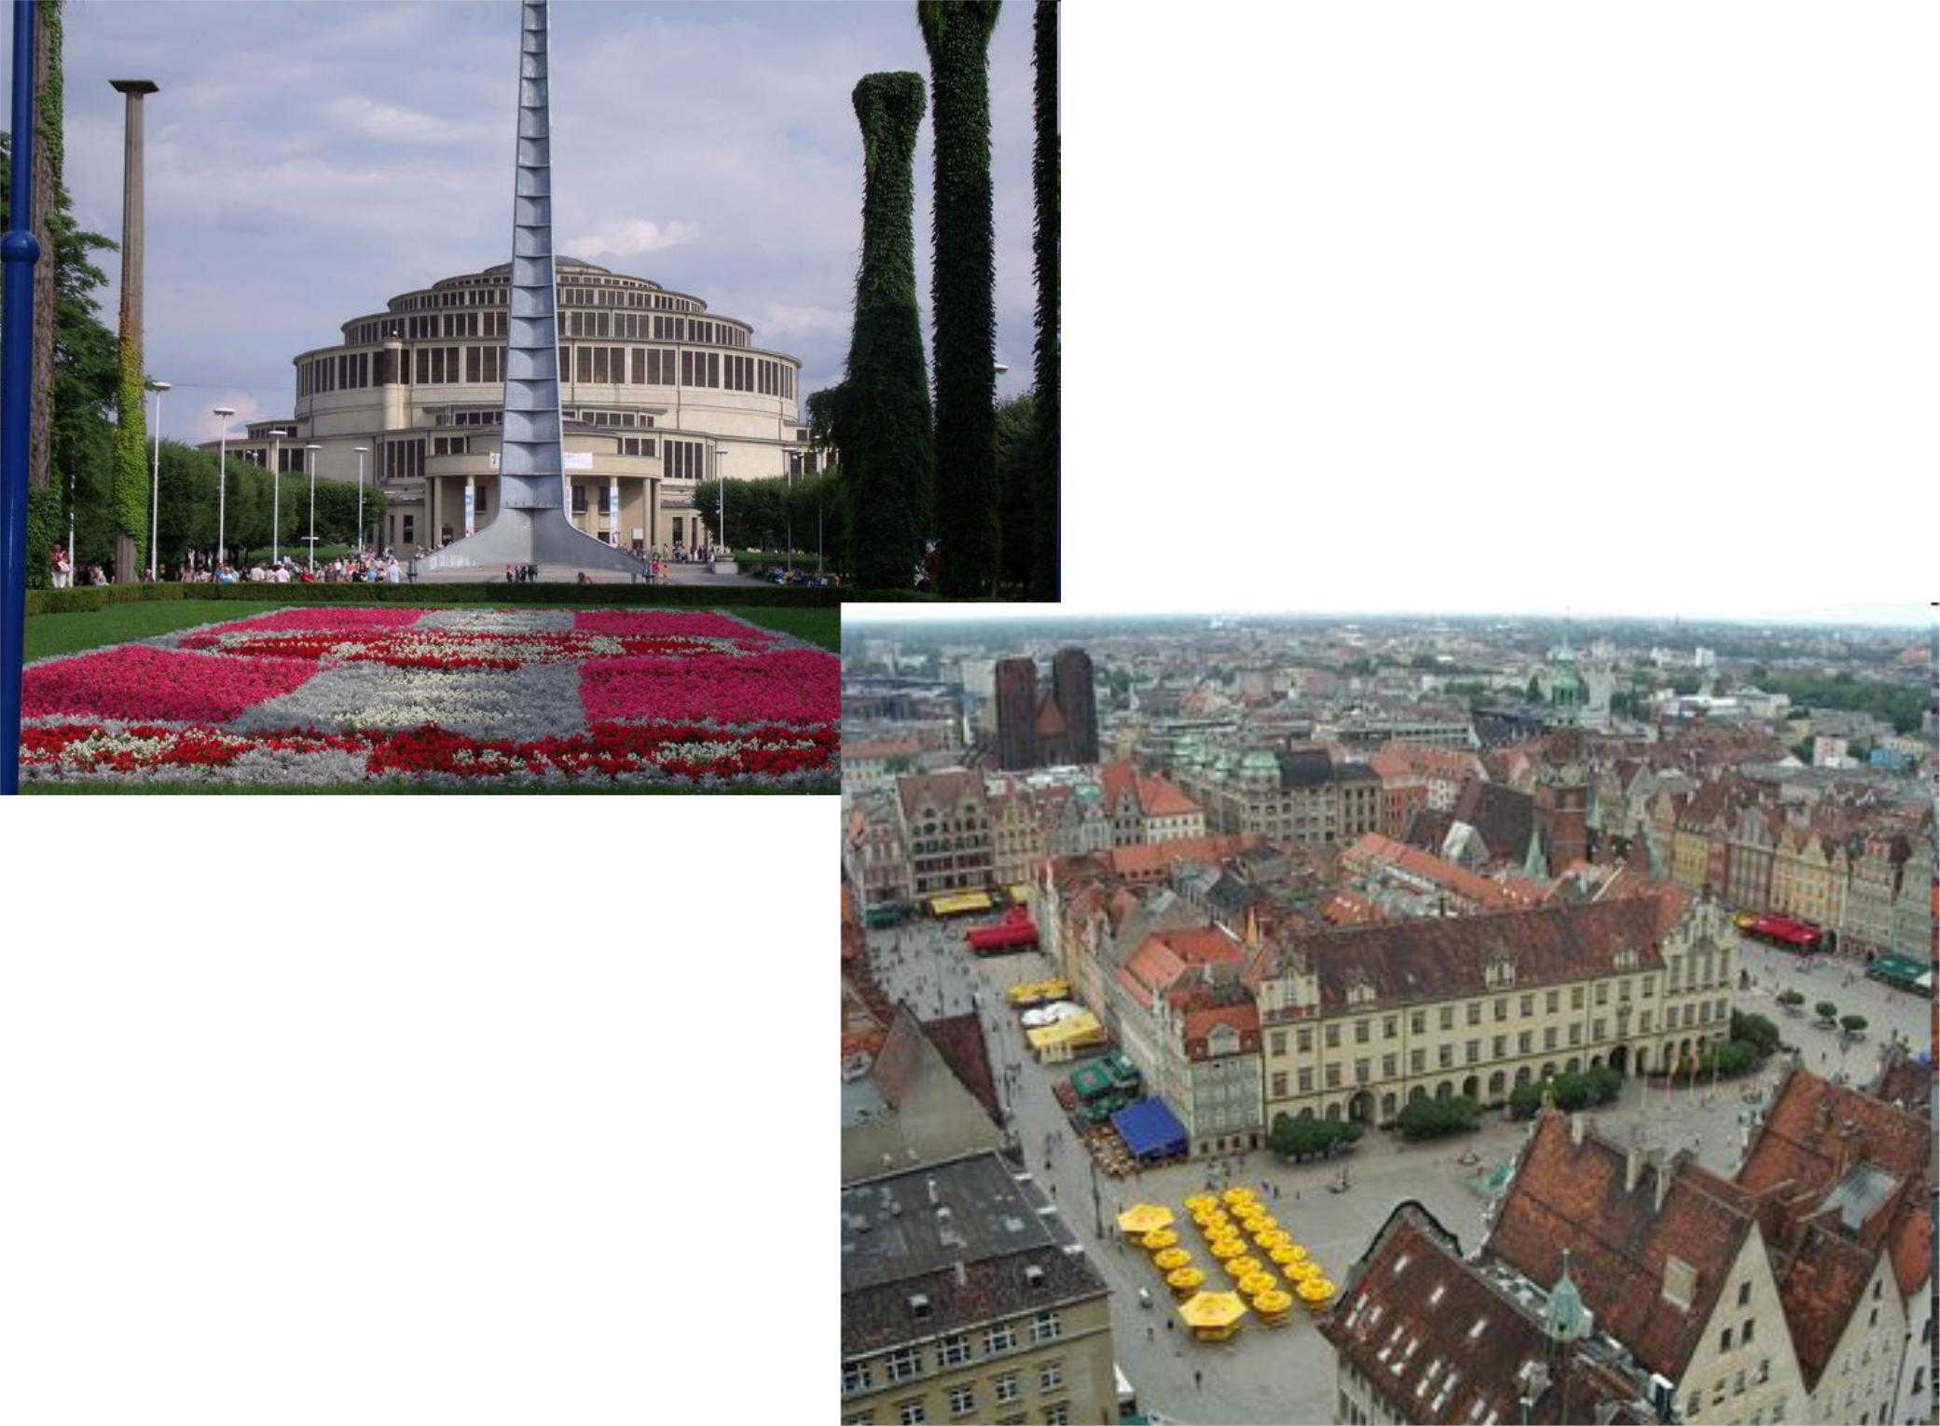
CENTENNIAL HALL WHERE CONCERTS AND SPORT EVENTS TAKE PLACE

PANORAMA ON THE CITY CENTRE
KATOWICE

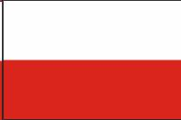
- Capital city of Silesia region ( Śląsk) - industrial region of Poland

- Has got many coal mines

- Famous for its sport hall called Spodek ( saucer) which looks like a UFO
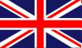
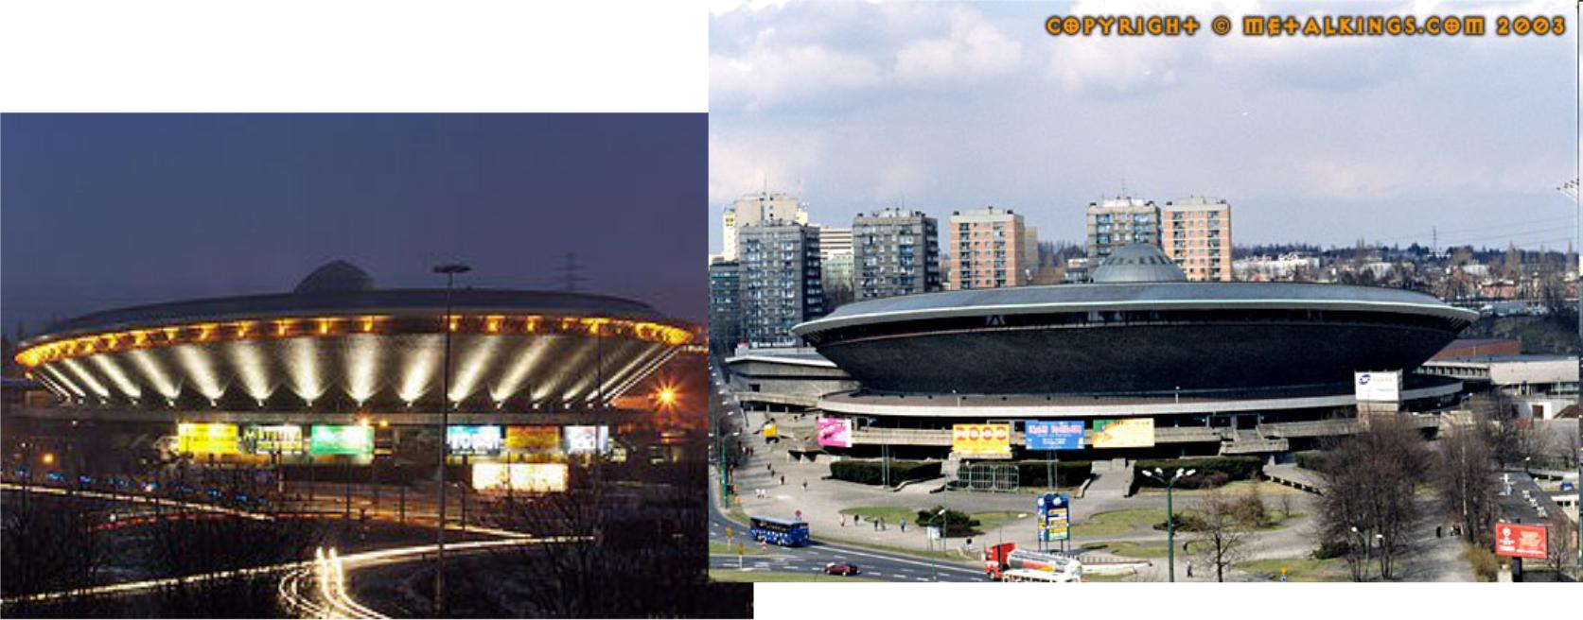
SPODEK

OLD MINING DISTRICT AND A COAL MINE
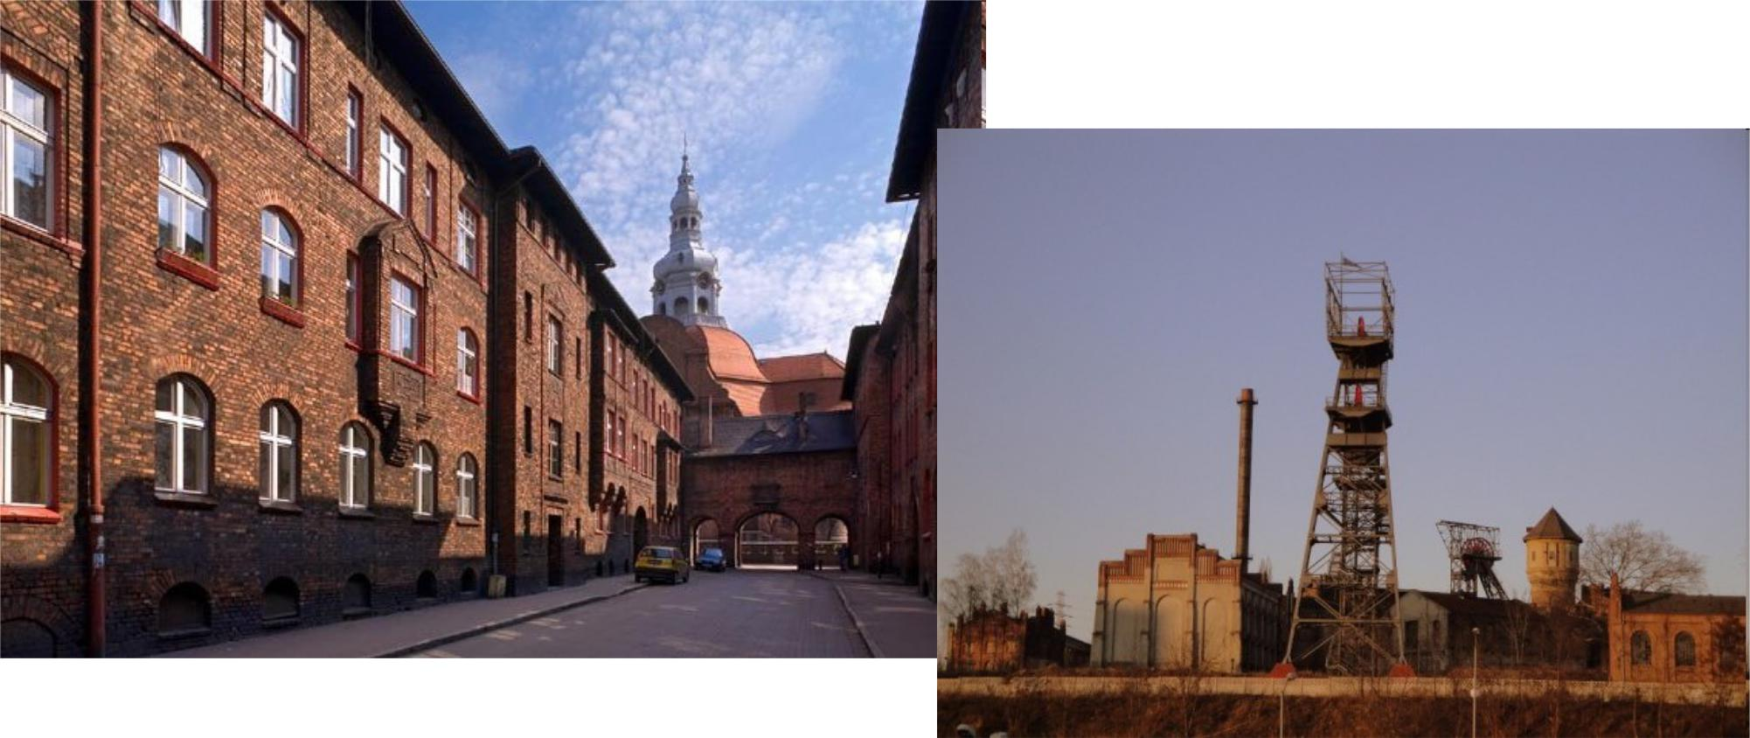
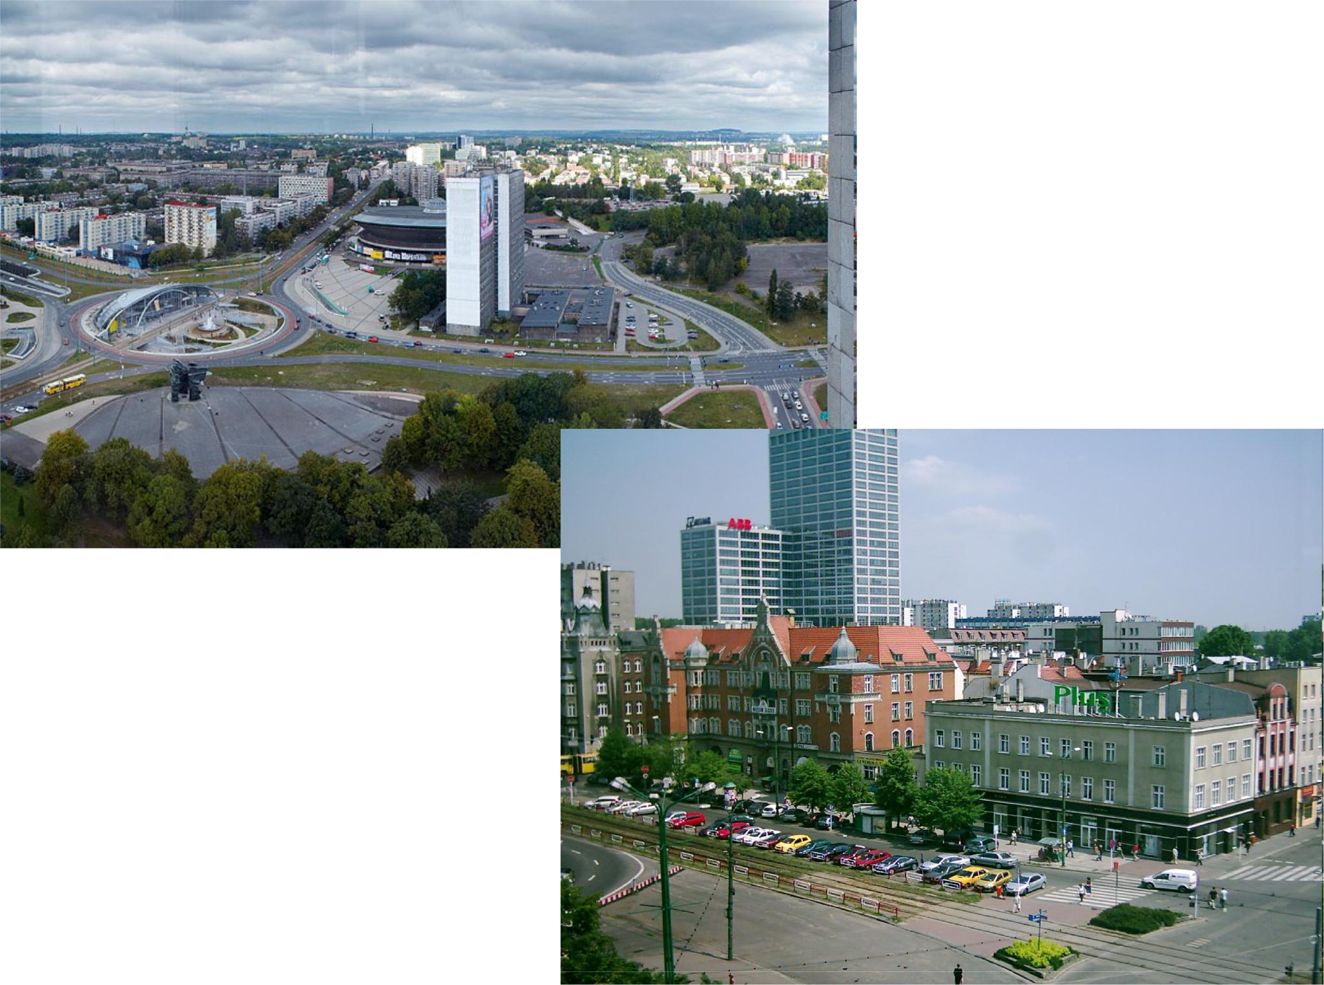
VIEW ON THE CITY CENTRE
KRAKÓW

- Historical capital city of Poland

- Academic and artistic centre

- According to a legend it used to have a dragon

- Like Warszwa, Kraków lays on Wisła river
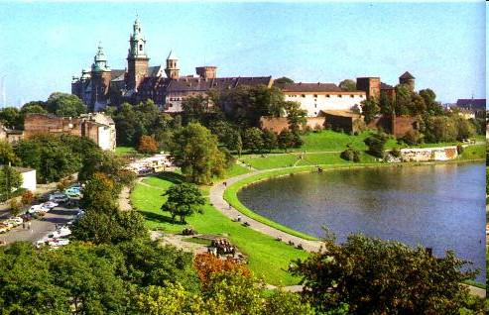
VIEW ON THE CASTLE CALLED WAWEL
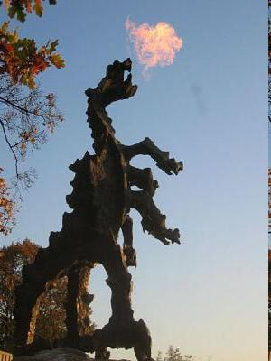

STATUE OF CRACOVIAN DRAGON BREATHING FIRE
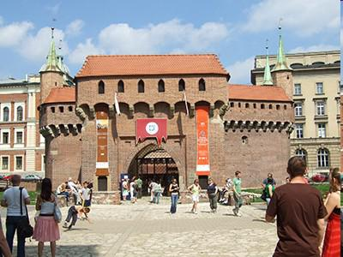

FLORIAN’S GATE

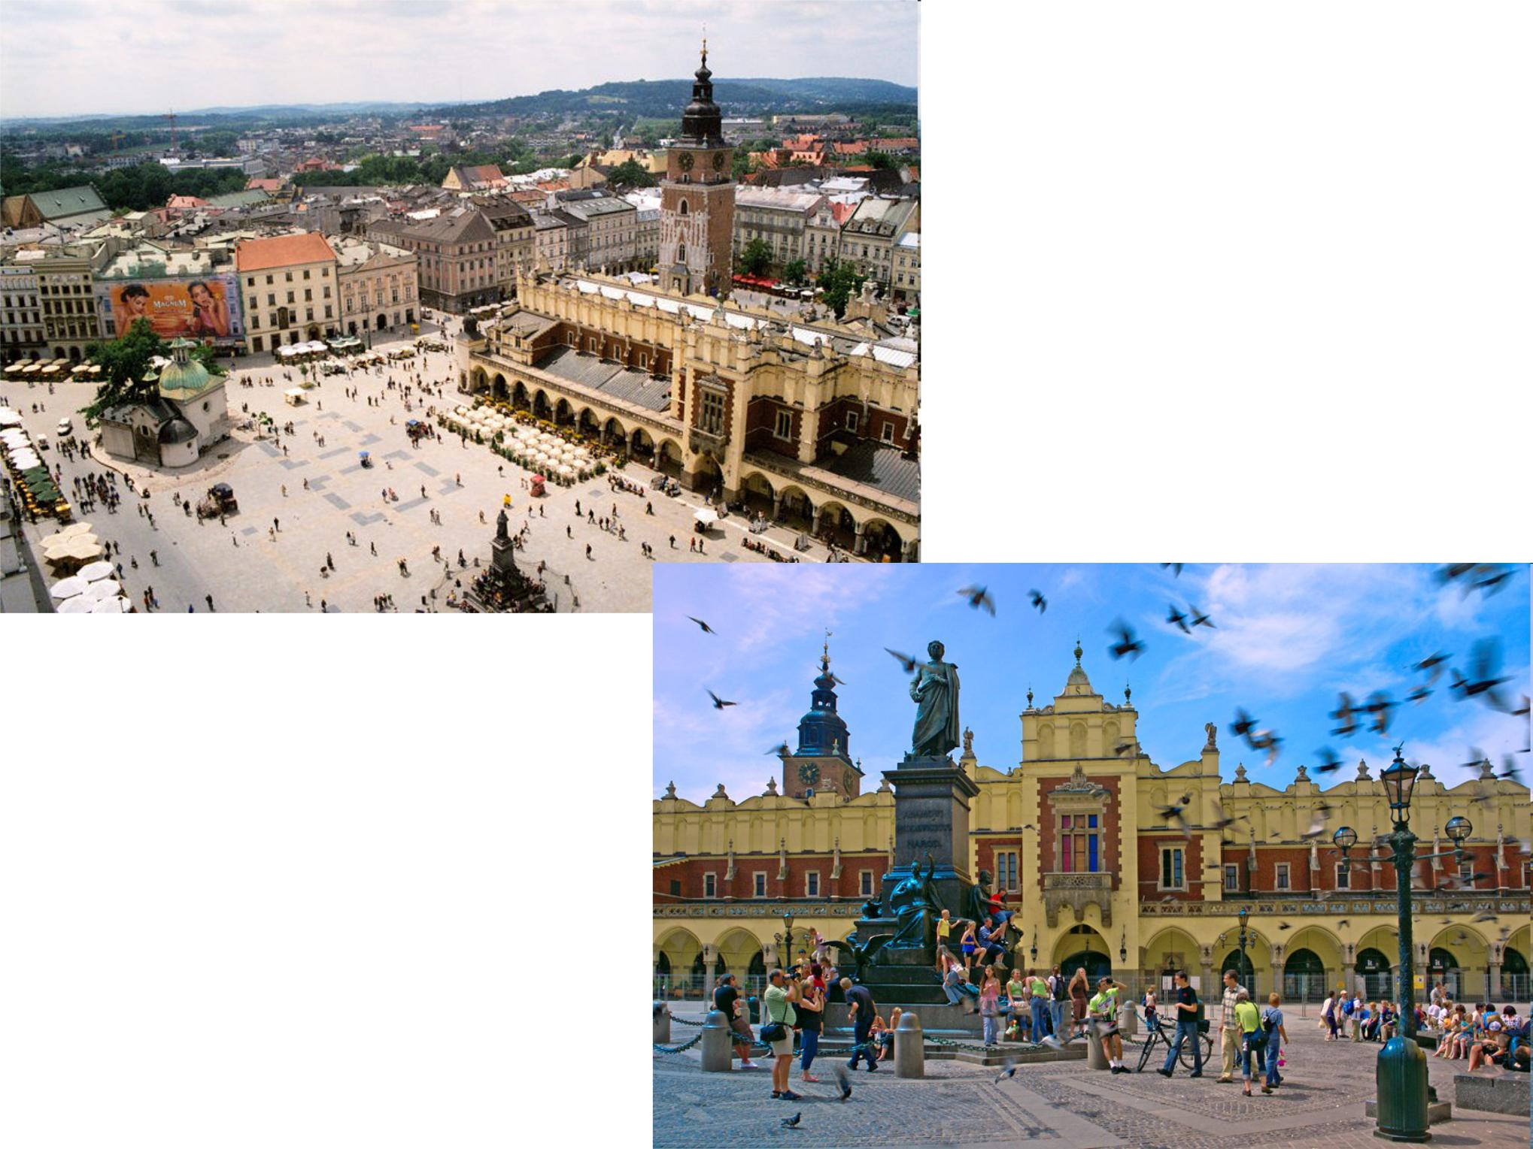
MAIN SQUARE

OLD MARKET PLACE WHERE PEOPLE SOLD CLOTHES CALLED SUKIENNICE (FROM POLISH WORD MEANING A SKIRT)

GDAŃSK

- Situated at the seaside

- Fourth biggest Polish city

- Known for the uprising of Polish workers during Communism in Poland

- Famous for annual summer Sand Festival when artists make sand sculptures on the beach
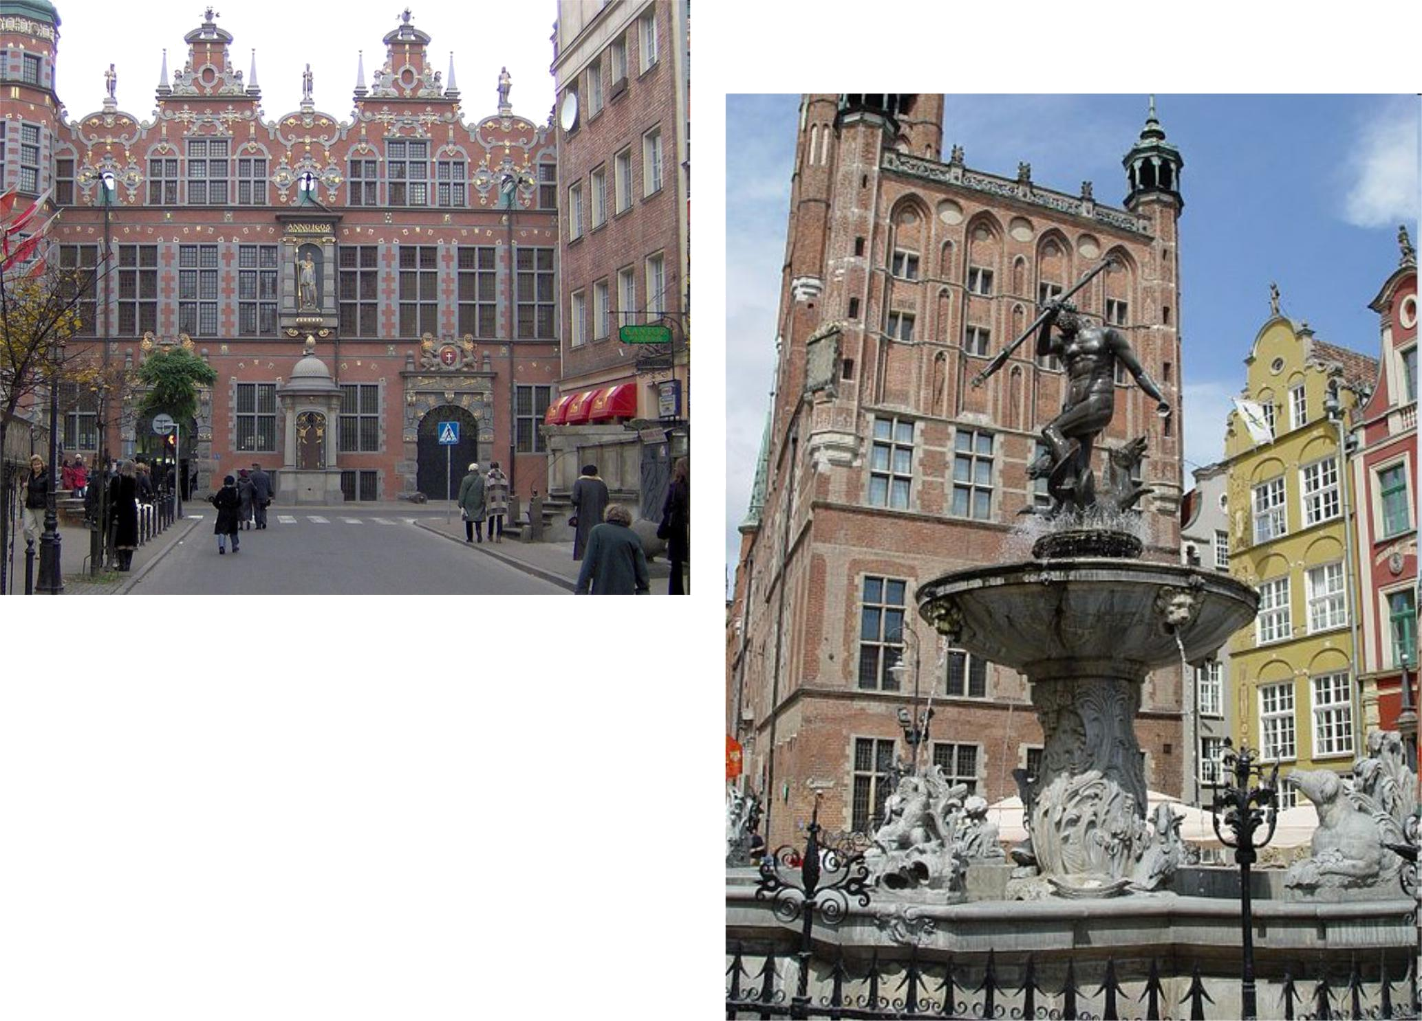

DUTCH-STYLE BUILDINGS

NEPTUN’S FOUNTAIN

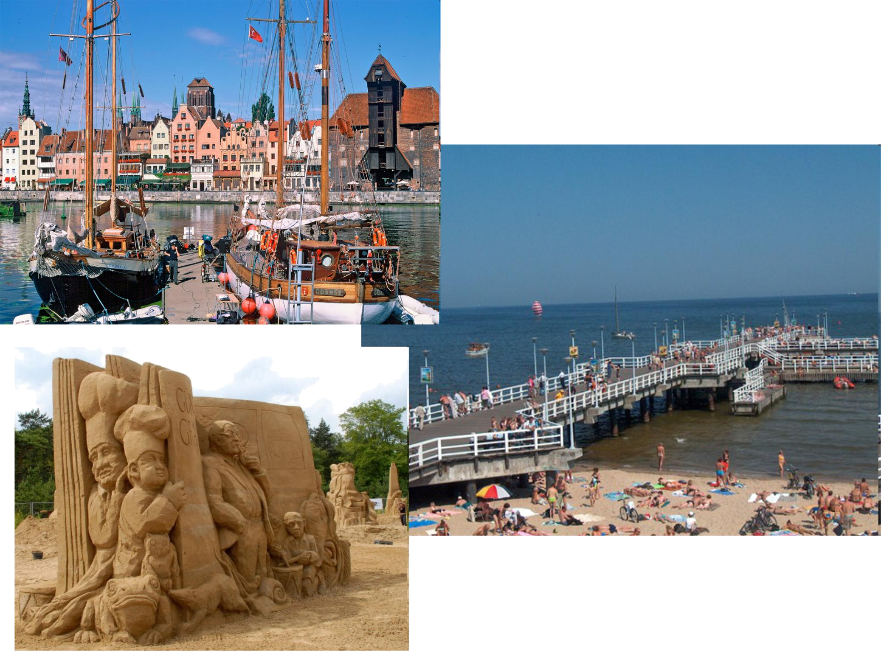

HARBOUR

SAND SCULPTURE

See you…. in Poland!

