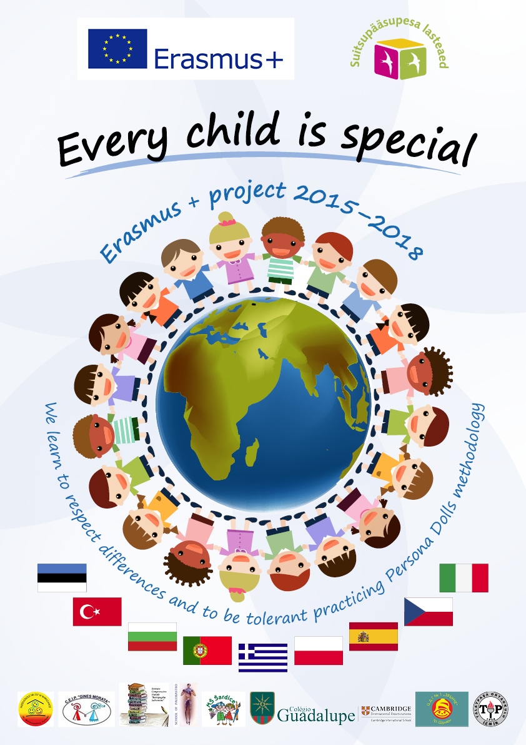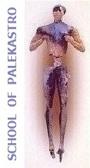

|  |  |  |  |  |  |  |  |  |  |  |
| --- | --- | --- | --- | --- | --- | --- | --- | --- | --- | --- |
|  |  | **QUESTIONNAIRE** | |  | **ANSWERS of 24 KIDS** | |  |  |  |  |
|  |  |  |  |  |  |  |  |  |  |  |
| 1 | Which differences | Hair | Skin Colour | Eye Colour | Male/Female | Nationality | Weight | Height | I don't know |  |
|  | could people have? | 4 | 8 | 1 | 4 | 3 | 2 | 1 | 1 |  |
| 2 | What is this? |  | | | | | | | |  |
|  |  | I know | I don’t know | Use another name |  |  |  |  |  |  |
|  |  | 14 | 8 | 2 |  |  |  |  |  |  |
| 3 | When are these aim articles used for? | For the sun | To see | To walk | When we’re injured | Other answer | I don’t know |  |  |  |
|  |  | 6 | 1 | 8 | 5 | 3 | 1 |  |  |  |
| 4 | Do you know someone | Yes | No |  |  |  |  |  |  |  |
|  | who has a special |  |  |  |  |  |  |  |  |  |
|  | need? | 18 | 6 |  |  |  |  |  |  |  |
| 5 | How can you help a | Play with | Give a help hand | Help them in any activity | Pushing the wheel chair | Give affection | Help going to the school | I don’t know |  |  |
|  | need? |  |  |  |  |  |  |  |  |  |
|  |  | 6 | 4 | 4 | 3 | 2 | 5 | 0 |  |  |
| 6 | Is it possible to play | Yes | No |  |  |  |  |  |  |  |
|  | with a child who does |  |  |  |  |  |  |  |  |  |
|  | not hear,walk or see? | 19 | 5 |  |  |  |  |  |  |  |
| 7 | What are these games | Running | Dance | Bike | Play music | Draw | Hide  and seek |  |  |  |
|  | we can play together? | 3 | 5 | 2 | 6 | 4 | 4 |  |  |  |
| 8 | Is diversity (differences) good or bad thing for people? | Good | Bad | I don’t know |  |  |  |  |  |  |
|  |  | 17 | 4 | 3 |  |  |  |  |  |  |