Doll 4
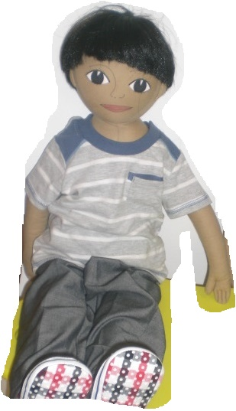
Name:Carlos

Family: 50 year-old father, 52 year-old mother and 20 year-old twin sisters.

Cultural background:He was born at home in the village of Monsaraz (Alentejo).

Home:They live in a rented house by the river.

Language: Portuguese

Likes:He likes eating popcorn and going fishing.

Dislikes: He doesn’t like people making fun of the way he talks (his accent) and calling him “alentejanito” (short person that was born in Alentejo)

Food: Likes: He likes eating “açorda de alho”, a typical dish from Alentejo, made with crumbled bread and garlic.

Physical peculiarity: Due to complications during delivery, he has some breathing problems.
He doesn’t like kissing and hugging. As he has Asperger syndrome, he doesn’t look people in the eyes when talking to them.

Recent history:His parents have always worked in pottery but due to financial issues caused by the crisis that affected Portugal, the family had to move to the fishing city of Setúbal. Nowadays, his father works as a fisherman and his mother as a cleaning lady. Despite the family’s delicate economic situation, his two twin sisters go to private schools.

