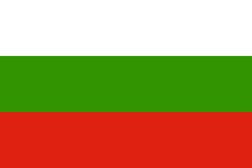
Bulgarian customs and traditions
Waits /street singers of Christmas carol/
https://www.youtube.com/watch?v=97jUN8zSci0
The waits (koledari) walk house to house. One of the men is called blesser. He pronounces the blessing. Sometimes the group is accompanied by a piper who plays only when the waits move from house to house and they are not singing. In each house the waits first sing a song for the man of the house and after that for the others of family. The words are a blessing for health, prosperity and good life. Koleduvane ends on Christmas morning after all houses have been visited.
Grandmother Martha
https://www.youtube.com/watch?v=qaQ3IhMfwXw&index=3&list=PLNI2O08893DfsQGDJx0BfR2Mwr2ZIHMNN
Fire dancers – Nestinari
https://www.youtube.com/watch?v=EYtUf39vvKs
Nestinarstvo is a fire ritual originally performed in several Bulgarian- and Greek-speaking villages in the Strandzha Mountains close to the Black Sea coast in the very southeast of Bulgaria. It involves a barefoot dance on smouldering embers (жарава, zharava) performed by nestinari (нестинари). It is usually performed on the square of the village in front of the whole population on the day of Sts. Constantine and Helen or the day of the village's patron saint. The ritual is a unique mixture of Eastern Orthodox beliefs and older pagan traditions from the Strandzha Mountains.
Pravo horo
https://www.youtube.com/watch?v=Wpncg8mHNCU&index=18&list=PL860217B1AABCD8C7
Horo in Bulgarian means circle. The circle is a sense of completion, power and perfection. There are 100 kinds of horo.

