Doll 3

Name: Maria Eduarda

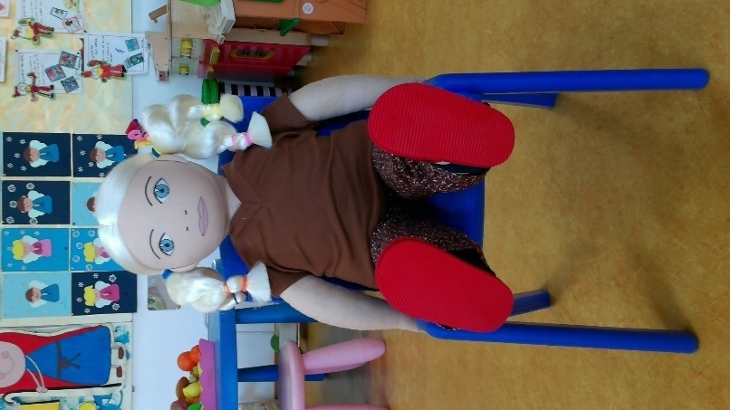
Family: 65 year-old father, 29 year-old mother and a 33 year-old step-brother (from the father’s side). The step-brother already has an 8 year-old son.

Cultural background:She was born in Portugal (Lisbon), where her father works as a businessman. Her mother works as a model and has an international career.

Home: They live in a luxurious apartment in the centre of Lisbon.

Language: Portuguese

Likes:She likes chocolate. She has some difficulties controlling her appetite.

Dislikes: She doesn’t like affection.

Food: Like: She likes eating everything.

Physical peculiarity: Overweight

Recent history: Maria Eduarda suffers from Attention Deficit Hyperactivity Disorder (ADHD). She is a victim of bullying due to her physical appearance. She takes refuge in eating when she is upset.

