Doll 1

Name: Valéria
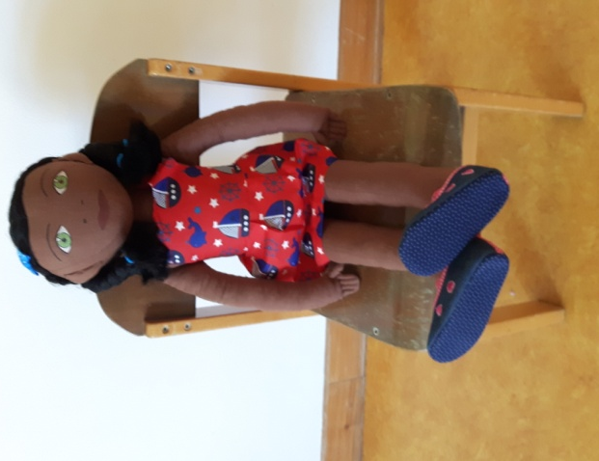
Family: Father, mother and two brothers.

Cultural background:Born in Maputo, Mozambique. Her father is a musician and her mother a housewife. They recently came to Portugal because the father was invited to play with a big orchestra.

Home: They live in a small flat, where she shares a room with her brother. They are looking for a bigger house.

Language: Portuguese

Likes: Ballet, the colour orange and school
Dislikes: noise, fights and dogs

Food: Likes: Salad, hamburger and prawns. Dislikes: codfish, gummy bear sweets and oranges

Fears:The dark, sleeping alone and dogs (because she has been bitten)

Physical peculiarity: Doesn’t have any

Recent history: Arrived recently and is still adjusting.
Valeria's grandparents stayed in Mozambique and she misses them. Her grandmother sends her dresses and they speak via skype.
In Mozambique, she stayed home with her mum, in Portugal she goes to school.
She has not made many friends yet.

