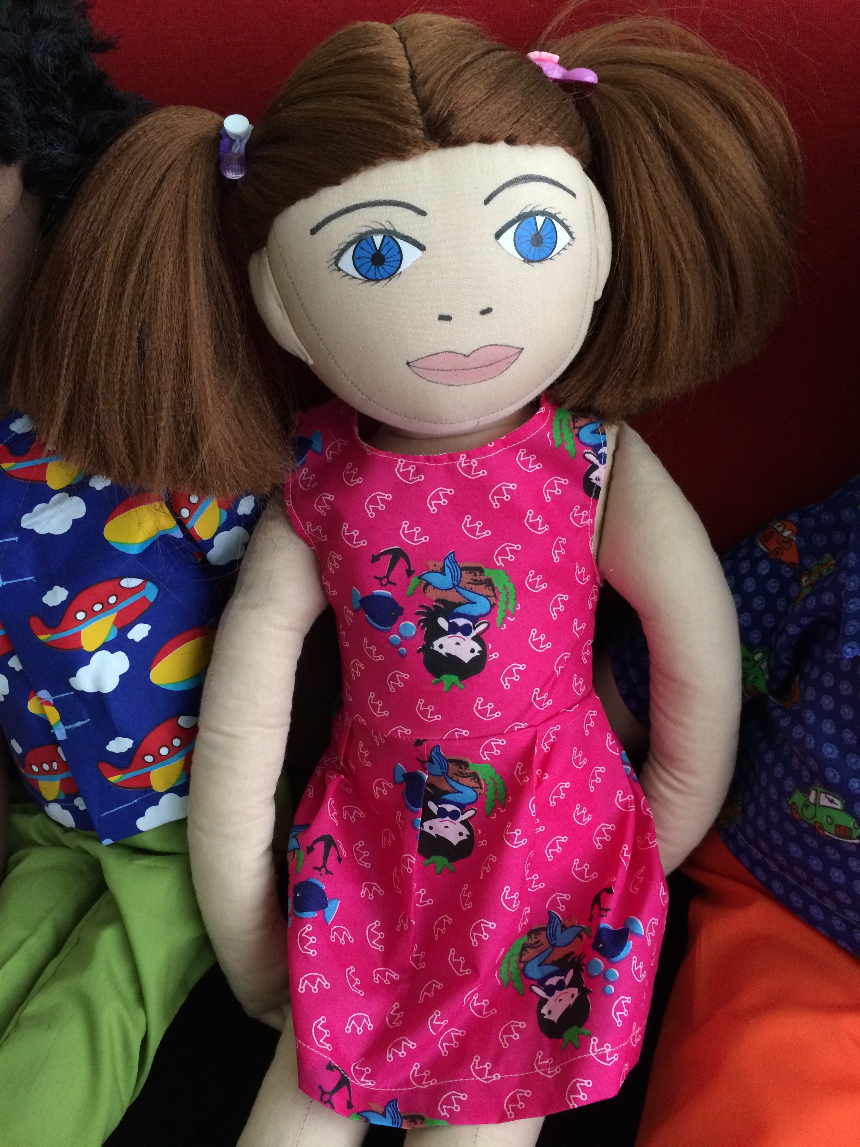
Name: Triinu
Family: Triinu lives with her father and fathers new wife and her 2 older sons.
Cultural background: Triinu’s father is Estonian and they celebrate at home Estonian traditions.
Where she lives: Triinu lives in a 4 room apartment at old big apartmentbuilding in Mustamäe.
Likes/dislikes/is difficult: Triinu would like to play together with other children and find herselt good friends but it is very difficult for her to connect with others because she does not know how to communicate with others. Because Triinu would like to play with others children she could be very pushing towards others, that could be annoiing to others.
When others exclude Triinu from games then she would be very sad. Sometimes she does not understand why she can not join others game she could then be aggressive, say nastu things and hurt others. Triinule dos not like when older brothers bully her and exclude from games. She then could be aggressive.
Triinule likes animals. She has at home a kitten who is her best friend. Triinu appreciates her kitten very much. Triinul likes different animal books and cartoons. Triinu favourite activity is playing with her kitten.
Triinul does not like when others comment about her speech or improve her words when they don’t understand her. Triinu does not like to clean the room.
Food she likes/dislikes: Triinu eats everything. Her favourite dish is macaroni and meat sauce. She does not like salads with sour cream, like potato salad.
Fears: Triinu is afraid to speak in front of others and then others will say that they don’t understand her. Therefore Triinu speaks with very low voice. Triinu calls herselt Liinu and Tiinu but she does not like when othes repeat it.
Physical peculiarity: Triinu has red hair and freckles. Triinu’s speech is incomprehensive.
Recent history: Triinu lived with her father. The father was always very busy and Triinu was often alone. Recently they moved to the home of fathers new wife and there also lives 2 older boys. Triinu was at first very happy that now she has somebody to play with but the bigger boys bully her instead. Father newer founds time to deal with Triinus concern. Triinu feels so sad and lonely. Recently Triinus teacher said to father that he need to go to speech therapy with Triinu, because other can not understand her speech. Triinu hopes that her speech improves and then others want to be her friend.

