How to make an apparatus for sensing Volatile organic compounds (VOC) –
WORKSHEET

Material and tools:  - Multimeter  - Breadboard  - DC source 5V-9V  - Electrical wires  - VOC sensor (TGS 2620)  - Resistor 1 kΩ  - Resistor 47 kΩ  - LED |  | 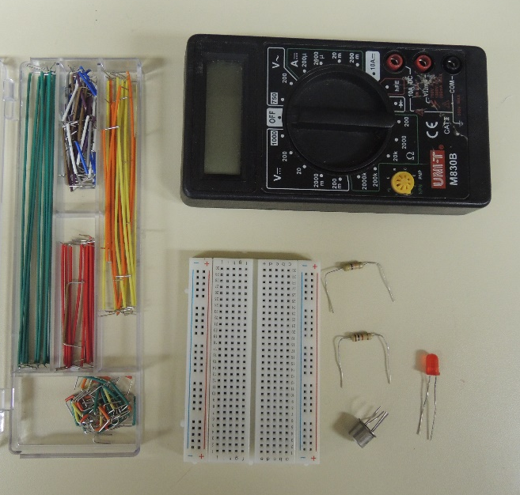
Photo and schematics of the aparatus |  | 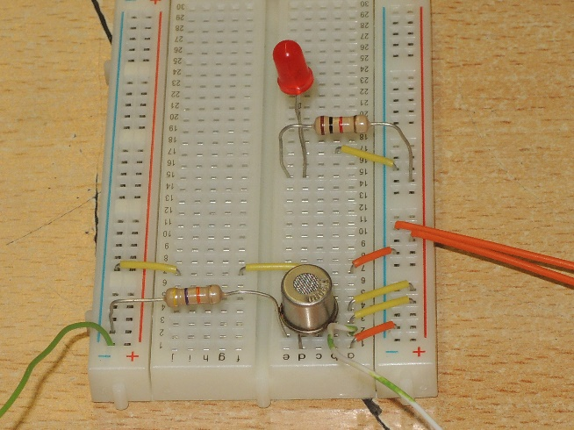  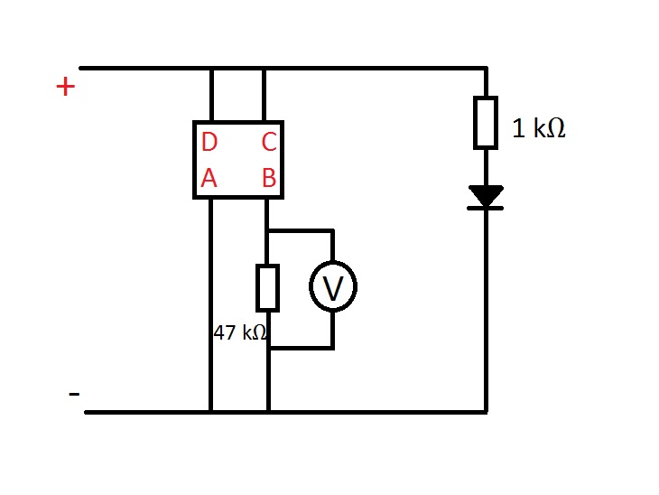
Instructions | Tools and materials |  | Photo instructions
- Pin on the breadboard:  - LED at + electrode in B21 and – electrode in B22  - Connect the resistor with the 1kΩ resistance with the + electrode and A21 pin  - Connect pin A22 and - electrode | - LED diode  - Resistance 1kΩ  - Electronic wire
- Pin on the breadboard:  - 47kΩ resistor from E2 to - line  - Connect with wires - lines (directly or how it’s showed on the picture) | - Resistor 47kΩ  - Electronic wires
- Pin on the breadboard:  - VOC sensor with it’s nodge turned towards the middle of the board; legs A,B,C and D into lines 1,2,3 and 4  - Wire from A1 to the - line  - Wire from A3 to the + line  - Wire from A4 to the + line | - VOC sensor  - Electronic wires
- Connect voltmeter on the breadboard:  - Connect multimeter terminal VΩmA with red wire to - line  - Connect multimeter terminal COM with black wire to A2 | - Multimeter  - Red wire  - Black wire
- Connect DC current source in the electrical circuit in the following way:  - + line on + electrode  - - line on - electrode | - DC current source

