THE MYTH OF THE GIANT TIFEO

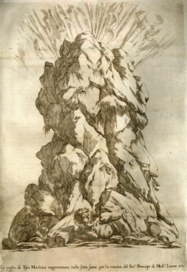

Today we will talk about the "Myth of the giant Tifeo", of that giant trapped in the land of Sicily that, from his mouth, erupts fire. The myth tends to explain the reason for the continual eruptions of Etna and the many telluric movements of this land.
The legend tells of a giant called TIFEO (also Typhon), condemned by the Gods to support Sicily for daring to climb the sky to seize the heavenly seat, imitating the Titans. Tifeo is the son of Tartarus, the personification of the Underworld and of Gaia, the Mother Earth. The giant is monstrous, with hundreds of dragon heads. His mother destined him to fight without a quarter against Zeus, guilty of having defeated the Titans, who were also sons of Gaia. During one of the many fights between the two, Tifeo flees to the east to reorganize his strategy. It thus arrives at the limits of the Syrian territory and stops waiting. The fight begins again with Zeus, but this time the giant snatches the weapon from the hands of the King of the Gods. With this he cuts the tendons of Zeus's feet and hands, then throws him into a cave in Cilicia, a district on the southeastern coast of Asia Minor. Zues receives, however, the help of Hermes and Pan who find his tendons, put it back on track and bring it back to Olympus, ready to start the comparison again. On Mount Nisa, the Moire (the three spinning girls, the Klothes, representing the destiny) refresh him with fruits usually destined to mortals: he, divine creature, in direct contact with that food, begins to lose strength.
Zeus immediately takes advantage of the opportunity and deeply wounds the giant who begins to lose so much blood (from that moment on the mountain where this last phase of the fight took place, is called Emo, blood in Greek). Typhon flees to Sicily, but the King of the Gods chases him and imprisons him forever under Etna. So with his right hand he supports Peloro (Messina), with his left Pachino, with his legs supporting Lilibeo (Marsala) and with his head Etna vomiting flames from his mouth. Sometimes Tifeo tries to shake off the weight of the island, the mountains and the cities and it is at that moment that the earth trembles producing earthquakes.
Typical example of how the myth intervenes to explain natural events that man himself could not understand!

Class I sez. C
Students: Giorgia Russo and Carmen Zappalà

