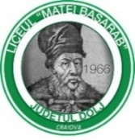

Erasmus + Strategic Partnership
Open Doors for Non Formal
2014-1-RO01-KA201-002889
National Day of Netherlands
Activity with Students -02.03.2016
Liceul ”Matei Basarab”

Teachers organizers:
Nadia Serban
Georgeta Chiurtu

Netherlands national day was celebrated by our students and teachers in the project “Open doors for non formal”.
Students prepared geographical geographical information about climate , rivers, natural resources, cities and economy.
They indicated the date of then national day, which corresponds with the birthday of King-30th of April.
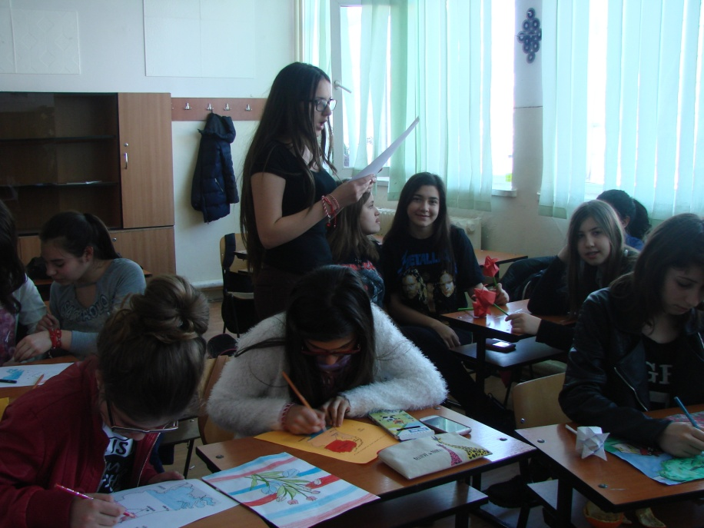

Students painted flags and drew symbols of this country - tulips and windmills. Tulips were achieved through Origani technique.

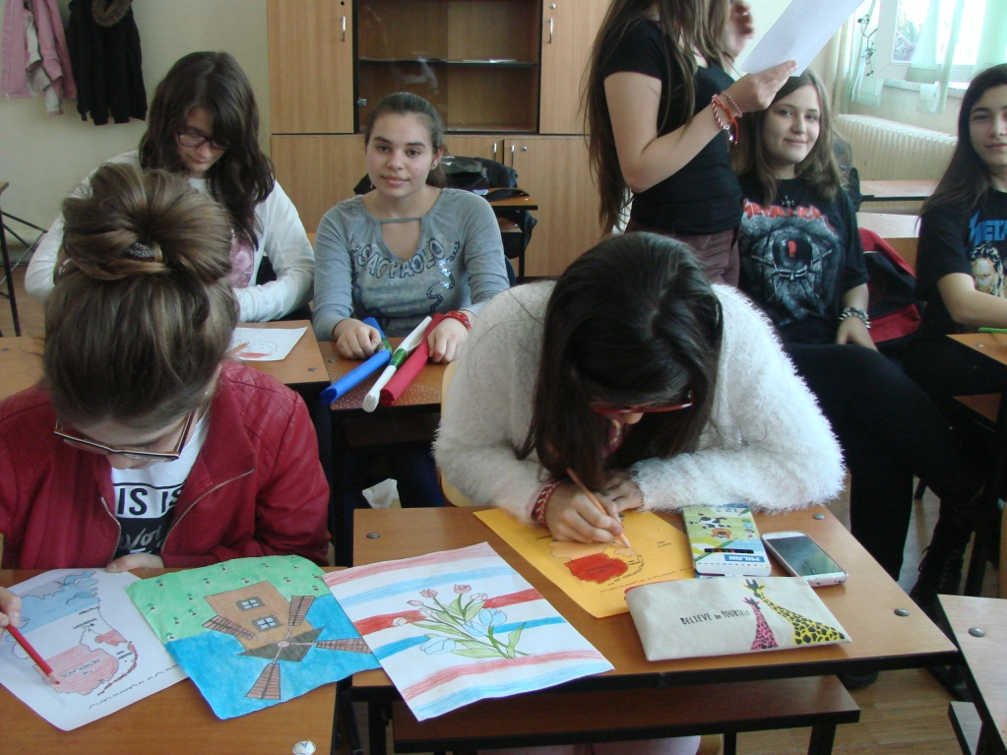
The products were exposed on a schoolboard in the classroom.

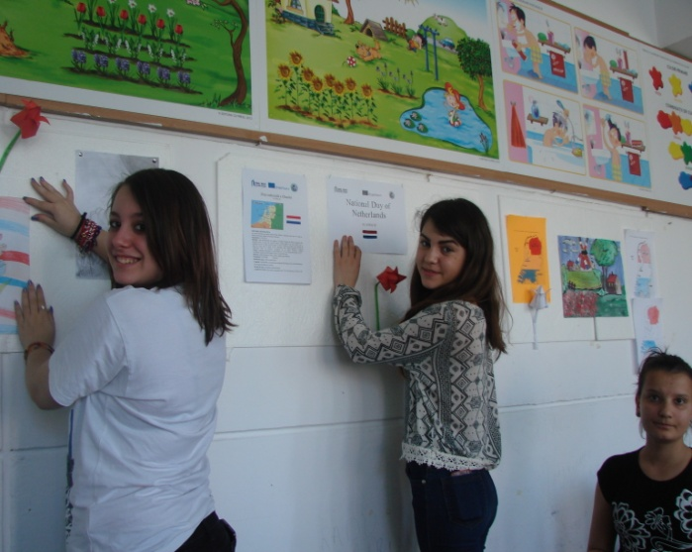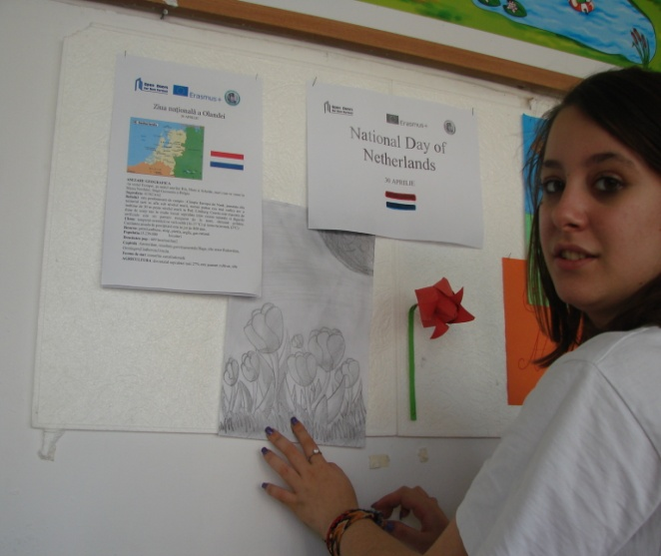

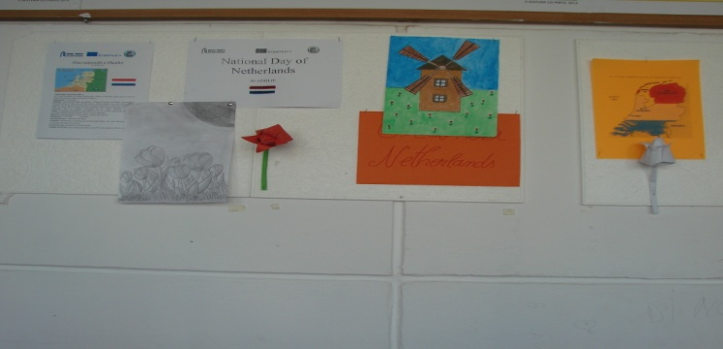

Finaly, few skilled pupils prepared a kind of donuts, filled with jam , which they eat with pleasure.

