The National Day of Lithuania

Teachers Organizers: Chiurtu Georgeta
Șerban Nadia

Lithuania, a land of wood and water, celebrates the National Day on 16th February. Students and teachers of Liceul Matei Basarab celebrated this special day for the Lithuanian people. The activity took place within the Erasmus+ Project Open Doors for Nonformal.
The first part of the activity took place in the classroom where students were presented information about Lithuania geography and history.

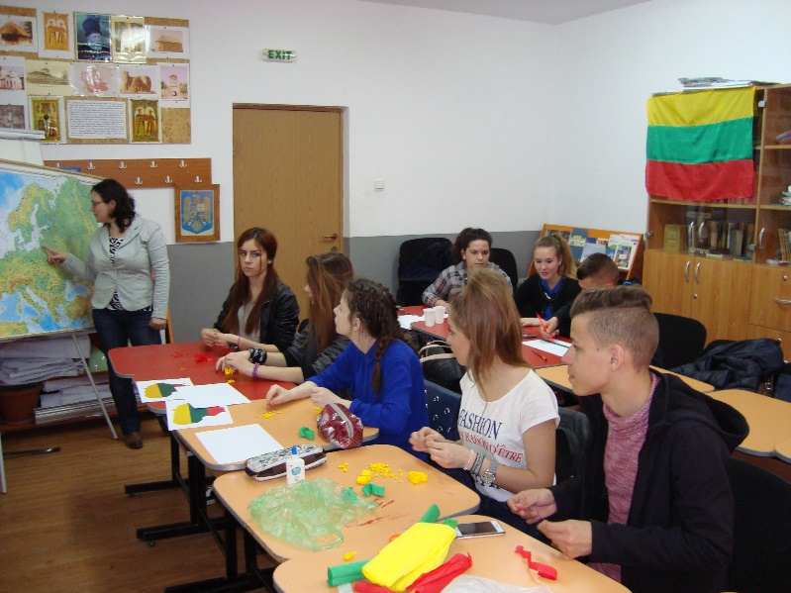

The teachers presented ”Vilnius – Open Doors to the Past”, a material created by teachers and students after the mobility in Lithuania.

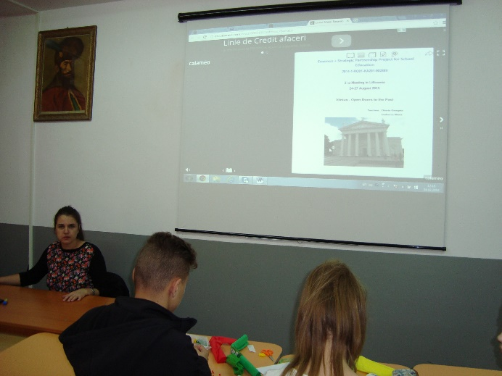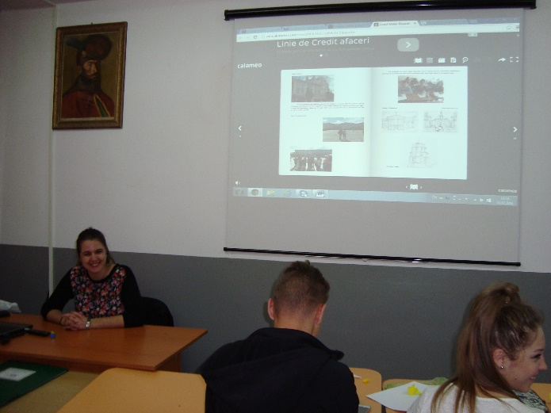

They started making the Lithuanian flag using different techniques and materials: painting, colouring, paper etc.

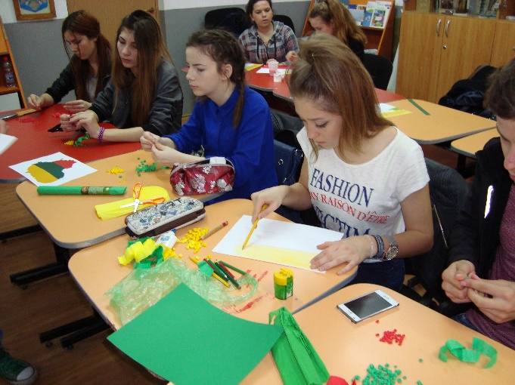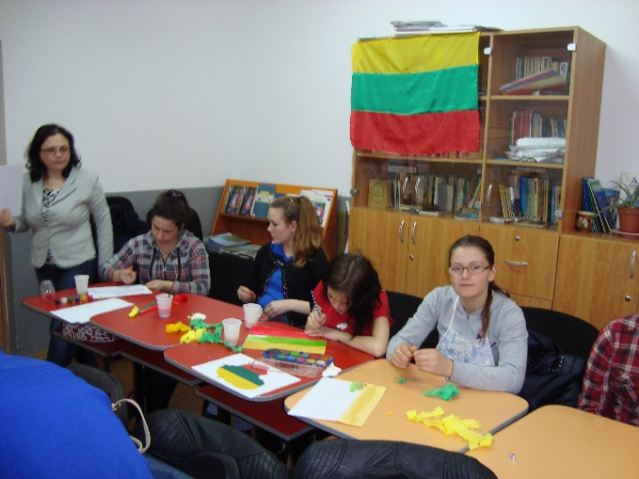

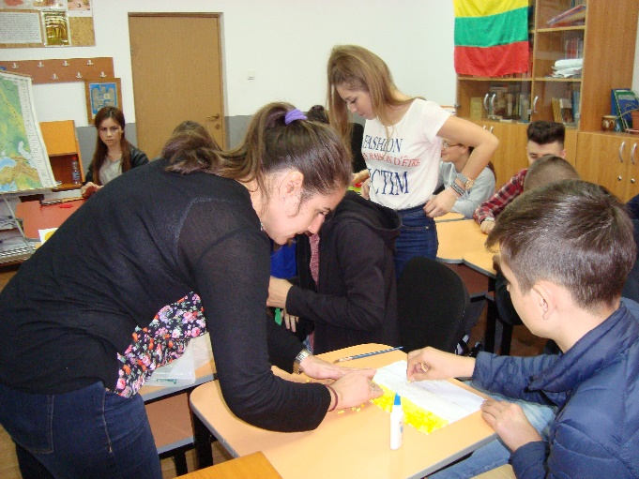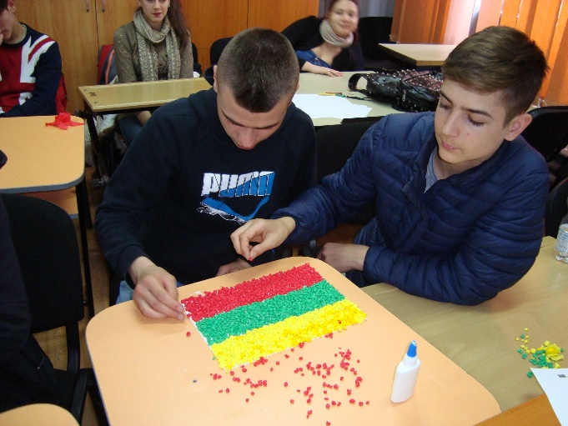

Students prepared a school panel with all the materials sharing their work with everybody in the school.

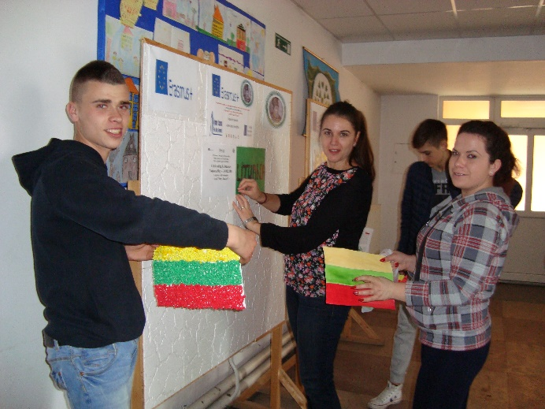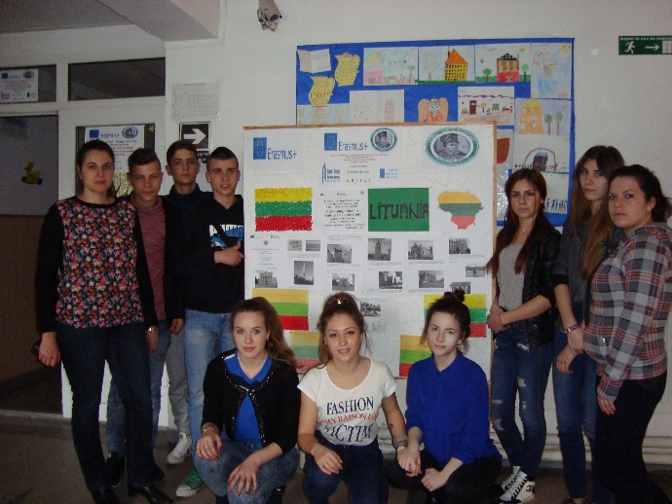

The second part took place in the school cantina where students prepared rye bread, traditional in Lithuania.

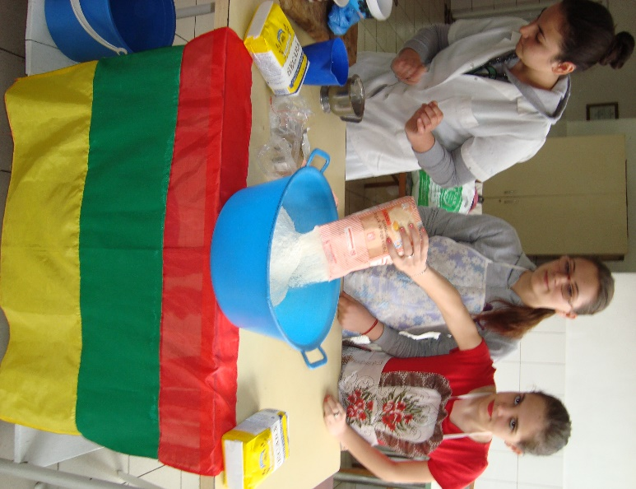

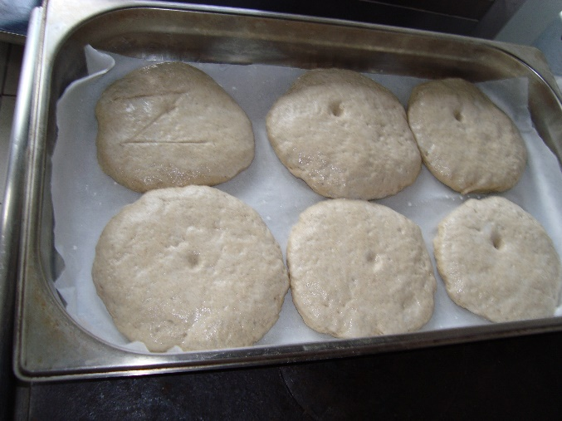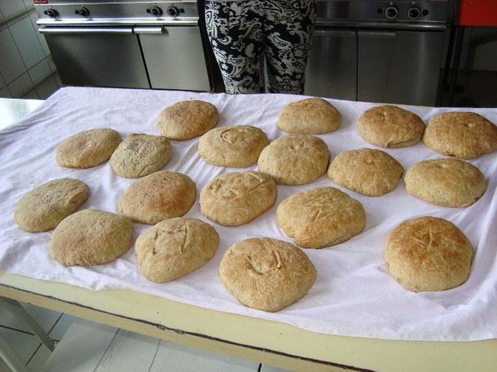

We celebrated together surrounded by the flavours and spirit of Lithuania.

