Glass from the Bavarian Forest
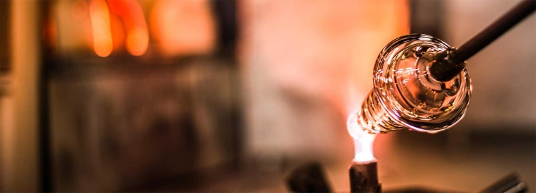
At first to the question:
What is glass?
Glass is an inorganic melted product, which is able to harden without crystallizing. It´s made out of sand potash, soda (Na2CO3), calcium carbonate and red lead (Pb3O4).
The Bavarian Forest has always been a provider for glass production. Despite a raw climate, hard lives in the woodlands and a volatile income, the glass maker´s determination was rarely daunted and continues on until today. For incredible 700 years now. Consequently, the Bavarian forest is now being known as Europe’s centre of glass; and it is here, where the traditional skills of glass making have been carefully nurtured and therefore added to this unique culture.
Modern glass makers combine the traditional handcraft of the Bavarian forest with modern design. They are specialists for the entire process of creating unique glass products. There you can see glass-artists, glassblowers, engravers and painters.
Not just our common windows or glasses to drink are out of glass. But also trophies and awards, pens, decoration and sculptures.
Glassblowing
Glass needs to be heated up until it has the right temperature and texture. Then you blow through a glassblowing whistle into the space in the little glass bulb and turn it constantly while blowing. Meanwhile it needs to be heated up again. This process has to be continued until the glass has the figure, that is wanted. It is decorated with differently colored glass pieces, that are put on the slightly molten glass. Then the decoration glass gets molten on the finished glass figure so that it can be embellished.
Quelle: Informationsmappe Joska, mit freundlicher Hilfe von Frau Brigitte Maimer

