Christmas wishes from Tarnobrzeg

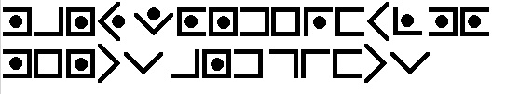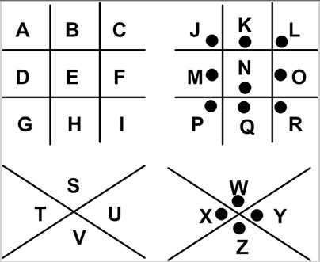

Solution: …………………………………………………………………………………………………

……………………………………………………………………………………………………………….

