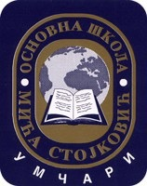
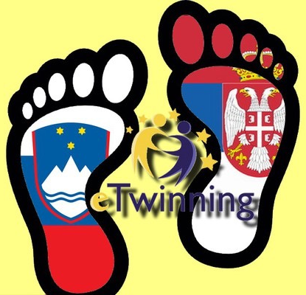
20th May
departure in the morning
Slovenia & Serbia
“ITCHY FEET DOWN MY STREET”
Dobrovo, Slovenia | 15 - 20 May 2017
19 th May
full day trip to Postojna Cave and Predjama Castle; farewell party at school
18th May
morning: march and field work on Mt Sabotin
afternoon: sport activities & editing TwinSpace
17th May
morning: science workshops “From grapes to wine”, visiting Dobrovo wine cellar
afternoon: treasure hunt on Gradnik trail & tour of Brda
16th May
morning: treasure hunt and olive oil tasting in Šmartno
afternoon: tour of Sveta Gora & Nova Gorica
15th May
arrival till 13.00
welcome speech
meeting host families

Slovenia hostiNG programme
eTwinning project & students' exchange
" Coming together is a beginning, staying together is progress, and working together is success."
Henry Ford

partner

schools:

:
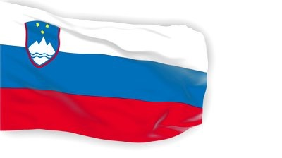
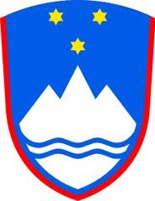
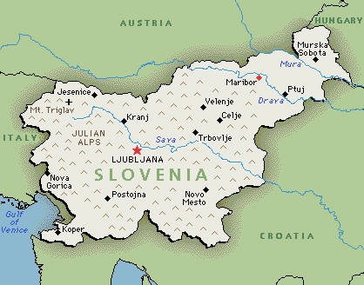

- FINDING SLOVENIA, J. W. Stewart, Ljubljana 2009
- THE WALK OF PEACE, T. Koren, Kobarid 2008
- POSOČJE Tourist Guide, Kartografija, Ljubljana 2011
- http://www.slovenia.info/?naravne_znamenitosti_jame=449&lng=2
SOURCES:
- www.slovenia.si and other web sources
- FACTS ABOUT SLOVENIA, J. Prunk et al., Ljubljana 2011
- SLOVENIA, S. Fallon, Lonely Planet, 2004
- http://www.bled2015.org/about-bled/
- http://www.ljubljana.si/en/about-ljubljana/

- http://www.slovenia.info/?naravne_znamenitosti_jame=449&lng=2://www.slovenia.info/?naravne_znamenitosti_jame=449&lng=2http://www.slovenia.info/?naravne_znamenitosti_jame=449&lng=2

Slovenian national flag and coat of arms
State/ Democratic parliamentary republic since 25 June 1991, Member of EU since 1 May 2004
Capital/ Ljubljana
Size/ 20.273 km²
Length of coastline/ 46,6 km
Neighbouring states/ Austria, Italy, Hungary, Croatia
Inhabitants/ about 2 millions
Nationalities/ Slovenian 83%, Hungarian 0,3%, Italian 0,1%, Croat 1,8%, Serbian 2%...
Highest mountain/ Triglav 2,864 m
Longest river/ Sava 221 km
Largest towns/ Ljubljana (260,000), Maribor (108,000), Kranj (39,400)...
Landscape/ The territory of Slovenia is geographically divided into four basic types of landscape - Alpine in the north, Mediterranean in the south - west, Dinaric in the south and Pannonian in the east.
Climate/ There are three different types of climate in Slovenia: continental in the central part, Alpine in the north and submediterranean along the coast and its hinterland.

FACTS ABOUT SLOVENIA
God's blessing on all nations, Who long and work for that bright day, When o'er earth's habitations No war, no strife shall hold its sway; Who long to see
That all men free
No more shall foes, but neighbours be.

Slovenian national anthem
14th to 15th centuries: Most of Slovenia's territory was taken over by the Habsburgs
15th century: Turkish invasions begin
15th to 17th centuries: Peasant revolts
1550: Protestantism; the first book written in Slovene
18th century: Enlightenment
1809 -1813: Napoleonic conquest - Illyrian Provinces
1848: Unified Slovenia, the first Slovenian political programme
1918: The State of Slovenians, Croats and Serbs,
the Kingdom of Serbs, Croats and Slovenians,
renamed Kingdom of Yugoslavia in 1929
1941 -1945: Dismemberment of Yugoslavia by Axis
Powers
1945: The formation of the Federal People's
Republic of Yugoslavia, republic of Slovenia as
one of its 6 federal entities
25 June 1991: Proclamation of the independent
Republic of Slovenia
1 May 2004: EU membership

BRIEF HISTORY FROM 14th CENTURY
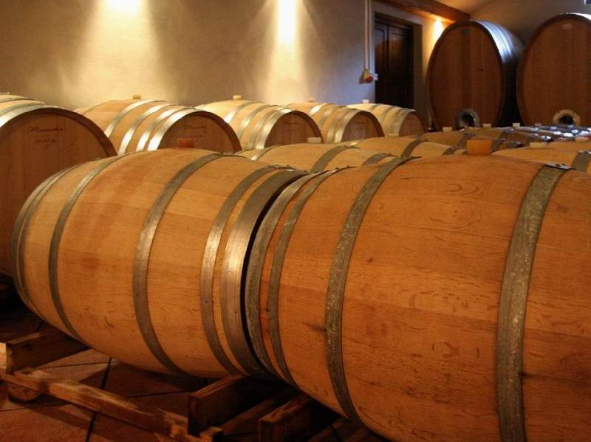
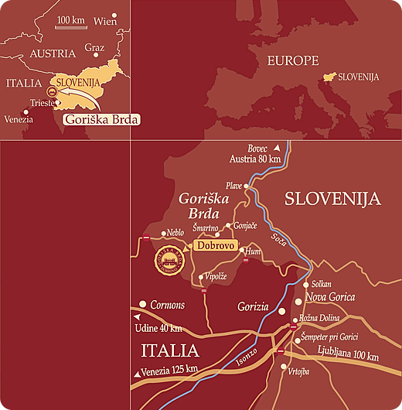
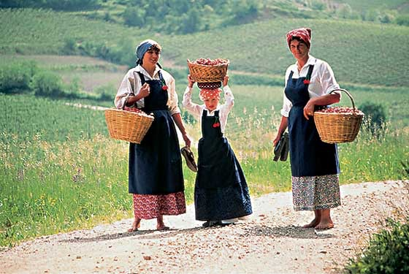
In the far west of Slovenia, stretching for 72 km2, there is a charming and interesting area called Brda. The land extends over the state border with Italy, from the emerald green Soča River in the southeast to the Idrija River in the northwest.
Two hills enclose the land proudly: Sabotin in the East and Korada in the North. The Brda hills – approximately six thousand inhabitants live here in closely grouped villages that usually encircle a little church – sweep gently down to the Friulian Plain. Here, on a nice day, a new horizon opens onto the Adriatic Sea. It is the influence of the sea combined with the beneficial Mediterranean climate that nourishes the fertile soil on the flysch base.
Good working conditions and the hard working hands of the locals produce numerous sunny fruits: cherries, peaches, apricots, olives, figs, chestnuts and last but not least grapes, which are then turned into a distinguished, sweet wine on St. Martin´s Day. The Brda region is a land with a turbulent history and an interesting present. On your way from village to village you may encounter evidence of rich, natural and cultural heritage.
Brda is a land of castles and small white churches (about 30 well-preserved), usually situated on the top of the hills. Nature plays an interesting part in many places of the Brda region; and working hand in hand with the locals it offers beautiful white, yellow and pink blossoms in spring, juicy fruits in summer, and a magnificent game of colours in autumn, when the most important activity of grape harvesting takes place. In late autumn and in winter nature calms down; sometimes it snows, farmers stay in their cellars and good wine flows from the barrels.
Hospitable locals will be delighted to offer tourists some of this delicious wine. Do come and visit the land of invigorating moments.

Goriška Brda, the Slovenian Tuscany,

due to similarities in landscape and quality of wine
"camp sabotin 2012"

day 21: 15th May 2017

arrival to Brda

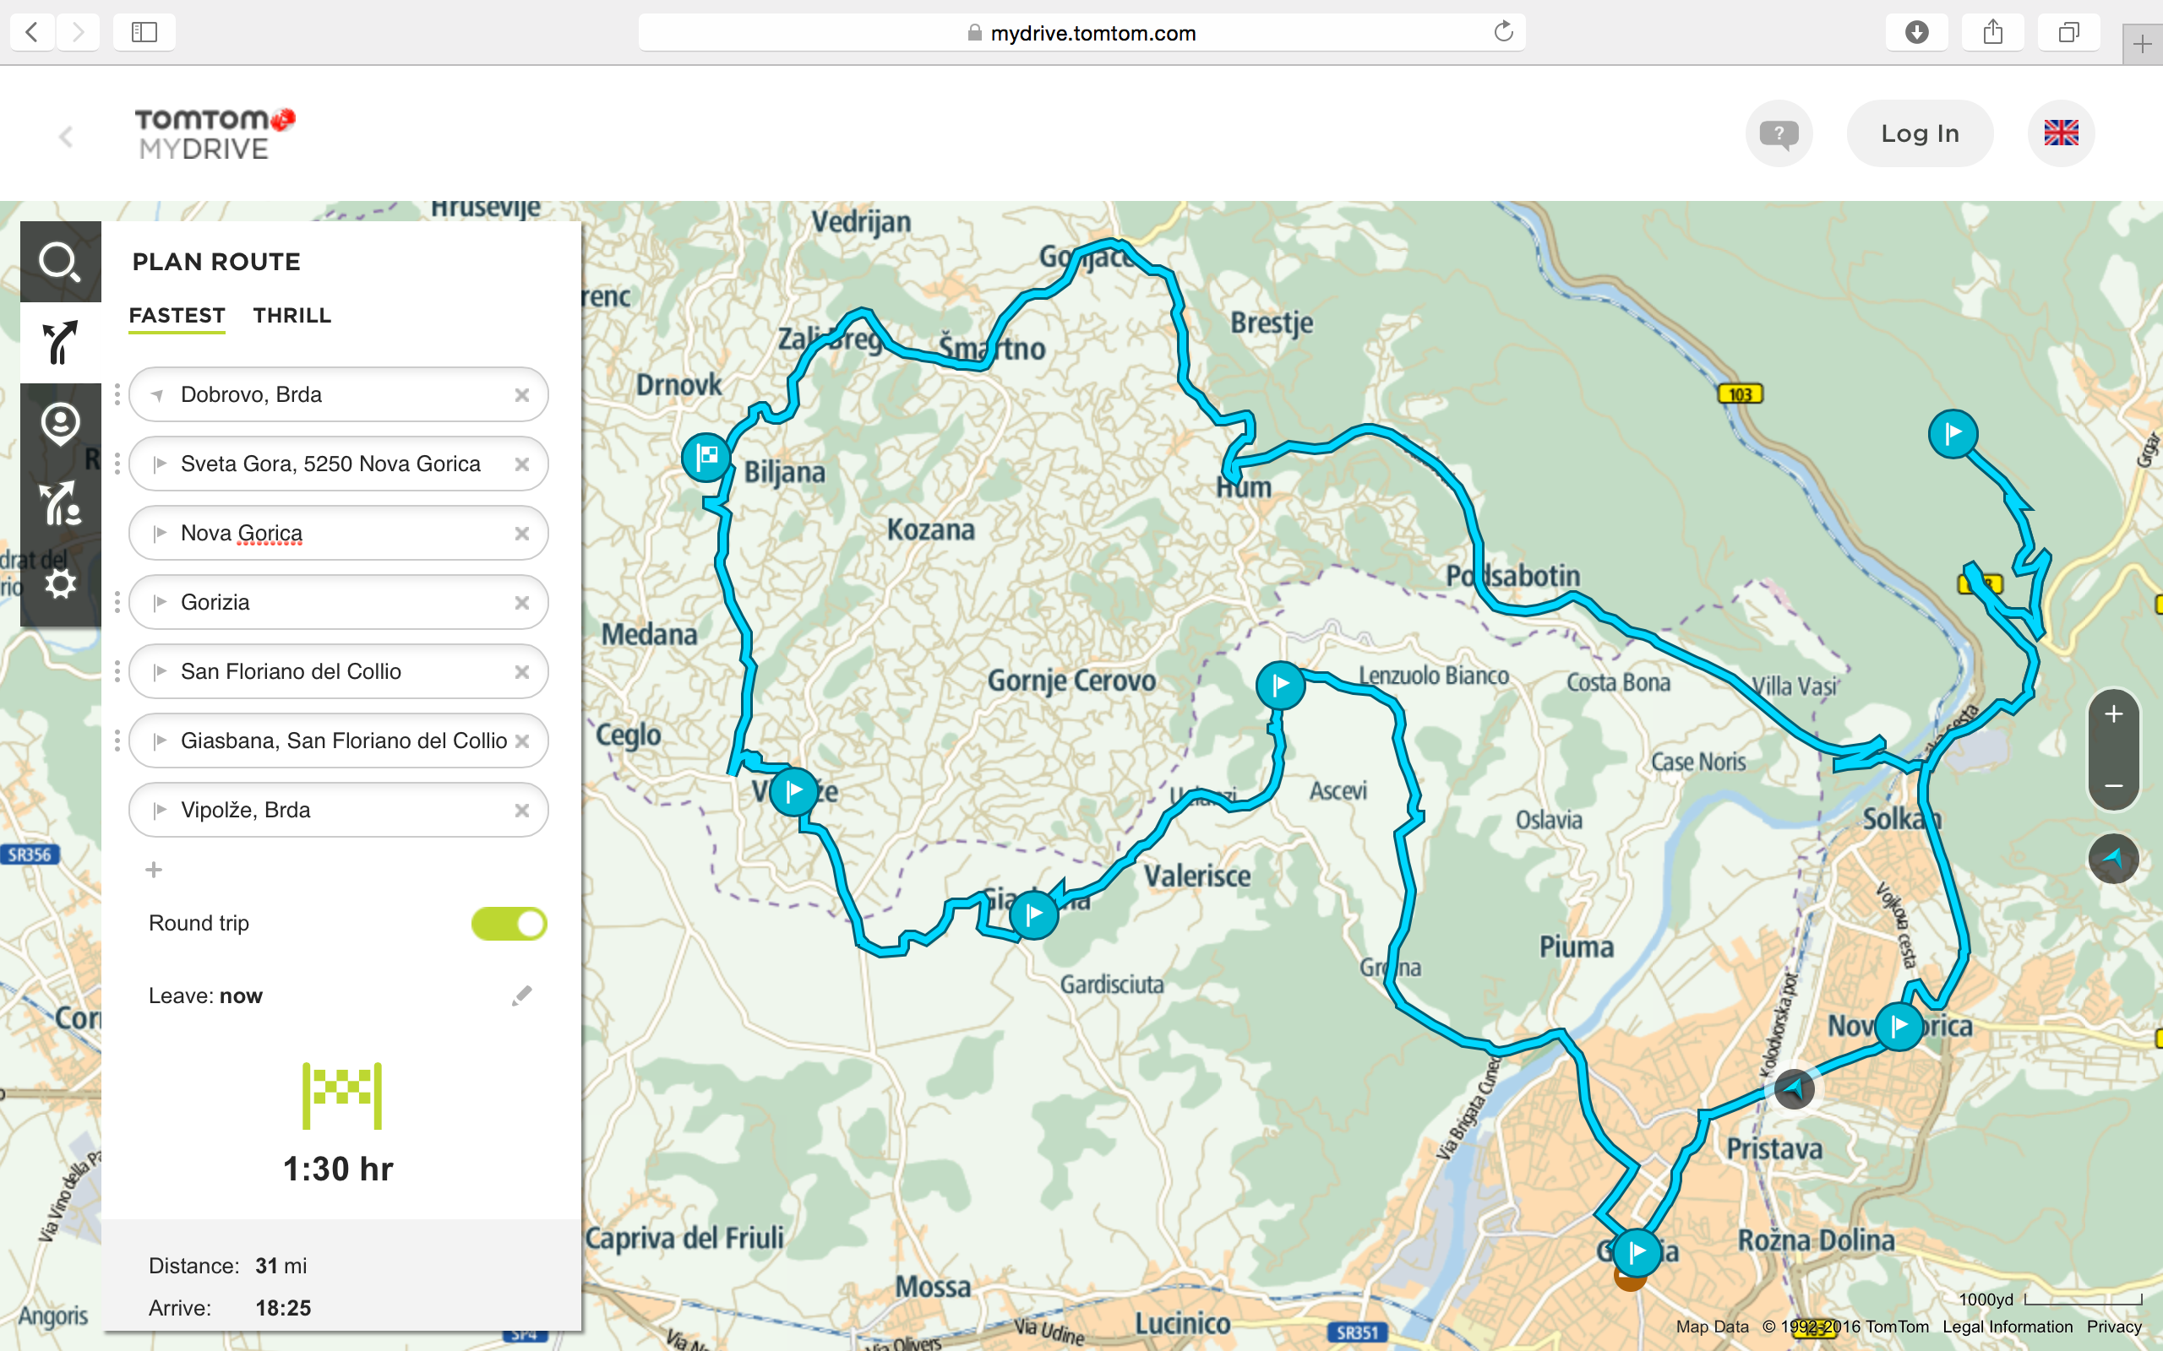

day 2: 16th May 2017

treasure hunt and olive oil tasting in Šmartno & tour of Sv. Gora and Nova Gorica

GORIZIA
The settlement was first mentioned in 1001. In 1307, Gorizia was mentioned as a town. During WWI it was considerably damaged.
NOVA GORICA
The history of the town begins after WWII. The 1947 peace treaty between Italy and Yugoslavia left the Slovenian part of the Gorizia region without an economic and cultural centre. The government decided to build a new centre. Therefore Nova Gorica was first mentioned only in 1949, when it began to grow in to a modern town.
KOSTANJEVICA
The monastery, which is located on hill Kostanjevica above Nova Gorica, is one of the 13 Franciscan monasteries in Slovenia. It is best known for its tombs, located in the church crypt, where the members of the French Bourbon royal family, including Charles X, the last French king of the dynasty (otherwise the penultimate king in general), are buried. It is also home to a 200-year old library. The monastery was founded in 1623 when Count Matija Thurn first build the church, and then the small monastery.
SVETA GORA
A pilgrim church was built in 1544 and was able to accommodate 4 to 5 thousand pilgrims.
On the order of Emperor Josef II, the church was torn down in 1786, but just few years later it was reconstructed.
In the fighting on the Soča Front in June 1915 Italian bomb shells destroyed the church.
After the war, the church was rebuilt in a historical style.

day 3: 17th May 2017

science and cooking workshops & treasure hunt on Gradnik trail & tour of Brda

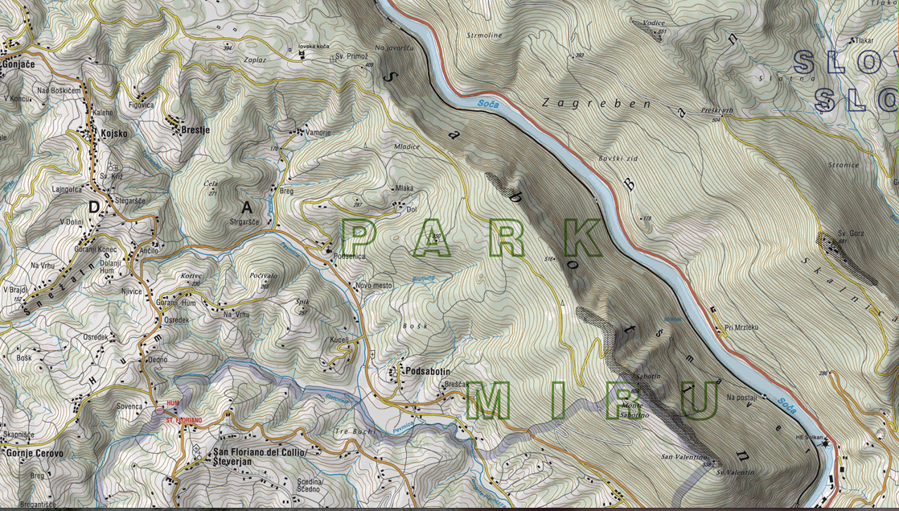

Mt Sabotin
Sabotin is an exceptional mountain, rich in natural, historical, and cultural heritage sites.
On the slopes of Sabotin, soldiers from 22 nations took part in the battles along the Soča Front. The mountain was their ally, their friend and confidant, and, all too often, their last home.
Sabotin is a Dinaric mountain and a contact zone for Alpine, Dinaric, and Mediterranean flora. The horned viper sheds its skin on the mountain's slopes, and the majestic griffon vulture flies above them.
The international border between Slovenia and Italy runs along Sabotin's ridge.
With Slovenia's entry into the European Union, the border as a divisive line was finally overcome.
In 2005 Sabotin became a part of Peace Park. A park connecting all 22 nationalities whose blood was shed at this site. Sabotin shall become a symbol of peace, integration, and connection.

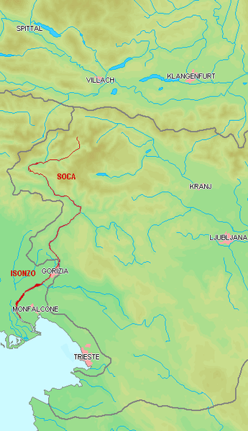
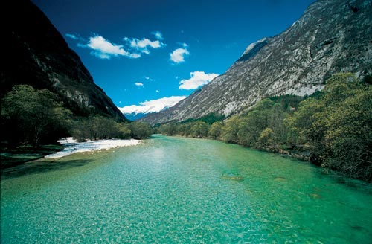

PRIMORSKA

region

The Soča river

and valley
The Soča or Isonzo is a 138 kilometre long river that flows through western Slovenia (96 km) and northeastern Italy (43 km).
An Alpine river in character, its source lies in the Trenta Valley in the Julian Alps in northwestern Slovenia, at an elevation of 876 m.
The river runs past the towns of Bovec, Kobarid, Tolmin, Kanal ob Soči, Nova Gorica (where it is crossed by Solkan Bridge) and Gorizia, entering the Adriatic Sea close to the Italian town of Monfalcone.
Due to its emerald green water, the river is marketed as "The Emerald Beauty". It is said to be one of the rare rivers in the world that retain such a colour throughout their length.
The Soča inspired the poet Simon Gregorčič to write his best-known poem "Soči" (To the Soča).
This region served as a location for the 2008 Disney film Chronicles of Narnia: Prince Caspian.

Course of the Soča/ Isonzo

"The Emerald Beauty"
The Soča Valley region (Posočje) stretches from Triglav National Park to Nova Gorica. Its most dominant feature is the 96 km long Soča River coloured a deep turquise. The valley has more than its share of historical sights, but most people come here for rafting, hiking and skiing.
The Soča Valley has been an important trade route between the Friulian Plain and Alpine Valleys since earliest times. Under the Romans the valley was on an important road between Noricum and the province of Histria.
The proximity of Venice and the Napoleonic wars of the late 18th and early 19th centuries restored the valley's strategic role.
During WWI millions of troops were brought here to fight on the battle front stretching from the Karst to Mt Rombon.
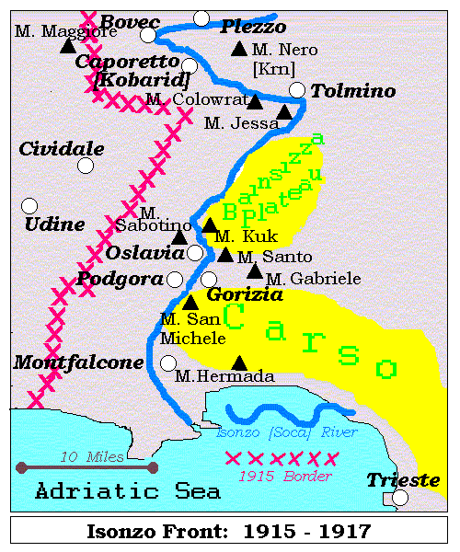
The breakthrough in the Soča Front, known as the Isonzo Front, by the combined Austro - Hungarian and German forces near Kobarid (Caporetto) in October 1917 was one of the greatest military campaigns fought on the mountainous terrain and an extremely costly one in terms of human life. By the time the fighting had stopped 17 days later, hundreds of thousands of soldiers lay dead or wounded, writhing and screaming in the blood-drenched earth, gassed and mutilated beyond recognition.
In May 1915, Italy declared war on the Central Powers and their allies and moved its army across the southwestern border of Austria to the strategically important Soča Valley. From there, they hoped to move eastward to the heart of Austria - Hungary. By then, however, the Austrians had fortified the lines with trenches and bunkers for 80km from the Adriatic and the Karst to the mountain peaks overlooking the Upper Soča Valley as far north as Mt Rombon.
The First Offensive launched by the Italians was successful in the first month, and they occupied Kobarid and Mt Krn to the northeast.
The Italians launched another 11 offensives over the next 2 ^{1/2} years, but the difficult mountain terrain meant a war of attrition between two entrenched armies. Territorial gains were minimal, but fighting in the limestone plateau to the south was horrific.
The 12th Offensive - the "miracle of Kobarid" on 24 October 1917 - routed the Italian army and pushed the fighting back to the Friulian Plain, where the war continued for another year. A Farewell to Arms by Ernest Hemingway, who was wounded on the Gorica battlefield, describes the Italian retreat. The 12th Offensive was the greatest breakthrough in WWI, and it employed some elements of what would later be called "blitzkrieg".
The Italians alone lost 500,000 soldiers, and another 300,000 were taken prisoner. Casualties on the Soča Front for the entire 1915 - 17 period, including soldiers on the battlefields and men, women and children behind the lines, number almost a million.

THE WWI SOČA - ISONZO FRONT
KKK

day 4: 18th May 2017

treasure hunt on Mt Sabotin & sports activities & editing TwinSpace

POSTOJNA CAVE
Postojna Cave is a network of 20 kilometres of passages, galleries and chambers into which experienced guides have accompanied more than 35 million visitors in the last 188 years.
It is the largest cave in the “classic karst” and the most visited show cave in Europe. In 1872 railway lines were laid in the cave; electricity arrived in 1884.
Today you begin your visit aboard the cave train; the electric lighting allows you to admire the size and splendour of the underground world, where the geological past is recorded in a unique manner. Visitors to the cave are dazzled by a wealth of speleothems: calcite formations, stalactites and stalagmites abounding in a variety of shapes, colours and age. The constant temperature in the caves ranges from 8 to 10° C
PREDJAMA CASTLE
One of the most picturesque castles in Slovenia, Predjama Castle is built into an overhanging rock in front of a karst cave hall that is connected with a cave system underneath the castle. It is situated just a a few kilometres from the entrance to the Postojna Cave.
The castle is now a museum on five floors that shows the life in the 16th century, with an armoury, dungeon, halls, living quarters and other castle facilities. Interesting is the dialogue between man-made architecture and natural structures that combine into the castle's fortification system.

day 5: 19th May 2017

fullday trip to Postojna cave and Predjama castle & farewell party

.

SERBIAN STUDENTS | SLOVENIAN  STUDENTS | MENTORS &  PARENTS
Milica IVKOVIĆ  Milica MILOŠEVIĆ  Dušan SRETENOVIĆ  Ivan MIKOVIĆ  Nikola STOJKOVIĆ  David JEREMIĆ  Tijana TOMOVIĆ  Ivana IVKOVIĆ  Andrija MILIĆ | Žiga KODERMAC  Matej ŽEŽLIN  Žiga FON  Maks KLINEC  Peter DRAŠČEK  Tina DRNOVŠČEK  Taja FABRICIJO  Neja PRINČIČ  Enia MARINIČ  Vasja BUŽINEL  Alen MURENC | Danijela KUŽET  Danka SIMOVIĆ  Slobodan MILIĆEVIĆ  Tamara KLANJŠČEK ŠAVLI  Damijan MARINIČ  Tanja S. TOMINEC
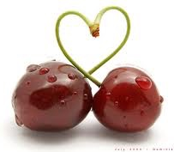

PARTICIPANTS

of

eTwinning project & student’s exchange

Slovenia & Serbia
“ITCHY FEET DOWN MY STREET”
October 2015 - June 2016

