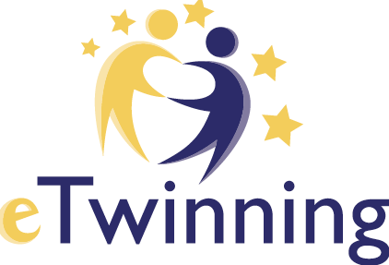

Planning your project with your partner(s)

Project description
Describe your project. This information is very useful for your National Support Service in order to be able approve the project.

DESCRIPTION
Title
Use letters or numbers but not ) < >
250 characters

Short description
Type the description of your project, be clear and use keywords to help people to find you

1000 characters

LANGUAGES
You can choose more than one
[Tick the chosen languages]

PUPILS
What is the age range of the pupils who will participate in the project?
Age from 3 4 5 6 7 8 9 10 11 12 13 14 15 16 17 18 19 20+

Age to 3 4 5 6 7 8 9 10 11 12 13 14 15 16 17 18 19 20+
[Indicate the age range]

How many pupils altogether are going to participate in the project?
0-10 10-30 30-50 50-100 > 100
[Indicate the anticipated total number]

SUBJECTS
You can choose more than one
[Tick the chosen school subjects]

AIMS
Try to be specific, particularly in terms of competences and skills you hope your pupils will gain through this project. Refrain from stating too abstract concepts such as "European Dimension of education" or "Intercultural communication".

1000 characters

WORK PROCESS
State how you intend to work with your partner schools and how responsibilities are shared. Give an approximate calendar of activities, state how frequently you will work with your partner; indicate how you intend to involve your pupils; if you intend to create teams of pupils of different schools, and other relevant information.

1000 characters

EXPECTED RESULTS
Indicate here if you are planning a final product such a public Twinspace or other resources. You might envisage instead the improvement of a school practice, or new knowledge.

1000 characters

ERASMUS+ PARTNERSHIP
Indicate here whether you have received funding from Erasmus+ KA1 or KA2, or if your project is pending approval. You will be able to add this information even after the submission of your application. Kindly note, that this is strictly for informational purposes.

Has this project received funding from Erasmus+ KA1 Or KA2?
[Tick: No Yes Pending approval *]
* Only applications waiting for an approval for Erasmus+ funding should tick this box.

PROJECT KIT
Is your project based on an eTwinning Project Kit?
[Tick: No Yes]

