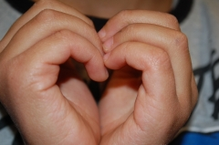
The game of kindness
Heart, kiss, cuddle?
AGE: from 6 to 12 y.o
PARTECIPANTS: from 2
SETTING: school, family
LOCATION: gym, class, home etc…
DURATION: variable
MATERIAL: nothing

INTRODUCTION: Besides being expressed by heart and head, kindness can be showed up through the sensitivity to the wellness of the other person. Not everyone likes kind moves of contact, for this reason it’s enough to ask: “Can I cuddle you”?
DESCRIPTION: Kind moves turn words to gestures, to say “I love you” In Italy three moves, gestures can be used: the heart (made with hands), the kiss ( with the hand, or on the cheeks), the cuddle.
After having told this to the players and having defined the game place, they (the players) have to stand in a casual order. To the start (go!), the players walk slowly and whenever they bump into somone else they have to ask them “heart, kiss, cuddle?”, the answer can be one of the three gestures or a “no, thanks” (that’s a kind and polite expression too) . According to the reply, the players will give one of the three gestures or they won’t. The game keeps on involving all the players.
KIND KNOWLDGES DEVELOPED: empathy, kind gestures, attention, sensitivity.

