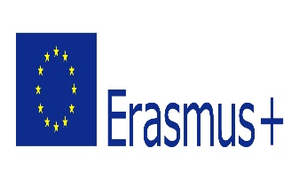
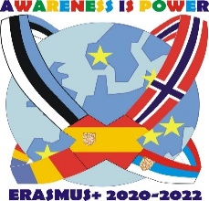

AGREEMENT NUMBER : 2020-1-EE01-KA229-077896_3
PROJECT TITLE: “Awareness is Power”
ACTION: Strategic partnership for schools only
ACTIVITY TYPE: Transnational Project Meeting in Spain
ATTENDANCE REGISTER
DATES: 8.11.2021 – 12.11. 2021
1. Name of the host institution: CEIP Mediterráneo (Pilar de la Horadada, Spain)
Name | E-mail | Signature
Ana María González Villalobos | anag.villalobos@gmail.com
Ana Albaladejo Carrasco | albaladejoana1975@gmail.com

2. Name of the sending institution: Kiltsi Põhikool, Estonia (Coordinator of the Project)
Name | E-mail | Signature
Merje Leemets | merje.leemets@kiltsimois.ee
Ann Laurand | ann.laurand@kiltsimois.ee

3. Name of the sending institution: Osnovna skola ''23. oktobar'' Sremski Karlovci, Serbia.
Name | E-mail | Signature
Irena Bijelić
Ivana Savić
Vesna Čolić
Jovana Kosijer-Anabusi | jkosijer@gmail.com

4. Name of the sending institution: Lyngdal Ungdomsskole, Norway
Name | E-mail | Signature
Marit Hanne Eggum Svennevik | marit.hanne.eggum.svennevik@lyngdal.kommune.no
Linda Mersland | linda.mersland@llyngdal.kommune.no

5. Name of the sending institution: Scoala Gimnaziala Pietroasa, Romania. (Absent)

I, the undersigned hereby declare that the information above is accurate and in the accordance with the facts.
Signature/ stamp____________________

Ana M. González Villalobos –CEIP Mediterraneo Principal

