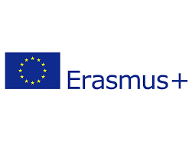
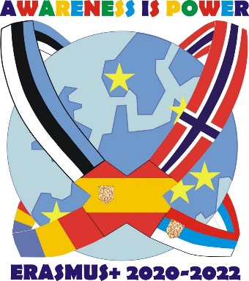
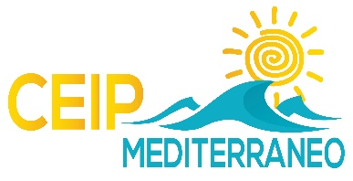

PARTICIPANT‘S CONTACT INFO- SHEET
Host school: CEIP Mediterráneo. Pilar de la Horadada. Spain
1st Transnational meeting
Field – School education
Dates: 08.11. – 12.11.2021
Participant‘s and travel info:
№ | Name | Country | What do you teach? | Email address | Flight details
 |  |  |  |  | Arrival  Date/time  Airport | Departure  Date/time  Airport
1.
2.
3.
4.
5.
6.
7.
8.
9.
10.
11.
12.
13.
14.
15.
16.

