Carnival dishes of Lesvos, Greece
In Greece, in the first two weeks of Carnival, we eat meat (pork, beef, lamb, chicken) mainly roasted, pasta . There is also a specific day when everybody bakes meat. This is called "Tsiknopempti."
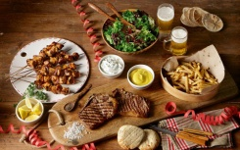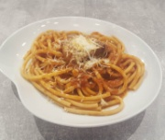
In the third week we eat foods that have milk, cheese and yogurt, pies, (cheese pie, leeks, spinach pie)
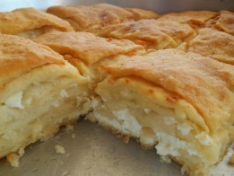 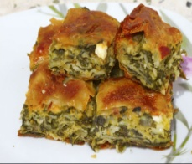 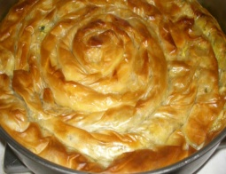
For sweets we eat donuts, milk pie, pumpkin pie, rice paddy.
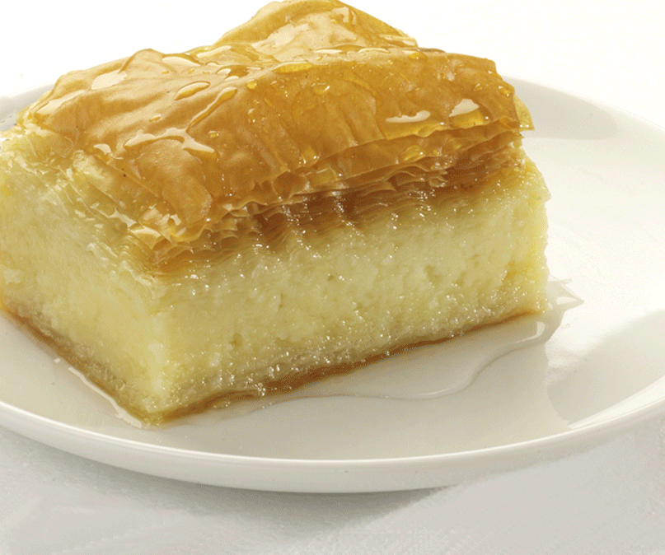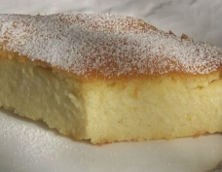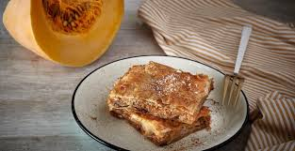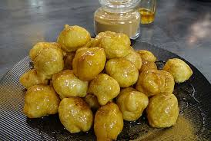
We drink wine and celebrate all these days.
Traditional dessert with fresh milk
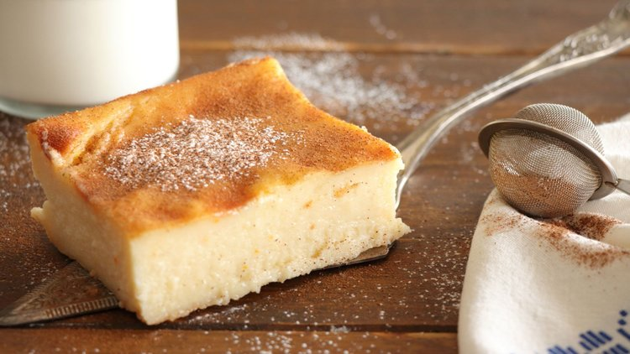
MATERIALS
1.5 liters of milk
200 g of sugar
4 eggs, at room temperature
120 g semolina fine
30 grams corn flour
1 kg of vanilla extract
½ orange zest
50 g of butter, cold in cubes
To overlap:
1 egg, at room temperature
2 cfu of sugar
2 CP water
For garnish (optional):
cinnamon
powdered sugar
In a large saucepan I drop the milk with sugar, on medium heat and stir until the sugar is warm and melted. I take off the fire and let it cool down a bit.In a bowl I beat the eggs to whip.Add the semolina, the vanilla extract, the vanilla extract, the orange zest and stir.I take a tablespoon of the milk mixture with the tablespoon and drop it into the bowl, stirring well (so that the eggs are not cooked). I continue like two other tablespoons (one by one).Transfer now the mix from the bowl to the pot, initially with one-one tablespoon and then all together, incorporating it with the milk in the saucepan.
I place the pot on a moderate heat and mix constantly until the mixture begins to coagulate. When "sitting" on the spine of the wooden spoon the cream is ready, I take it out of the fire and add the cold butter to cubes stirring to melt.I mix the mixture in a 33 x 25 cm baking dish that I have buttered and sprinkled with semolina.In a small bowl I knock an egg along with a little sugar and water.Add the mixture over the cream to the pan.I cook in a preheated oven at 180 ° C, on the resistors for 50 - 60 minutes.After 30 minutes I watch and if necessary cover with aluminum foil so as not to darken the color of the milktop above.I take off the oven and let it cool completely before I cut into pieces.I serve with sifted sugar and cinnamon.
Good appetite!!!

