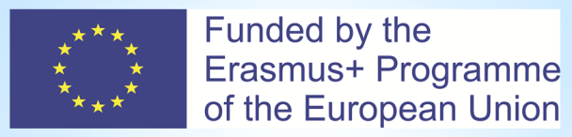
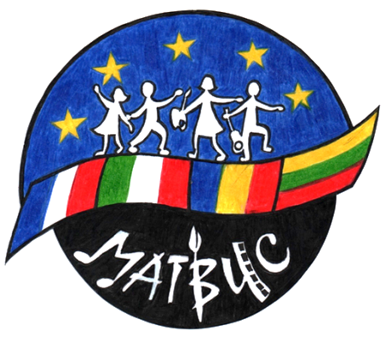
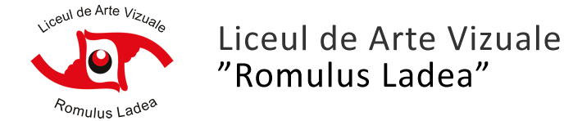
KA219Strategic Partnership Project for Schools only 2016-2018
“Making Art Together Brings Us Closer”
18 to 24 May 2017
Evaluation Form

1. Please write in a few words your experience while hosting a student from another European country.

2. Say with a few words how the project – and the meeting in Cluj – has improved your child’s:
A Knowledge of Europe

B Creativity

C Skills

D Self-confidence

3. Leave us any other free comments about the project and the meeting in Cluj Napoca.

Thank you for your cooperation.

