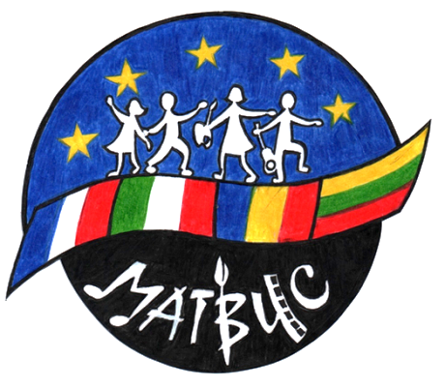
KA219Strategic Partnership Project for Schools only 2016-2018
“Making Art Together Brings Us Closer”
Mobility C2 CLUJ NAPOCA May 18-24 2017
Evaluation Form

A. Say with a few words how the project – and the meeting in Cluj – has improved:
1- Your knowledge of Europe and its artists

2- Your knowledge of Land Art or Ceramics

3- Your self-confidence and creativity

4- Your European citizenship

B. How many hours a week do you make Art – at school or elsewhere?
Which Art(s)?

C. Leave us any other free comments about the second meeting in Cluj Napoca:

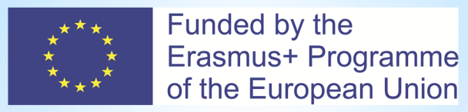
Thank you for your cooperation.

