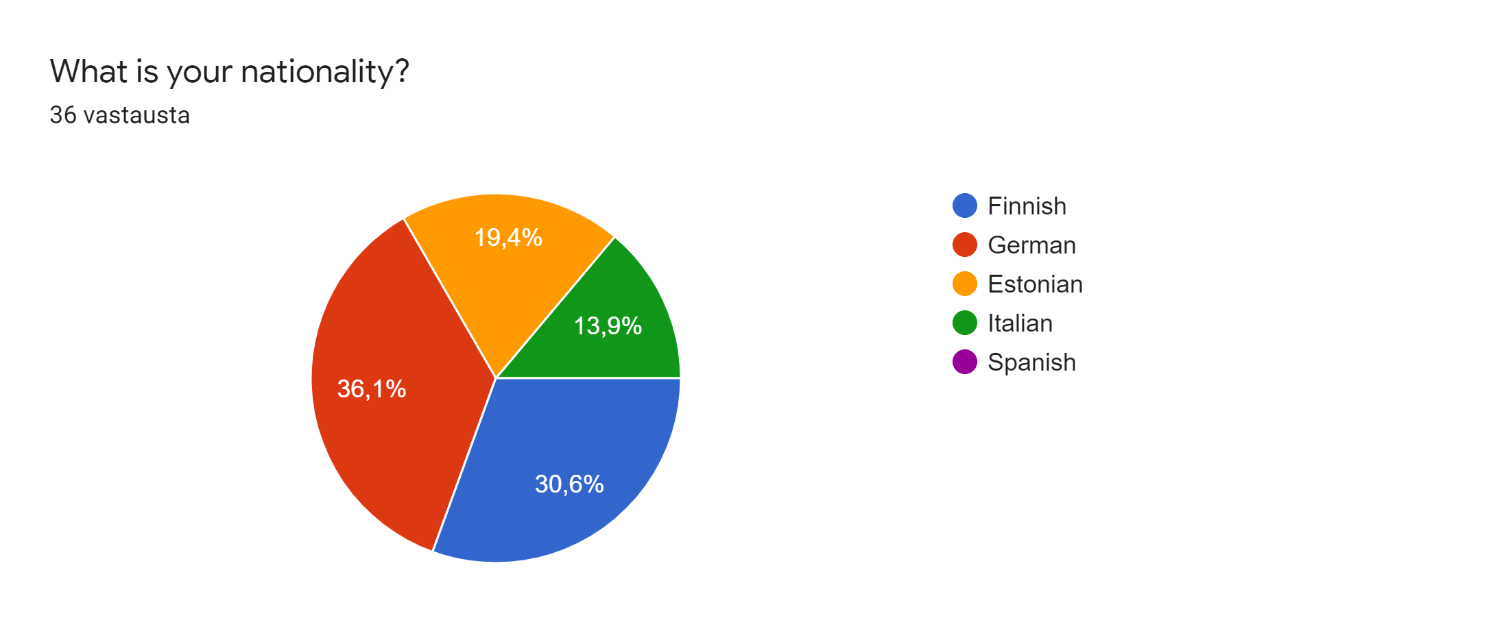

In what way has the pandemic impacted your town? You can (and should discuss) e.g. if there have been numerous cases in your town, in what way life in your town has changed due to the pandemic. Give examples.

- Nightlife is away from us
- The Shops are closed and the city center is nearly empty
- There is no nightlife in the city anymore.
- Everything is closed, shops and restaurants, people are staying at home, theatres are closed
- schools have been closed for a long time, we were not allowed to meet many friends, we had to stay at home, there were no freetime activities and we could not really go on vacation. We started onlinelearning and we had to learn how to explain schoolstuff to our selves. Also we stopped driving by car that often and we spent more time outside. I think it was a good time for our climate...
- In my city, all the entertainment and shops that were not essential were closed. There have been no major changes. People still move on the streets but much less than before.
- in my town there were a lot of cases and my life is changed for exemple i did't go to swimming pool or I couldn'tseen my friend al day at school. My grandparents took the covid and i haven't been abla to see tham for two moths.
- More People enjoy Ehen they can go outside
- I can't do my hobbies or see my friends and relatives
- Many hobby and free time places are closed
- In our town are some stores that had to close because they had no money because there was no people you bought there something
- I live in a small town near Florence with about 18000 residents: there have been numerous cases during last year but at the moment we can almost live a normal life. We have been through difficult times especially because school was closed for months and we couldn't meet our friends or hanging out with them. The economy of my town is quite good because all the shops and the restaurants are open, but we still have problems with sports and cinemas
- You can't go to all the hobbies, you have to wear masks everywhere, you can't see so much your relatives or friends
- We must wear masks in public facilities; In our subway, we even have to wear ffp2 masks; sport activities were canceled; I don't meet as much people as before the pandemic
- A lot of businesses have gone pankrupt because of Covid-19.
- At first, everything was closed in last March. Even now everything is closed, but people still are not careful as they should.
- in my town were been a lot of cases and we were obbligated ton stay in quarantine for a lot of months. The gyms were closed, as the theatre and the cinema, we weren't able to go out with ours friends. All the restaurants were closed as the bar/pub, this led to an economic decline.
- In my town many peolpe keep walking around with the mask.
- There have been many cases in our country and our lives have cHANGED A LOT
- The pandemic hasn't affected my home town as much as many other places. There has been quite many cases in here but in my friend group or family no one has had it. Of course all the events and other things has been cancelled so there isn't much to do. For example some traditions that has been arranged for many many years like vanhan kirjallisuuden päivät wasn't arranged last year beacause of the covid.
- The pandemic hasn't been that bad in my home town. But school has been online some of the time and we haven't been able to practice all of our hobbies. Also for example restaurants have been closed.
- Long Queues in Front of Shops, less People in the City, no More Events
- Schools were closed for a while, and we had to study from home.
- There hasn't been that many cases in our town. And there aren't big changes but still something. Restaurants and cafe's were closed for a while. Grocery stores have been open normally. Wearing a mask isn't mandatory but most people wear them.
- The change has mostly been about schools, they are closed and students are workin from home. People can not dine outside at restaurants, they can only buy food on the go and that has made the financial status of the restaurants pretty difficult. Also there has been zero events that usually take place here every year and the life of the town is quite small.
- You wear mask all the time when you aren't inside your home.
- School was closed and every people were in home.
- The pandemic has changed theatres. Right now in theatres there are less perfomances than before the pandemic.
- There are no student parties here at the moment, you have to wear masks everywhere where is people( supermarket, school...), some gyms are closed and the number of visitors is limited, in the worst moments the hobbies of young people and adults are on the break, sometimes restaurants go closed and we can only use take- away
- We haven't had that many cases in our town and only one in our school. Still there are some things that have been impacted by corona. When seeing my friends, we have to check if anyone is feeling sick and we have to count how many of us are allowed to be in the same place at once. In school we wear masks and wash our hands, a lot. Some restaurants in our town are now closed.
- The city appears more like a ghost town because there are no crowded areas.
- Nearly everything is closed including shops, cinemas, gyms and pitches, restaurants, bars, etc...; meetings with friends aren´t allowed anymore with more than 3 people; learning at school is still possible but only with protective masks and negative corona tests

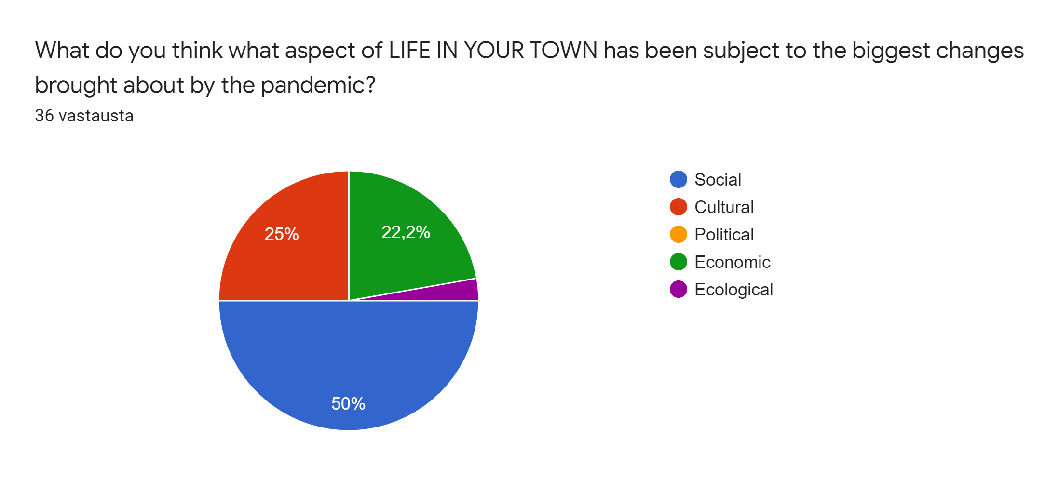

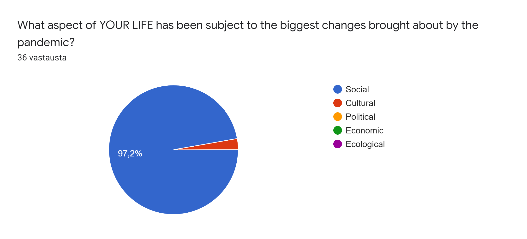

In what way are you able to contribute to the virtual project meeting? Consider skills you need to work on an international level, project management skills, digital skills, skills you need to produce photo documentaries and short video clips.

- Opening mind, intelligence, teamwork
- Teamwork is the key to succes
- Teamwork
- Digital skills I guess
- there are not many things I can really do except of the international conection and project management skills
- I hope I can help with different group works.
- I am able to making power point presentation
- Make photos and handle group working
- I am not sure
- I think the skills that I definitely have to / want to work on my digital skills.
- I have some digital skills because i am very interrested in stuff like this.
- As far as I'm concearned, I'm used to improve my digital skills, most specifically I'm quite good at writing articles and power point presentations
- I can use my computer skills to my advantage but at the same time they will get much better.
- I am used to work with programs like adobe premiere pro and Lightroom which could help considered making short video clips and photo documentaries. I'm also very good at creating powerponts
- I like to think of myself as a team person,I work well with people. I am open to the ideas of my teammates and i have few good ideas of my own. I'm a hardworker and get things done efficiently.
- I consider myself good in project management skills. My english isn´tthat bad even, but it may take time for me to talk better.
- i'm quite good at using my computer and taking photos
- I'm very good to taking photos.
- I thin that I can explain TO THE PEOPLE THE ITALY SITUIATION
- More project management skills
- I can work on my computer skills but also use them as my advantage in online working.
- Knowledge in regard to digital media, communication skills, English skills, cutting skills
- I am pretty good with computers and my english is also pretty good
- maybe rehearsing project management skills
- In school i have audiovisual media and photography courses and I'm doing video editing an photography as a hobbie also. I have edited several wedding videos and travel videos and i love doing that.
- I can work on my computer skills but also use them as my advantages in online working.
- I don't know
- Produce photo documetaries
- My digitall skills are poor but I think that my brother can teach me
- Group management skills, I think

In what way do you expect to benefit from the virtual project meeting? Consider skills you need to work on an international level, project management skills, digital skills, skills you need to produce photo documentaries and short video clips.

- Teamwork , openmind
- We can improve our skills at a digital level and also the communication with other people
- Get to know other cultures
- I want to work on my skill to do work in international level
- work on an international level, digital skills and the rest
- I hope to meet new people. I would like to do something I have not done before and it would give me a chance to put myself to the test.
- i am able to power point presentetion and word
- Meer new peolpe and learn new perspectives
- I think the digital skills will improve at least little and also management skills.
- I can maybe learn more things about producing short video clips.
- Improving my social skills and learn from my international friends
- My English skills will get better and I can make new connections to new countries. I also think that my skills on computer will get much better.
- Meeting new people with other cultures and point of views always always has benefits. Additionally, I expect to improve my English skills especially talking
- I get to meet new people and practice my English skills.
- I would like to benefit for my international level. My english isn´t that bad even, but it may take time for me to talk better.
- i'm able to make power point poresentations and to analyze documentaries
- Personally I really need to learn how to handle the pc. I love taking photos and I would like to learn how to improve the grafics.
- I think that I can see how the other country live this situation
- Project management skills
- I think I will learn new digital skills and make international connections and learn new things about different cultures which will be useful in the future hopefully
- Improve my English, get an real insight to the situation in other countries, get to know other people in Europe, gain experience in regard to video cutting
- Probably will get more experienced with computers, and also my english skills will be better
- maybe I'll get more project management skills
- I think it's a great way to develop my social and English skills, as well project management.
- I think that to work on an international level helping me to future and of course project management skills
- sociality and talking
- Improve my english speaking skill and improve team work.
- I hope my digital skills will get even a little bit better. I think all of these projects will help us to get more confident English speakers.
- Improve english speaking skills and learn something new about other European countries with regard to Corona

