PICTURE

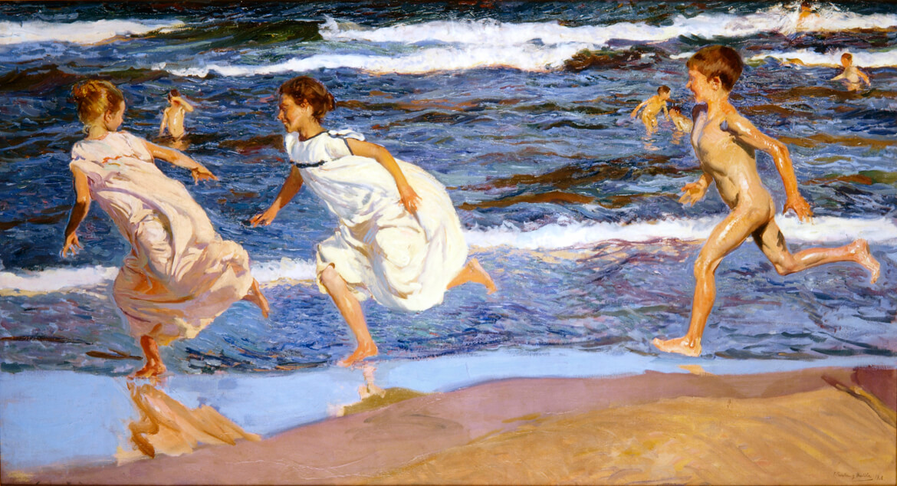

RUNNING ALONG THE BEACH

PAINTER | YEAR/STYLE | WHERE IS THE PICTURE NOW | MEANING | WHY WE SELECTED IT
JOAQUÍN SOROLLA | 1908  Impressionism | Bellas Artes Museum in Asturias (Spain). | This painting is a representation of the people and landscape under the bright sunlight of Mediterranean land and sunlit water, showing the healthy and happy atmosphere of mediterranean life through children’s game. | Sorolla is probably the most famous Valencian artist in history. His work is exhibited in museums throughout Spain, Europe and America.  He excelled in the painting of portraits, landscapes, and monumental works of social and historical themes.

PICTURE
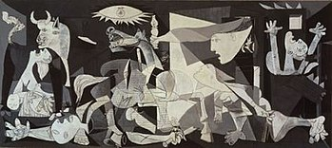

GUERNICA

PAINTER | YEAR/STYLE | WHERE IS THE PICTURE NOW | MEANING | WHY WE SELECTED IT
PABLO PICASSO | 1937  Symbolism | Reina Sofia Museum, Madrid (Spain) | The painting was created in response to the bombing of Guernica, a Basque Country town in northern Spain, by Nazi Germany and Italian warplanes. | The painting was done with a palette of gray, black, and white, and is regarded by many art critics as one of the most moving and powerful anti-war paintings in history.

PICTURE
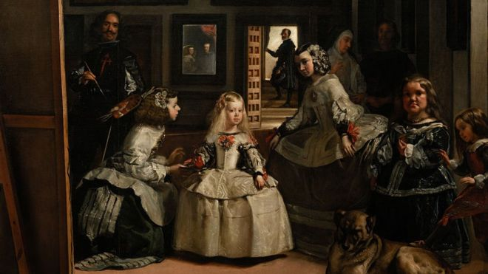

LAS MENINAS

PAINTER | YEAR/STYLE | WHERE IS THE PICTURE NOW | MEANING | WHY WE SELECTED IT
DIEGO VELÁZQUEZ | 1656  Baroque, Portrait | Prado Museum, Madrid (Spain) | The painting shows a large room in the Royal Alcazar of Madrid during the reign of King Philip IV of Spain, and presents several figures from the Spanish court, captured in a particular moment as if in a snapshot showing the importance of monarchy in Spain through history. | Las Meninas has been one of the most widely analyzed works in western painting and it’s one f the most famous in Spanish Art History.

