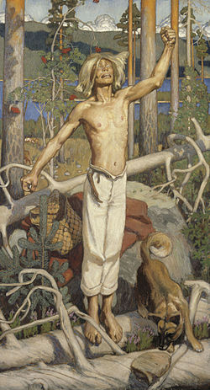
Kullervos Curse

The painting is called Kullervon Kirous.
Akseli Gallen-Kallela has painted the picture.
It was made in Finland in 1899. The painting is painted with oil paints on a wedge-framed and primed linen fabric. The painting´s style is Symbolism. Symbolism means an artistic and poetic movement or style using symbolic images and indirect suggestion to express mystical ideas, emotions and states of mind. Now the painting is in the art museum called Ateneum Taidemuseo which is in Helsinki. Kullervos Curse represents a scene from Kalevala in which Kullervos curses a herd of cows turning them into bears to attack a women who´s been tormenting him. We picked to paint Kullervos Curse because it represents a Finnish mentality and it is a very famous Finnish painting.
sources: Wikipedia and urban dictionary Made by: Sade and Fjolla

