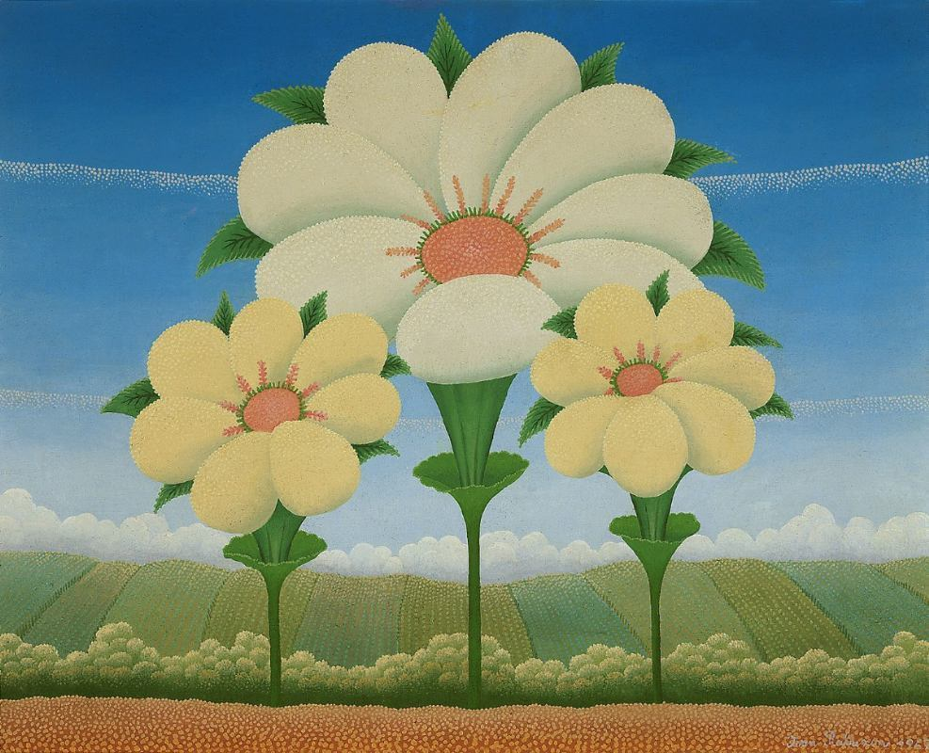
Three Flowers by Ivan Rabuzin (1921-2008)
YEAR/STYLE
1967, Naive art (Primitivism)
WHERE IS THE PICTURE NOW
The Croatian Museum of Naïve Art, Zagreb
MEANING
Eternal spring, untouched, heavenly nature and light with gentle pastel colours and poetic compositions that become a vision of Heaven on Earth. Rabuzin found the utmost simplicity, concision and perfection in the sphere and the circle, which were to become his symbols of the absolute, symbols of completeness. He found inspiration in the nature of his birthplace, Croatian Zagorje.
WHY WE SELECTED IT
Rabuzin's paintings are very popular in Croatia and in the world, as he defined his own style among the naive painters of the 20th century referred to as "peindre a la Rabuzin". This painting gives a balanced and stable, yet growing impression.

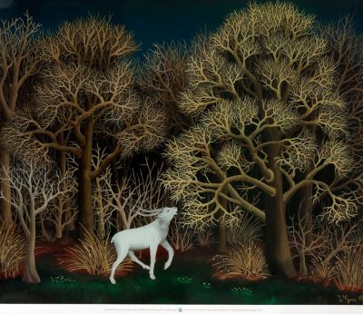
Deer in the Forest by Ivan Generalić (1914-1992)
YEAR/STYLE
1956, Naive art (Primitivism)
The Modern gallery, Zagreb, Croatia
MEANING
A farmer by occupation, he embraced folk style and the clear colours in which he depicted peasant scenes with tragic deaths. He developed childlike simplicity by studying painting, not because he was self-taught like many naive artist.
WHY WE SELECTED IT
He became the most celebrated Yugoslav naive painter and the central figure of a group of naive painters known as the HLEBINE SCHOOL. We wanted to compare Rabuzin's and his works, showing same style but different meanings and impressions.

