My holiday in croatia

where and when did i go ?
I was here in Croatia about the holidays.

who did i go with?
with my family.

where did we stay?
in hotel Lero.
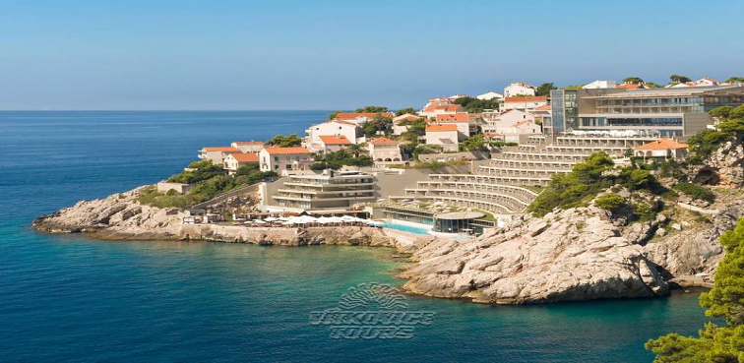

what can you visit in this country?
Plitvice Lakes National Park
The Plitvice Lakes National Park has been admiring the public since the late 1970s, even today, despite the damage that occurred here in the unfortunate times of the Serbian occupation in the 1990s. The park is made up of 16 lakes, admirable torrents and breathtaking waterfalls. and also,Zagreb Croatian Prague,cathedral in Osiejek,Omiš,Trogir,Istrie,Hvar,Šibenik,Dubrovník, Makarska,Split,
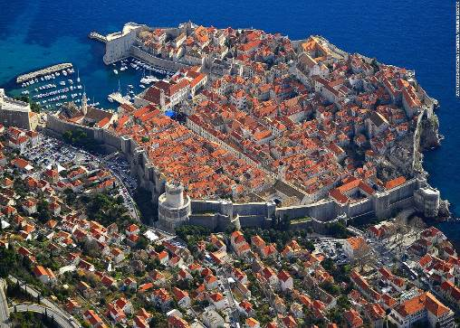
what did you visit?
I visited :Zagreb Croatian Prague,cathedral in Osiejek,dubrovník
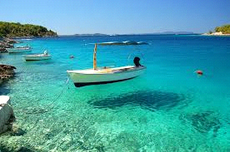

vypracoval: alex struhalik

