A Cinderella Story: Christmas Wish
A Cinderella Story is an American Christmas fairy tale from 2019.
The main characters of this film are Laura Marano, Gregg Sulkin, Isabella Gomez, Barclay Hope, Garfield Wilson and many others.
It is the fifth installment of A Cinderella Story film series.
The film was released on October 15, 2019.
There are a lot of beautiful Christmas songs in the film.
The story is similar to the original film, called Cinderella.
Kat grows up with her stepmother and two sisters
Her biggest dream is to record songs, but her stepmother doesn't let her.
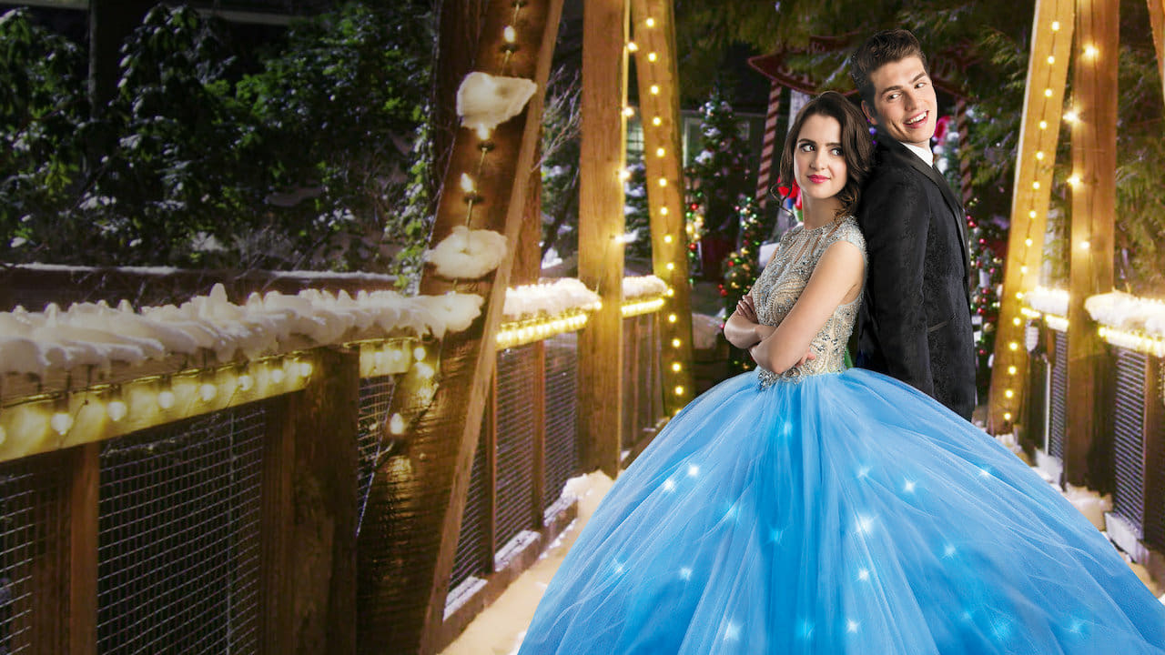
She met a boy from her town and this began to fulfill her biggest dream.

