My holiday in Italy

Where and when did I go?

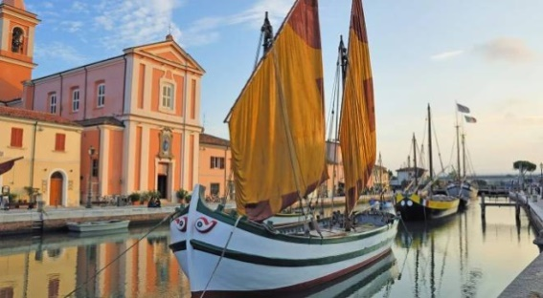
Where did I go, to Italy more precisely to Cesenatico in July 2015.

Who did I go with?

I went with my mother and my dad. My sister also went to Italy, but somewhere other than us.

Where did we stay?

We spent the most time at the seaside or by the pool when we were not by the sea or swimming pool so we spent time in the caravan where we were staying, but once we went to the nearby amusement park Mirabilandia there was fun.
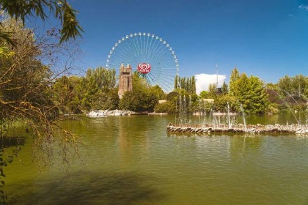

What can you see?
We can see: San Marino (according to the population of the 3rd smallest European and 5th smallest in the world) the sea, Venice, Milan, Rome, Sorrento and Amalfi, Pulgia and Sicily.
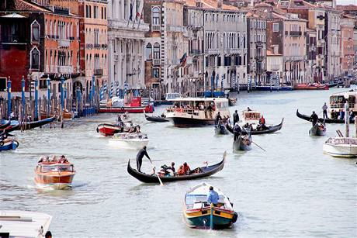
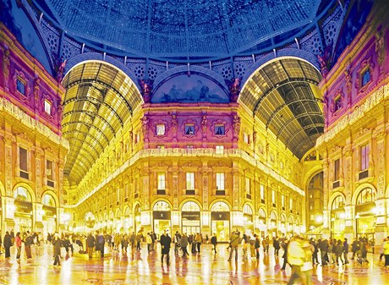

What did you see

What did I see Italy flag, then the sea and then we were in San Marino (one of the smallest states) we were still Mirabilandii.
