PICTURE
Anemones
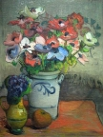

PAINTER | YEAR/STYLE | WHERE IS THE PICTURE NOW | MEANING | WHY WE SELECTED IT
Władysław Ślewiński | 1905 post impressionism | National Museum in Warsaw | .

PICTURE
Winter Landscape 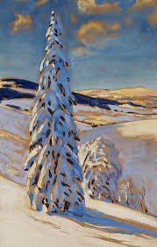

PAINTER | YEAR/STYLE | WHERE IS THE PICTURE NOW | MEANING | WHY WE SELECTED IT
Julian Fałat | 1900  impressionism | National Museum in Warsaw

PICTURE
Astronomer Copernicus 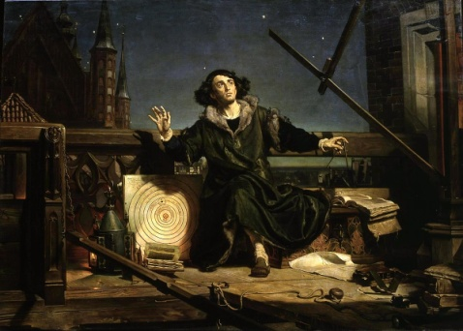
PAINTER | YEAR/STYLE | WHERE IS THE PICTURE NOW | MEANING | WHY WE SELECTED IT
Jan Matejko | 1873  oil painting | Collegium Novum Jagiellonian University | The painting depicts a kneeling, inspired Nicolaus Copernicus observing the heavens transitioning from night to dawn. He is on a balcony, near or at the cathedral in Frombork, surrounded by various astronomical tools and aids. The scene likely portrays the epiphany moment of Copernicus profound discovery, with his own Heliocentric model drawn on a large flat board standing next to him.

