Climate Change
Climate change (sometimes also climate change) is a significant and constant change in the statistical distribution of weather conditions lasting from one decade to millions of years. It can be a change in average climatic conditions as well as a change in the occurrence of extreme weather events. Climate change is caused by factors such as biological processes, changes in solar radiation falling on the Earth, changes in plate tectonics and volcanic eruptions. The climate in the past is studied by paleoclimatology. Some human activities have also been identified as major causes of recent climate change, often referred to as "global warming
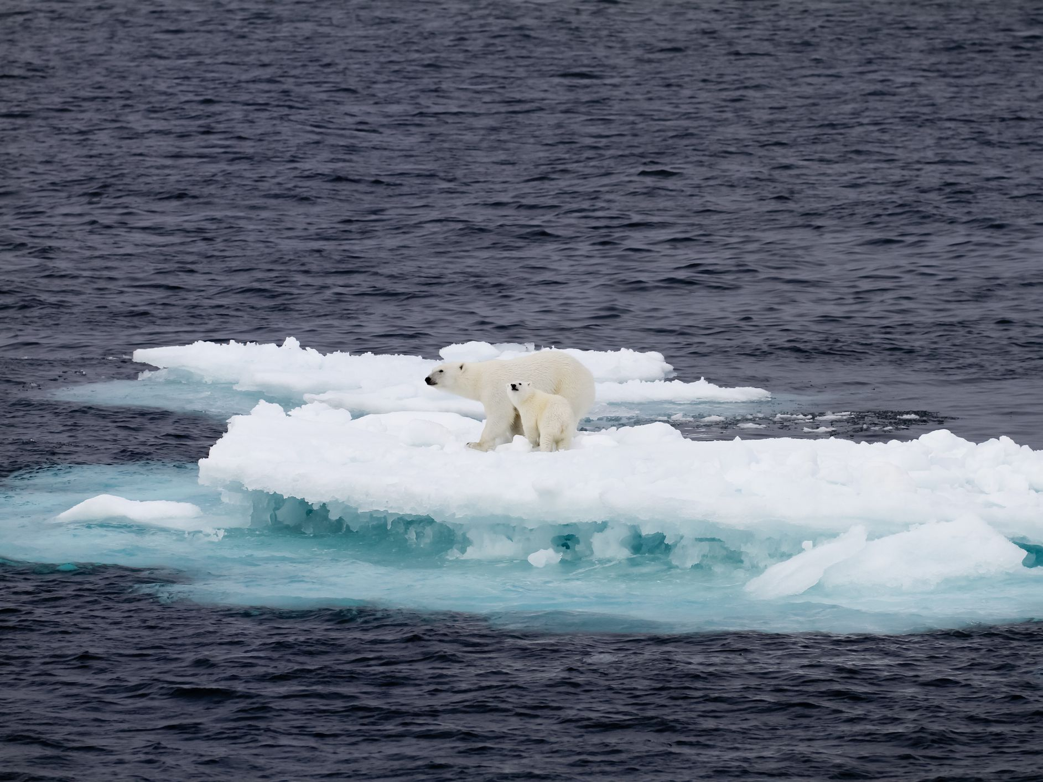
Scientists are actively working to understand past and future climate behavior through observations and theoretical models. Climate records have been taken that go deep into the Earth's past.

Global Warming
Global warming represents a long-term increase in the average temperature of the Earth's climate system; this aspect of climate change is reflected both in instrumental temperature measurements and in other manifestations of warming. The term is generally used for the observed warming caused mainly by man since the Industrial Revolution and its supposed continuation. Periods of global warming also existed in the earlier history of the Earth. Currently, the terms global warming and global climate change are used interchangeably for these phenomena, but the term climate change more broadly includes both global warming and its other effects, such as precipitation changes and various regional impacts.
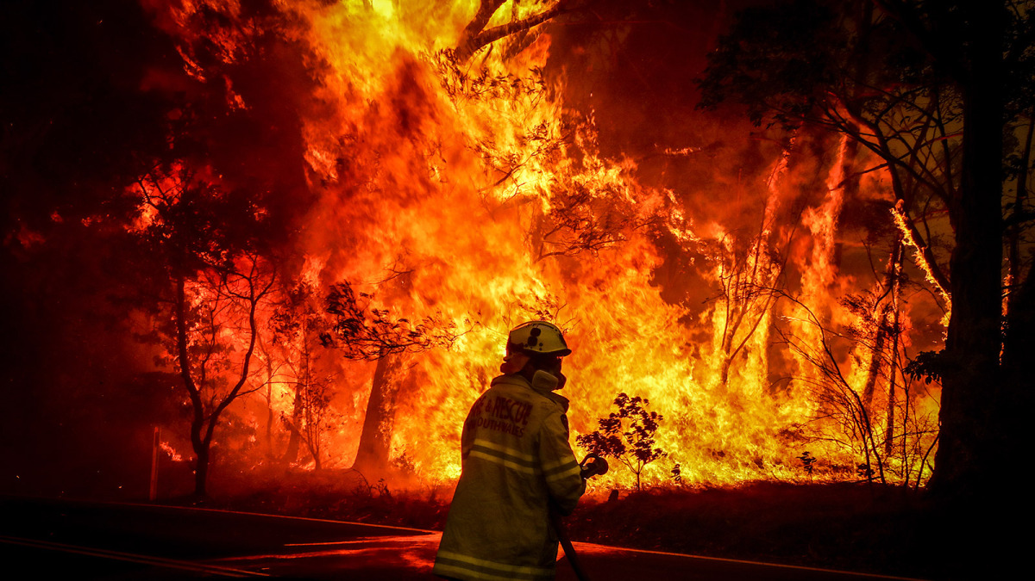

The term "global warming" is most often used to increase average air and surface water temperatures, but experts cite 10 indicators of global warming - in addition to rising air temperatures above the earth's surface and oceans and rising ocean temperatures. sea ice, melting glaciers, rising sea levels, rising humidity, falling snow, and rising overall heat trapped in the oceans. Most of the increase in accumulated thermal energy (90%) since 1971 has occurred in the oceans.

