Vincent Willem van Gogh
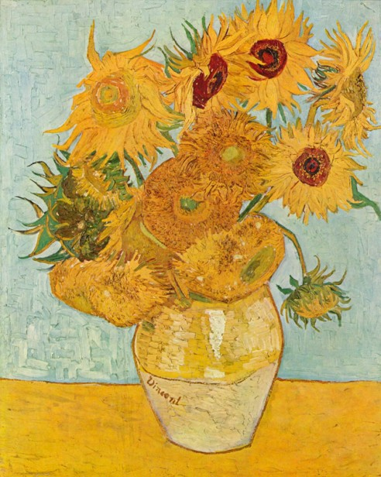
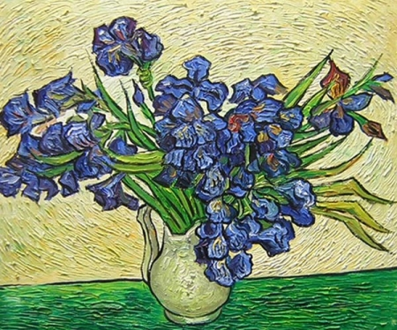

Sunflower, iris
1 / Which of these plants belong to the monocotyledonous plant species (Liliopsida, Monocotyledonae) and which belongs to the class of dicotyledonous plants (Magnoliopsida)?
………………………………………………………………………………………………………………………………………………………
2 / Write (and briefly describe) at least 3 examples of differences between monocotyledonous and dicotyledonous plants.
monocotyledonous plants | dicotyledonous plants
……………………………………………………………………  ……………………………………………………………………  …………………………………………………………………… | …………………………………………………………………………..  …………………………………………………………………………..  ……………………………………………………………………………

3/ Sunflowers and irises exist many species. In which continents are these plants found in nature (it is their place of origin)?
Sunflower: …………………………………………………………………………………………………………………………………….
Iris: …..…………………………………………………………………………………………………………………………………

4/ Write at least 3 species of irises found in Europe.
………………………………………………………………………………………………………………………………………………………
………………………………………………………………………………………………………………………………………………………
………………………………………………………………………………………………………………………………………………………

5/ Which locations do a sunflower (underline with a yellow colour) and an iris (underline with a blue colour) prefer?
wetlands floodplain meadows sunny places windless locations

6/ What is the scientific name of the well-known phenomenon known about sunflowers - turning towards the sun during the day?
……………………………………………………………………..
Correct answers:
The main difference between monocot and dicot plants is that monocots consist of seed that are a single piece, one example of this is corn. Dicot seeds can be split into two for example peas. The flowers of monocots have petals in multiples of three and dicots have petals in multiples of 4 or 5. The stem vascular bundles are scattered in monocots whereas in the case of dicots these are in a ring. https://www.youtube.com/watch?time_continue=61&v=DHoogb9Q794
1/ Monocotyledonous plant species: Iris Dicotyledonous plant species: Sunflower
2/ Possible answers:
Features: | Dicotyledonous plant species  “DICOTS” | Monocotyledonous plant species  “MONOCOTS”
A number of cotyledons | 2 cotyledons | 1 cotyledon
A root type | Main and lateral (taproot) | Bundled (fibrous root)
Leaf veins | Netlike leaf veins | Parallel leaf veins
A blossom | Floral parts in fours or fives | Floral parts in threes
Vascular bundles | Stem´s vascular bundles are arranged in a ring | Vascular bundles are throughout the stem´s ground tissue
A stem | It get thick secondarily (tree rings). It has a pith. | It does not get thick secondarily. It has no pith.
Pollen pores | 3 pollen pores | 1 pollen pore
Pollen grain | It has three pores or furrow | It has one pore or furrow

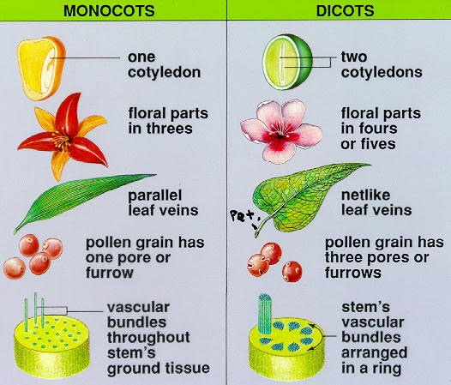
3/ Sunflower - The whole genus contains approximately 55 to 67 species, originating from North America, predominantly from the USA, including the southern regions of Canada. Several species also come from the mountain areas of South America.
Iris - is known about 230-280 species, which are spread in Europe, Asia and North America.
4/ Iris aphylla - Europe
Iris boissieri – Spain, Portugal, endemic
Iris cretensis - Crete
Iris x florentina- Mediterranean
Iris filifolia - Spain
Iris foetidissima - South Europe
Iris graminea – Europe
Iris halophila – East Europe, Asia
Iris arenaria - Europe
Iris illyrica – former Yugoslavia
Iris juncea – Spain, Sicily
Iris latifolia - France, Spain
Iris lorea - Italy
Iris lusitanica – Portugal
Iris lutescens – Southwest Europe
Iris marsica – Italy, endemic
Iris orientalis – probably an old garden hybrid grown in Greece and Turkey
Iris orjenii – former Yugoslavia
Iris pallida - Europe
Iris planifolia – South Europe
Iris pontica – East Europe
Iris pseudacorus - Europe
Iris pseudopumila – South Europe
Iris pumila – Central and South Europe
Iris reginae – former Yugoslavia
Iris reichenbachii – Southeast Europe
Iris ruthenica – East Europe
Iris serotina - Spain
Iris sibirica - Europe
Iris sintenisii – South Europe
Iris spuria- Europe
Iris suaveolens – Southeast Europe
Iris triflora - Italy
Iris unguicularis - Crete, Greece
Iris variegata - Europe

5/ Blue – wetlands, floodplain meadows Yellow – sunny and windless places

6/ Heliotropism
In fact, the adult sunflower cannot rotate the head on a stiff stem. Only the undeveloped buds (and the leaves are rotating in the sun) rotate at sunrise and gradually turn to the west in the bottom. In the night, it will return to the east. When the sunflower blossoms, the stem stiffens, and the flower usually faces to the east.

Sources:
https://cs.wikipedia.org/wiki/Kosatec
https://cs.wikipedia.org/wiki/Slune%C4%8Dnice
https://www.youtube.com/watch?time_continue=61&v=DHoogb9Q794
https://sites.google.com/site/plantstructurebhannan/monocot-and-dicot

