Nature in Art
Jan Zrzavý was a leading Czech painter, graphic artist, and illustrator of the 20th century.
Born: November 5, 1890, Okrouhlice
Died: October 12, 1977, Prague
Artworks: Café, A sitting girl, A square with a well, Sunday in Camaret, and more
Period: Modern art
Education: Academy of Arts, Architecture and Design in Prague

1) Look at the picture „Sunday in Camaret“
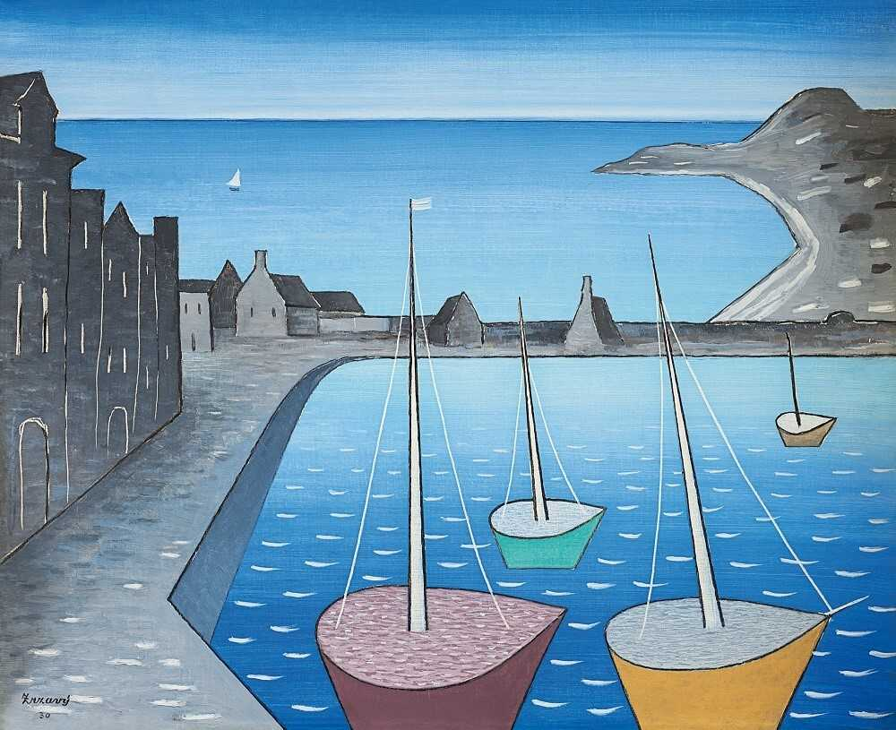
2) Describe what you can see in the picture. Where do you think that it was painted? Find it on a map.
Camaret is part of the name of two communes in France:
Camaret-sur-Aigues, in the Vaucluse département
Camaret-sur-Mer, in the Finistère département

3) What do you know about the environment of the picture (about ocean and see life)?
4) Paint a similar picture.
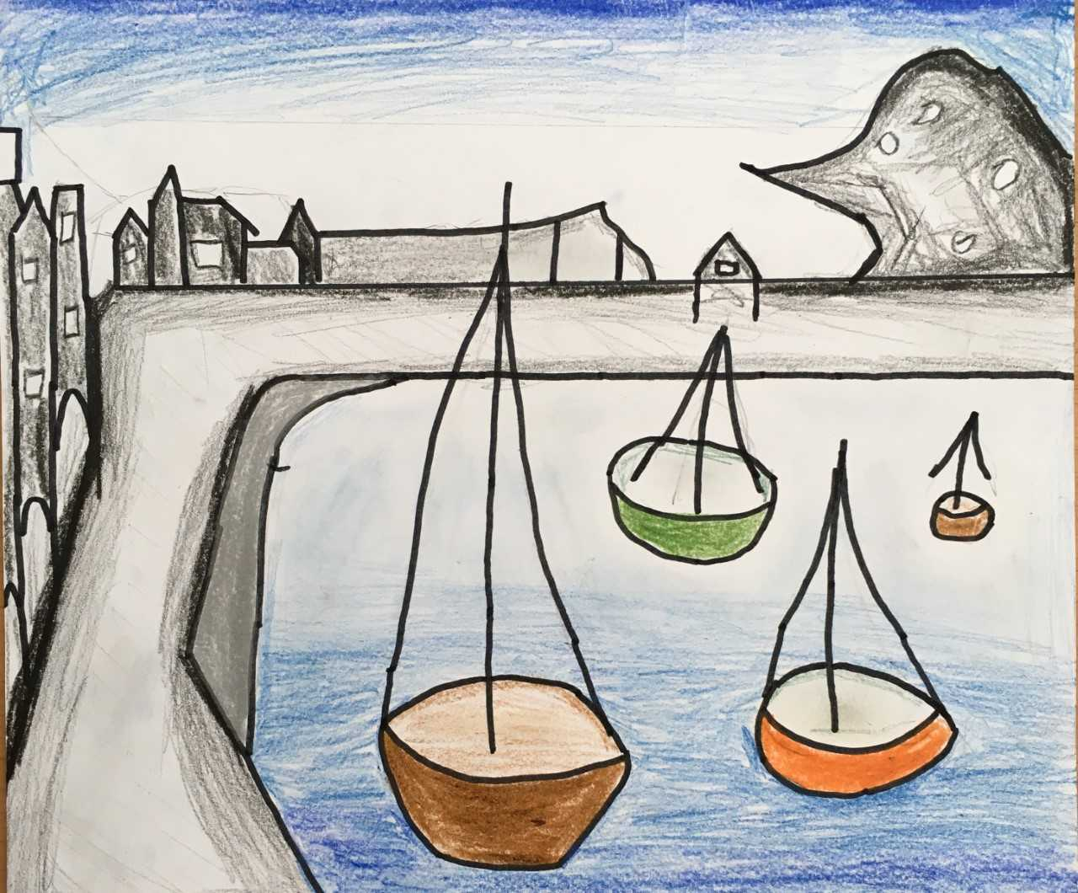
Picture 1, painted by Eliška, 12 years old

Picure 2, painted by Jakub, 12 years old
