Romanian painting 1 for Polish school
PICTURE
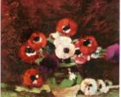

ANEMONES

PAINTER | YEAR/STYLE | WHERE IS THE PICTURE NOW | MEANING | WHY WE SELECTED IT
Ştefan Luchian  (1868-1916) | 1908  IMPRESIONISM | The Romanian  Academy | Flowers are the passion for nature, all love for life and for beauty | I chose this painting because Stefan Luchian is one of the greatest Romanian painters. As a sick man, since 1908 he has focused his attention on flowers, which have been a means of communicating moments of suffering or moments of victory. Since 1909, the painter paralyzed but continued to work with her hand brush, which made her flowers become true masterpieces.

Romanian painting 2 for Polish school
PICTURE
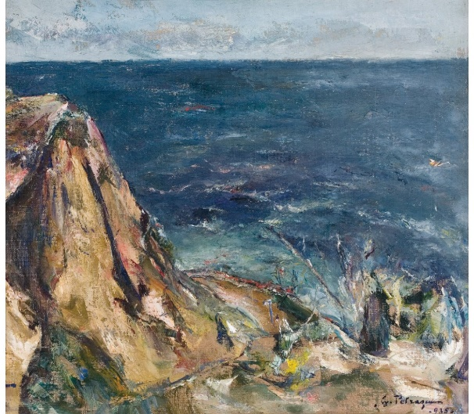

Rock at the sea

PAINTER | YEAR/STYLE | WHERE IS THE PICTURE NOW | MEANING | WHY WE SELECTED IT
Gheorghe Petraşcu  (1872-1949) | 1935  IMPRESIONISM | Art Museum | The work shows that the painter's endearment only renders the materiality of two essential elements of nature, emptying the landscape of any other reference. The first plan is asymmetric, to the left the high cliff rising close to the line horizon, while on the right the scene is dynamized by the waves that break through the shore. The mass of blue-gray water,modulated by a few white accents, occupies the surface of the picture up and the sky in turn animated by some white-pink clouds,  is reduced to a narrow strip. | We chose this painting because we love the sea, nature and the painter is born in Tecuci, in the area where we live.

