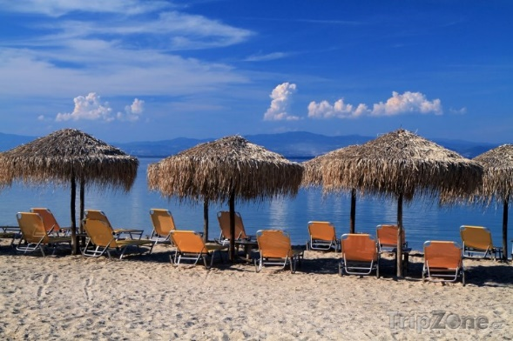
My holiday in Greece

1. Where and when did I go?
We went to the island of Kos on July 23rd.

2. Who did I go with?
I went there with my family. Dad did not go because he had a broken leg.

3. Where did we stay?
We stayed in the hotel by the sea. There was a swimming pool in the hotel area.

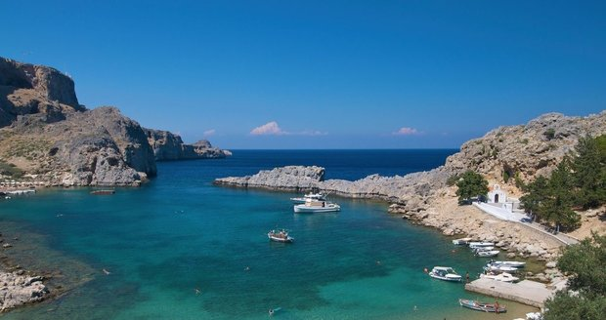
4. What can you see?
I can taste Greek food specialties in this country.

5. What did you see?
We visited the famous square in the capital of Kos named Kos.

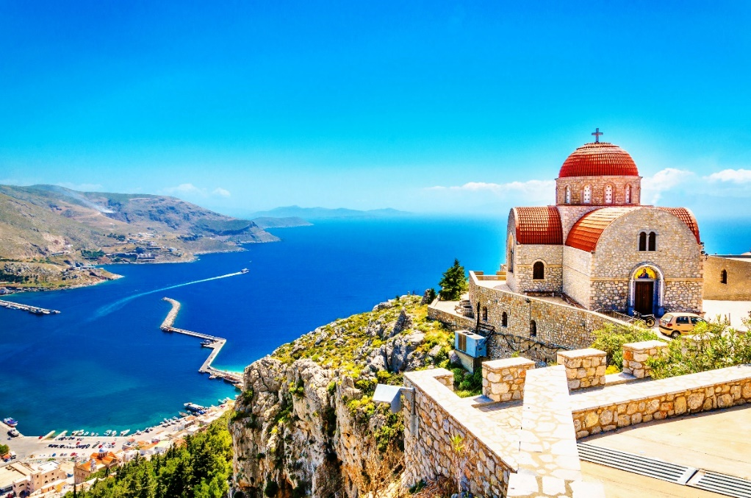

Zdroj: Wikipedie autor: Vojtěch Pavelka

