Dear Parents,

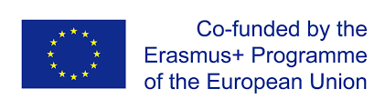
St Brigid`s Primary School Tirkane, as you may know, has successfully applied for a 3 years project, funded by the ERASMUS+ (European Fund), called Integrating STEM with CLIL. For its first year, we are running this project in our P6 class, where various new activities we introduce to promote STEM (Science, Technology, Engineering and Mathematics) and foreign languages (German, Spanish). Taking part in this International Project with 6 partner schools from 5 countries, offers great benefits for our pupils and teachers alike.

Please read our short project description below:

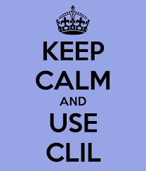
Linguistic and cultural diversity of the European Union is one of its major assets, but also one of its main challenges. Throughout the last decade, European multilingualism policy has been guided by the objective set by the Barcelona Council of March 2002, which called for the improvement of mastery of basic skills, in particular, by teaching at least two foreign languages from a very early age.

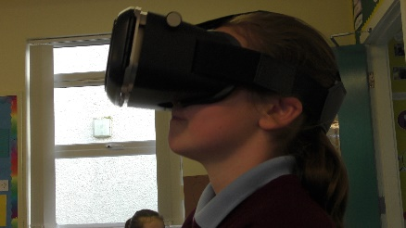
Integrating STEM content with advanced foreign language instruction provides a unique way for students to gain foreign language capacities directly related to promising career pathways. Content and language integrated learning (CLIL), also referred to as content-based language teaching, simultaneously promotes skills in the target language and advances content knowledge, making this a promising approach for students to gain STEM skills in a foreign language classroom.

There are 6 partners in the project:
3 transnational project management meetings (Macedonia, Poland, Turkey) and
3 learning, teaching, training activities (Northern Ireland, Romania, Northern Ireland) are planned.

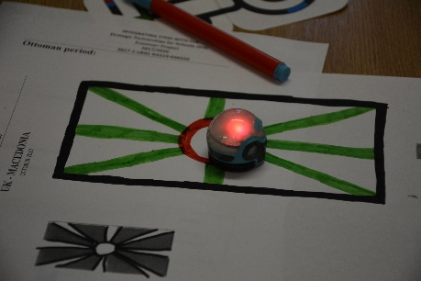
Impact on the participants: The expected impact on the participants is that they win new and different learning methods. They will be self-confident and have better foreign language skills. They have more confident to the STEAM subjects and can integrate them with the curriculum. They have more competence to use ICT in their learning and teaching methods.

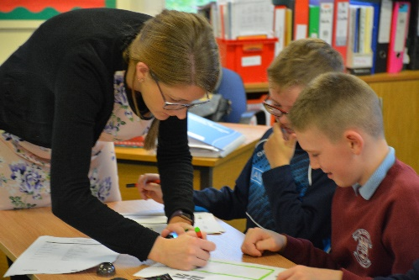
The participant teachers will become active participants in a team within an international framework which will give them a unique experience on reflecting, comparing, evaluating logical thinking issues from different perspectives. Also, they will develop communication skills in foreign languages and to experience the school systems of the partners. The participants schools will expand their points of views by means of project as they will have new visions and missions.

Please support our effort in promoting STEM and Foreign Languages by following our progress on
- eTwinning (https://live.etwinning.net/projects/project/150497),
- Padlet (https://padlet.com/bkecskemeti/ISWC)
- or our school`s website (http://www.stbrigidspstirkane.com/).

Thank you for your help and support in advance.
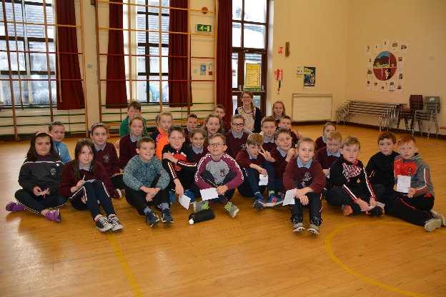
Best regards,

Balazs Kecskemeti
Project Co-ordinator
Erasmus+

