Chat
- Hello Marie.
- Ohh Vicky, what do you want AGAIN?
- I want you to go to the Headmaster, and this time you have to say that George hit your head and you did stitches.
- But this is not true and I won’t betray George, we are really good friends, and why do I have to do this?
- Because I say it, and I don’t think you want everyone at school learn that you were fat at the past, right?
- I don’t care anymore, say it, enough with the extortions!!!
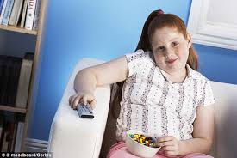
- Are you sure? If you cry after this, no one will care anymore!
- Ohh! Sweetheart, what matters is the present and not the past.
- OK, I’m sending it!

The next day:
- Here you are Mr., this girl threatened me and sent this picture to all my friends.
- Don’t worry miss Marie, she will be punished accordingly!

