Worksheet
Geo Challenge

Subject: Geography
Topic: world geography
Class: high school
Time: 10 minutes
Tools: cell phone

ABOUT APP
Geo Challenge is a geography quiz game to test your geography knowledge of the world. This geography game has four mini-quizzes to test your knowledge in four categories. First you will distinguish country flags. The second quiz is about recognizing countries only with a shape of their borders. The third quiz is about major cities of the world and your goal is to guess where approximately these cities are located and place a pin on the map. The last quiz is about guessing where famous landmarks around the world are situated and once again place a pin on the map. Each mini-quiz lasts 60 seconds. Your goal is to answer as fast and accurate as possible. If you answer correctly, you will get points or extra time.

TASK 1
The first task is very simple. Download the game on Google Play or App Store and press play. Fulfil all the mini-quizzes and wait for your results. The app will show you your score in all the four categories and then it will count your total score. You will compare your results with other members of your team. If you want to see correct answers, click on ‘view answers’ and you can check your answers and how accurate you were.

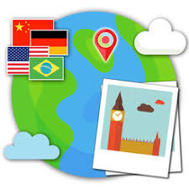
TASK 2
The second task is about the separate categories. Click on ‘training’ and go through all the separate quizzes. After each quiz you will get your results and again you can check your answers. After each quiz compare your results with your teammates.
