Digital teaching in natural scientific subjects

2017-1-CZ01-KA219-035416
Worksheet - Relative and absolute location
Learn from your phone
1. Write your answer to the question.
1.1 How many locations are there?
___________________________________________________________________________
Location Relative
2. Look the maps. Carefully observe the location of the countries of the ERASMUS Project
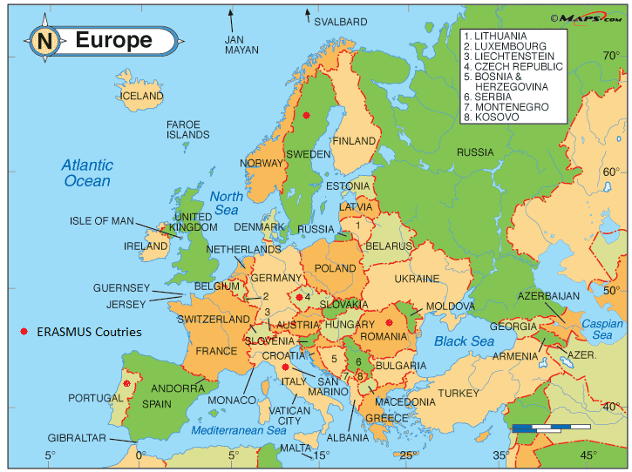
2.1 - What is the location of Portugal in Europe? _______________
2.2 - Which is the country of the ERASMUS group that is to the East and is bordered by the Black Sea ____________
2.3 - The Country that is Northwest the Romaine and near Germany is ________________________
2.4- The country that is northeast of Portugal is ________________________
https://www.infoplease.com/atlas/europe-map
3. Absolute Location
3.1 - What are the geographic coordinates that you know? _____________________________
3.2 - Latitude is ________________________________________________________________
3.3 - On your phone open Google maps. Each group will discover the place with the following coordinates
Coordinates in decimal degrees |  | Countries and the place | Geographic coordinates (DMC)
Latitude | Longitude |  | Latitude | Longitude
44.1166700 | 24.9833300
45.5953600 | 7.7945100
37.1377200 | -8.0196800
50.0039 | 17.4258
55.70584 | 13.19321

3.3 - Write in columns 4 and 5 the Geographic coordinates.
3.4 - What is the conclusion of this exercise?

Discover a place with the Digital Teaching application
Application of knowledge in the itinerary that we do outside the classroom, with the Digital Teaching application.
1º On phone open the Digital Teaching application
2º Each group will make the itinerary following the
latitude, longitude, coordinate and cardinal points of the compass and indicated in the worksheet:
A. 37.142224°, -8.016861°
B. 37.14193°, -8.017708°
C. 37.14005°, -8.18104°
D. 37.14064°, -8.020491° - Do you see the monument?
F. 37.14144°, -8.019848° - Stairs
G. 37.14197°, -8.019818°
H. 37. 14239°, -8.019547°
I. 37.142219°, -8.018575°
J. 37.14381°, -8.018012°
K. 37.1442°, -8.017758° - Meeting point ( write the latitude and Longitude )
Latitude: 37° 8´ 38´´N Longitude:8° 1´ 4´´ W
Statue of the popular poet of Loulé António Aleixo
Back to School
L. 37.14413°, -8.01742°
M- 37.14417°, -8.01687°
N. 37.14351°, -8.016225°
O. 3714286°, -8.016127°
P. 37.142224°, -8.016861°
A group member indicates the itinerary on the map.
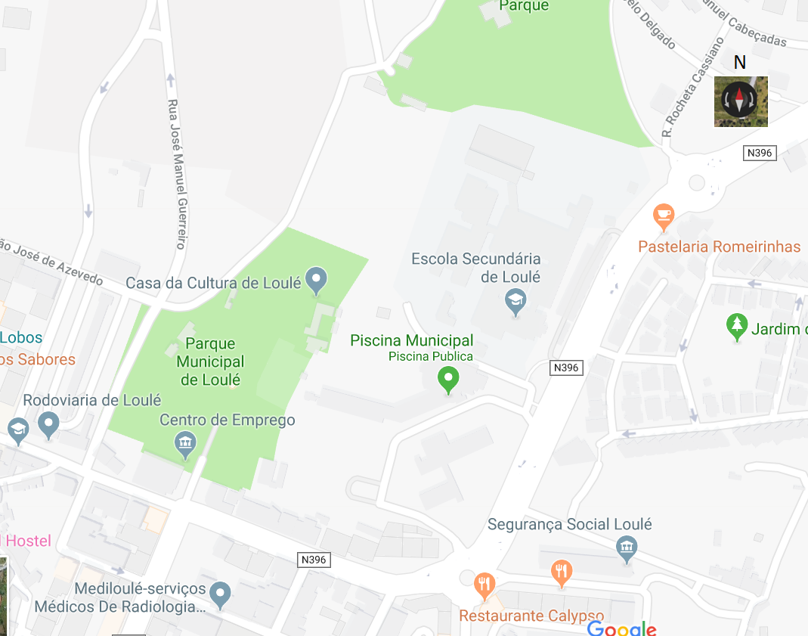

https://www.google.com/map

