SKYVIEW® LITE

SkyView® Lite is an amazing stargazing app.
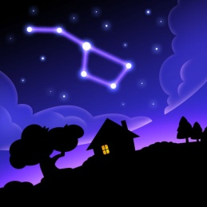
It´s better used outdoors but works indoors too.
You can use this app in the classroom in an interactive, competitive and fun way by dividing the students into groups and make them look for constellations, satellites, and more. In our presentation for this app we organised a contest to see who can find the fastest constellations using the app. We divided the students into 3 groups and each group had look for 3 different horoscope constellations. The app is easy to use, you just have to point your phone at the sky to identify stars and constellations. Two teams finished at the same time and then they had to look for the Polar Star to win but there are many more ways to use this app in the classroom.

Features:

• Simple: Point your device at the sky to identify galaxies, stars, constellations and satellites (including the ISS and Hubble) passing overhead at your location.
• Sightings: set reminders for celestial events and plan an evening stargazing & spotting satellites.
• Augmented Reality (AR): Use your camera to spot objects in the sky, day or night.
• Sky Paths: Follow the daily sky tracks for the Sun and Moon to see their exact locations in the sky on any date & time.
• Time Travel: Jump to the future or the past and see the sky on different dates and times.
• Social: Capture and share beautiful images with friends and family on social networks.
• Mobile: WiFi is NOT required (does not require a data signal or GPS to function). Take it camping, boating, or even flying!
• Supports Space Navigator™ binoculars, spotting scope, and telescopes.

Information

Seller: Terminal Eleven LLC
Size: 82.1 MB
Category: Education
Compatibility: Requires iOS 11.0 or later. Compatible with iPhone, iPad, and iPod touch.
Languages: English
Age Rating: Rated 4+
Copyright © 2010 Terminal Eleven LLC.
Price: Free
In-App Purchases : Brightest Satellites & Sightings $0.99
Stargazing Music Pack $0.99

You can find the app in App Store: https://itunes.apple.com/us/app/skyview-lite/id413936865?mt=8
https://play.google.com/store/apps/details?id=com.t11.skyviewfree&hl=en_US

