Workshop on National Identity
(by Konrad Schiffelholz)

- The students go together in groups of their nationalities (one Dutch, one Italian, one Spanish and one German group).
- Each group gets one big poster in a different colour and small, oval papers in the same colours for each country (Netherlands: pink, Italy: green, Germany: yellow, Spain: orange) and small white papers for their autostereotypes.
- First the students are asked to put three key words of the autostereotypes they have of their own nationality on the small white papers.
- Secondly, they have to put keywords of the stereotypes they have of the other countries on the small papers in the colour of their big posters, so that afterwards we can see which country has which stereotypes of the others.
- Last but not least, each group gets one white paper where they have to put keywords of what they thinkmakes up their European identity.
- Finally, each group has a poster as a "final product" and tells the others what they think of the results.

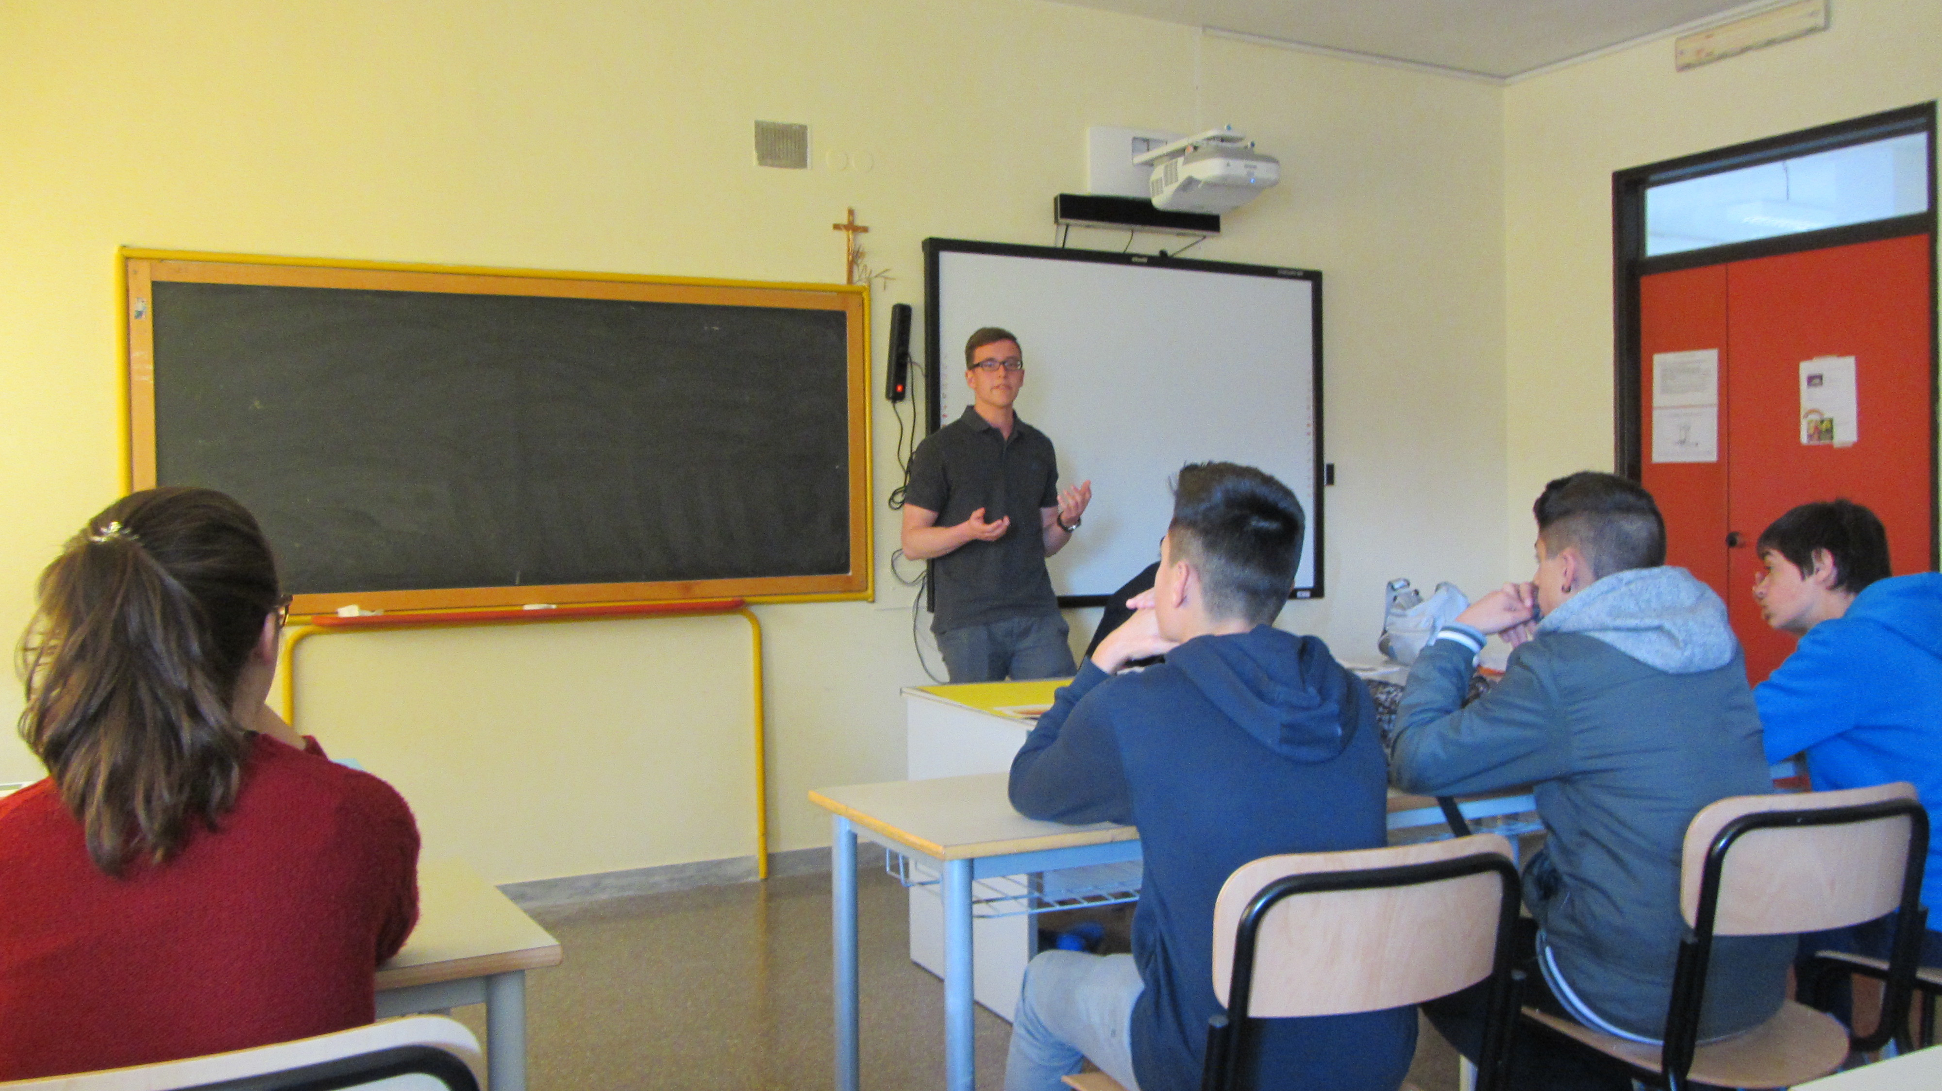
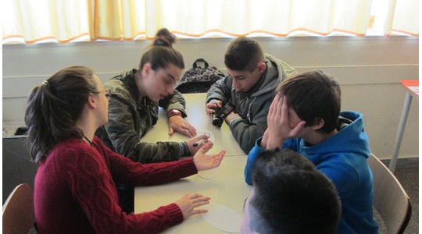

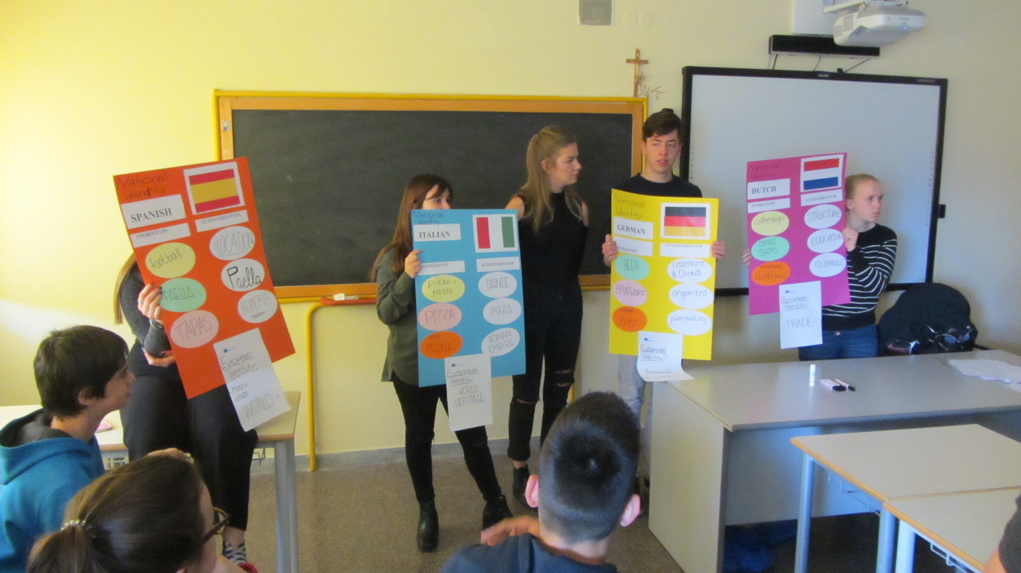

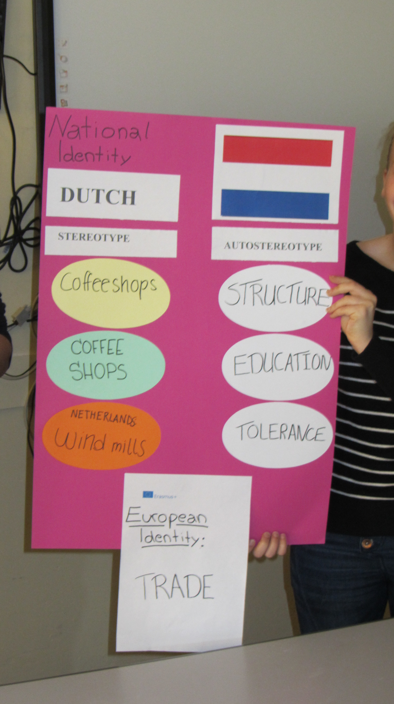

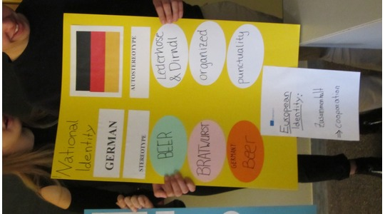

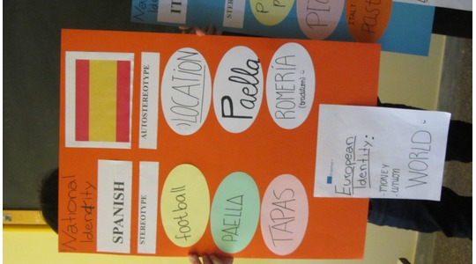

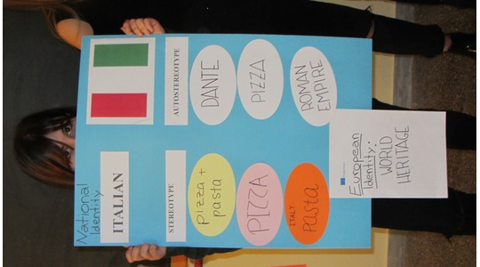

RESULTS
- The students were surprised how much their autostereotypes differed from the stereotypes the others had of their nationality.
- The Dutch were even shocked that they are associated mainly with coffee shops, as they are not important to themselves at all!
- The students were also surprised that their stereotypes were mainly about food.
- The teachers were surprised that the students did not associate the European Union with democracy and freedom.
- Nevertheless, all the students had positive associations with Europe!

