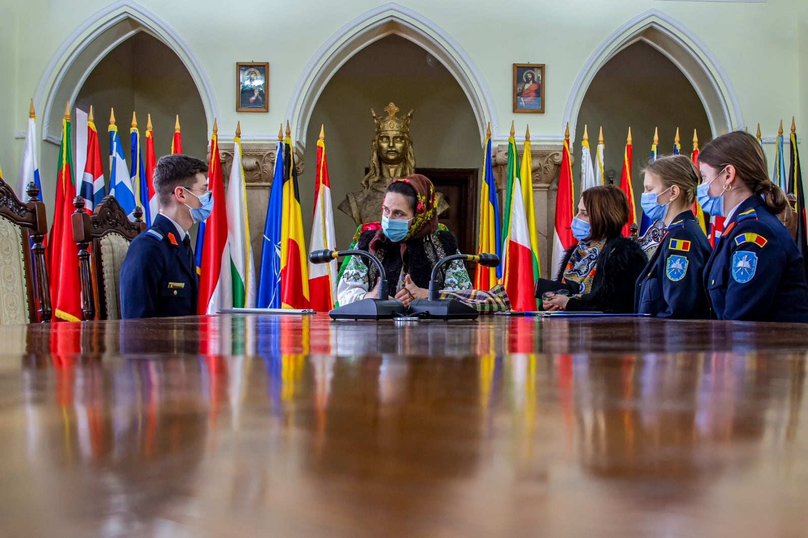
STUDENT: “In the attempt to know the human Felicia Oblesniuc in a different way than we see her on stage, please tell us more about yourself”
GUEST: “I was born in a big family in Moldovita, I have 10 siblings. One of our main traits is the love for beauty, respect and for traditions. At the moment, I am happy being a mother of 3 children and teaching special needs kids. I love people, beautiful people.”
STUDENT: ”Considering that your family is numerous and that you want to keep the local traditions going, we want to know who inspired you?”
GUEST: “By our side has always been my grandmother who was preoccupied with teaching us about traditions since we were little. She knew how to braid, how to spin cotton, to sing marvelous and all her life she had always worn the national costume with dignity. The place where we came from has something special. If we don’t try to get to know it’s secrets and pass it over, we actually don’t know who we are.”
STUDENT: “When did you realise this was your purpose?”
GUEST: “I have been singing since forever, the voice is not something that appears over night, it’s a gift from above. In 2008 I happily participated to a festival in France. People that didn’t know a thing about our traditions were very supportive and we felt lots of love from them.”
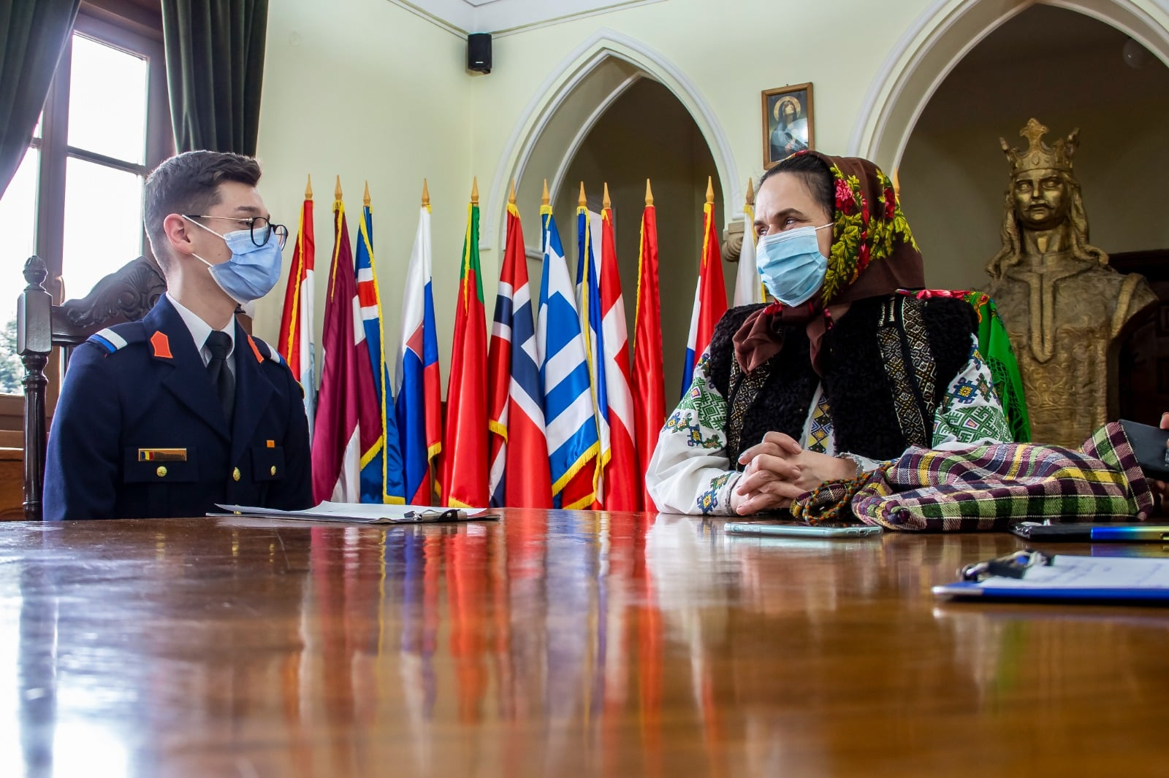
STUDENT: “We suppose that in your career you have experienced amazing moments. Can you tell us about some of them which had a bigger emotional impact?”
GUEST: “ Each public appearance gives you a strong emotional impact. I’ll never forget when I was invited in Ukraine. I didn’t realise that everybody was standing up and singing along with me with plenty of love. This kind of emotional moments make an artist feel so good. When you see that you’re able to make people feel good, you keep going.”
STUDENT: “In every career there’s ups and downs. Were there any hard moments that you.ve been through?”
GUEST: “Maybe the most disappointing moment for me was the one that I realized that not all artists are how they should be. For me, a human who loves art must behave. But when you know that what you do is beautiful and others can learn from you, you must look for the power to keep going. Life isn’t always easy.”
STUDENT: “Do you consider yourself a fulfilled artist or do you think you still have to work on yourself?”
GUEST: “You can’t make it without working. You must work for something to turn out great. You sing a song once, twice, and it seems like it could be better.”
STUDENT:” You have participated to various eveniments, one of them being the festival from France, but we also know about “Balul Bucovinei”. How did you feel about them?”
GUEST: “ “Balul Bucovinei” from Bucharest was an amazing event, simply because of the wish to transmit the traditions. The authenticity has been appreciated. People who have been abroad came home and enjoyed the show.”
STUDENT: “Do you think there’s a perfect place and moment, for people who are talented, to distinguish themselves?”
GUEST: “The appearance have their importance. Where, who sees you... Even though you are in a room with 10 people and you think that nobody will notice your skills, it’s not like that. Even if you sing to a single person, you don’t know what impact you’ll have. That person could be able to open a new door for you and to offer you an amazing opportunity.”
https://www.youtube.com/watch?v=yvn_IknR94I
https://www.youtube.com/watch?v=9H1eKk19V-E

