Challenge: Design a green city

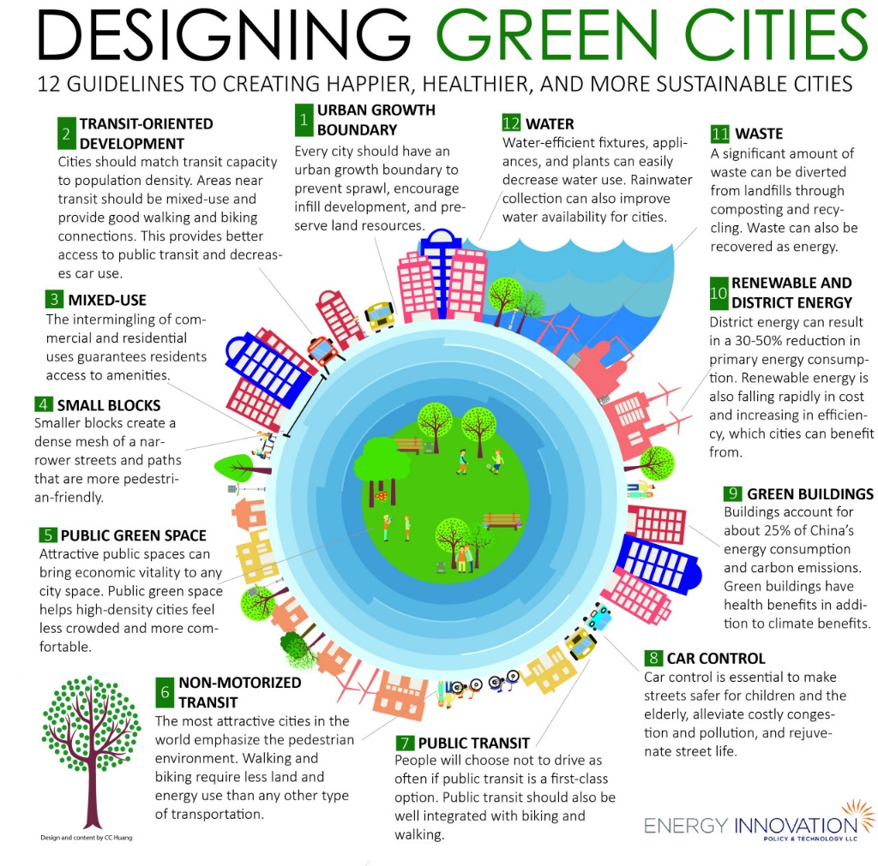

1. In groups discuss the layout of the green city and the location of the most important elements of the city. Important: Be creative and explain the choices you make. Include the following elements that characterise a green city and decide where to include each item. You can browse the internet to gather information.
- Public transport
- Green spaces and sports facilities
- Recycling plants.
- Bicycle lanes.
- Solar and wind generators

2. Go to the website icograms.com. Register on the website to be able to save your designs. Look on the left side of the interface for the elements you want to include, and drag them to the design area.
3. Design the city taking into account the decisions made in the previous point. The design is saved in the cloud.
4. Take a screenshot of the final layout of the city.
5. Make a presentation explaining the process followed to design the city. Include screenshots of each part of the city. Write a conclusion section at the end. You will have to present it to the rest of the class at the end.

