Slovak mobility – Results
Teachers
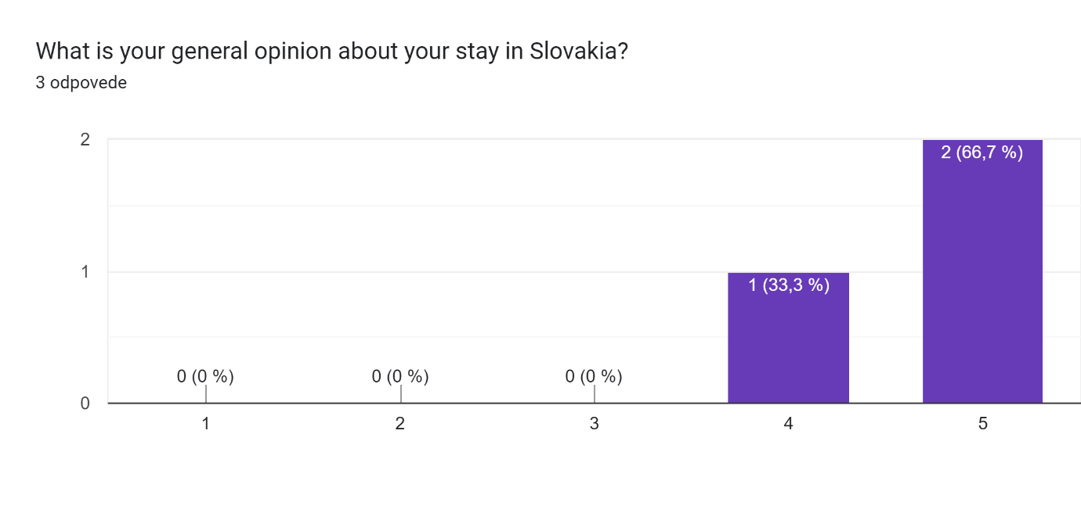
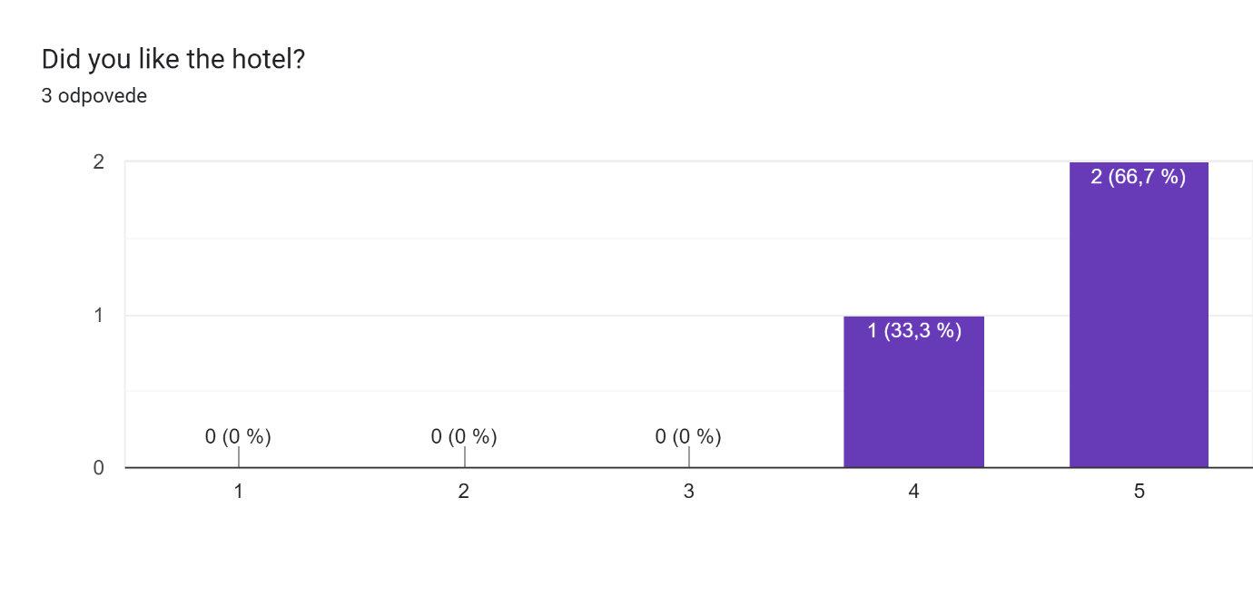
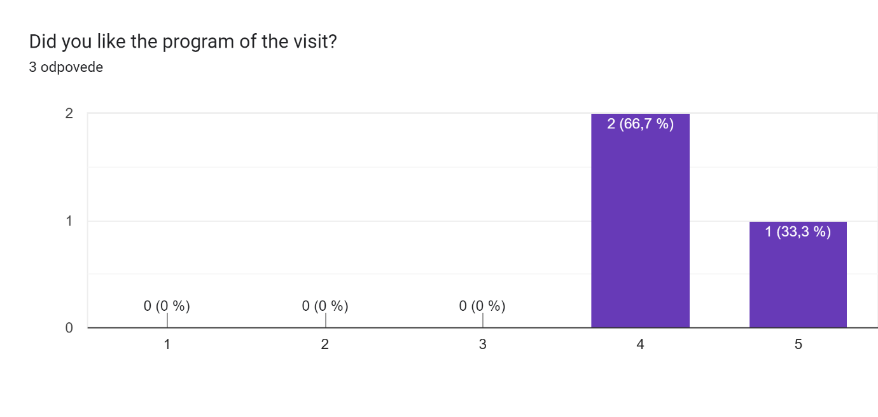
What do you think about the organisation of the activities?3 odpovede
very well organised, programme was well balanced between workshops in school and activities to explore the surrounding area, the students and staff that were involved were all highly motivated, we had a great stay
Very good
It was good.

