Slovak mobility - Results
STUDENTS
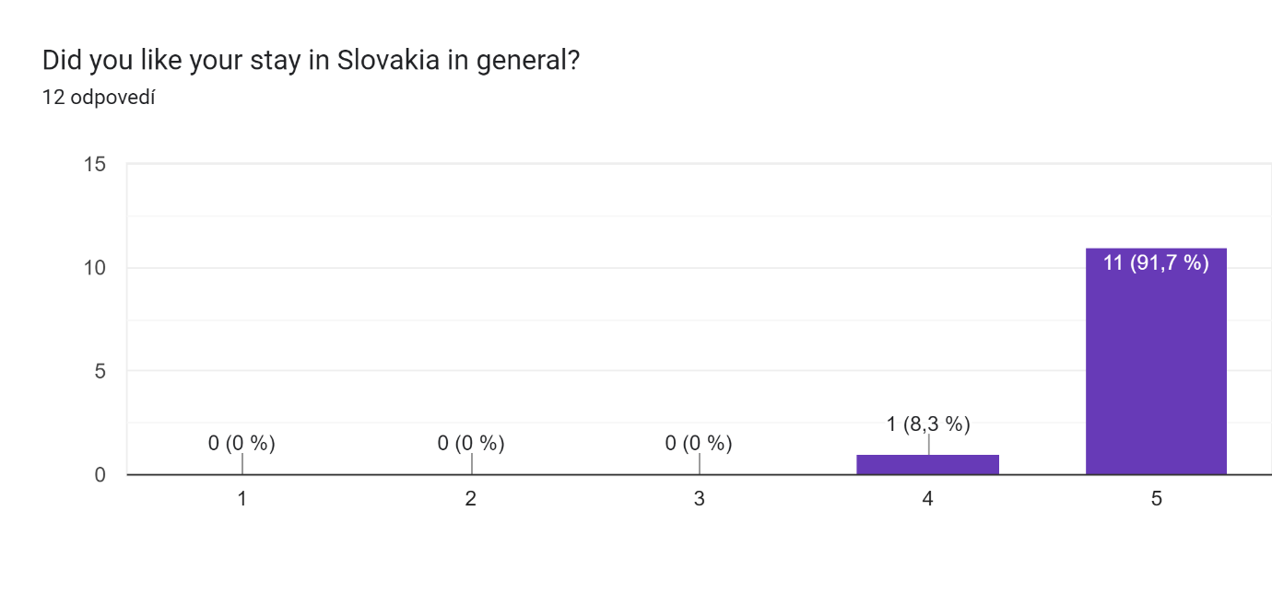
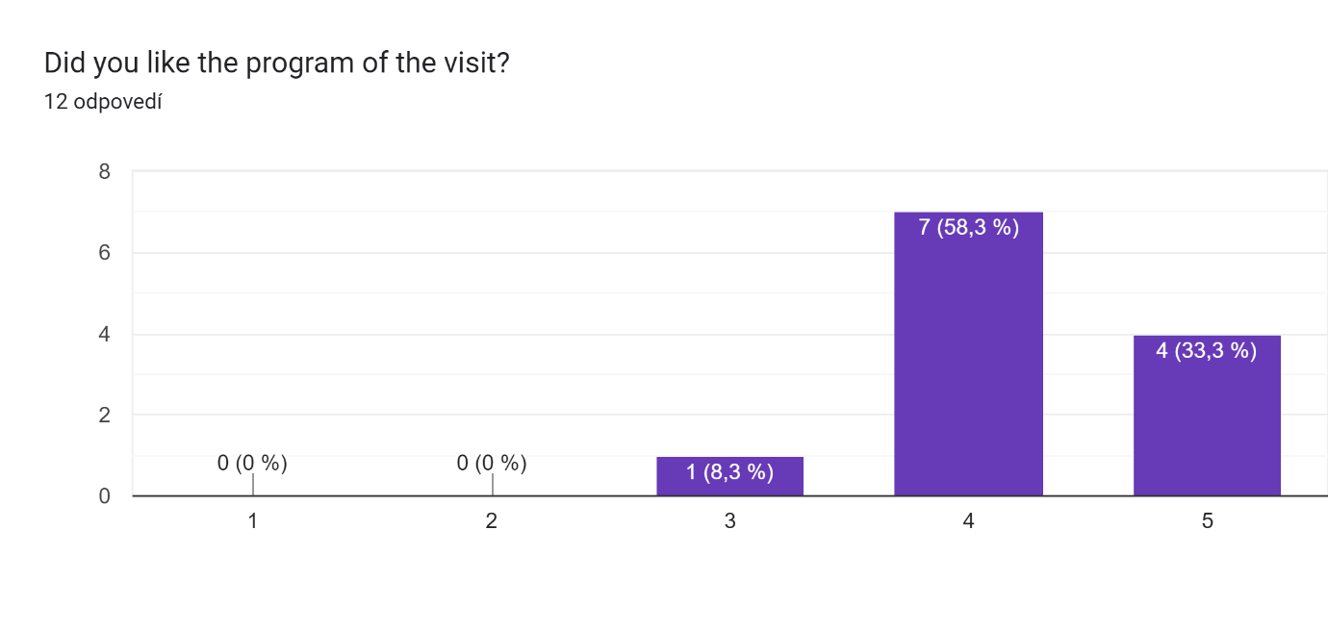
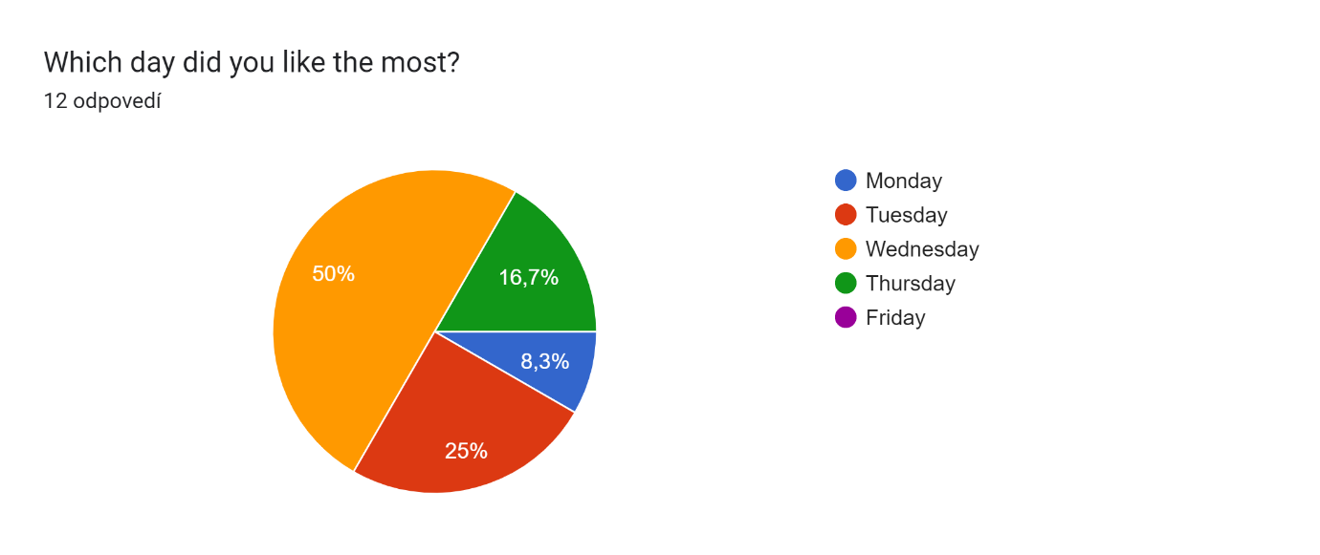
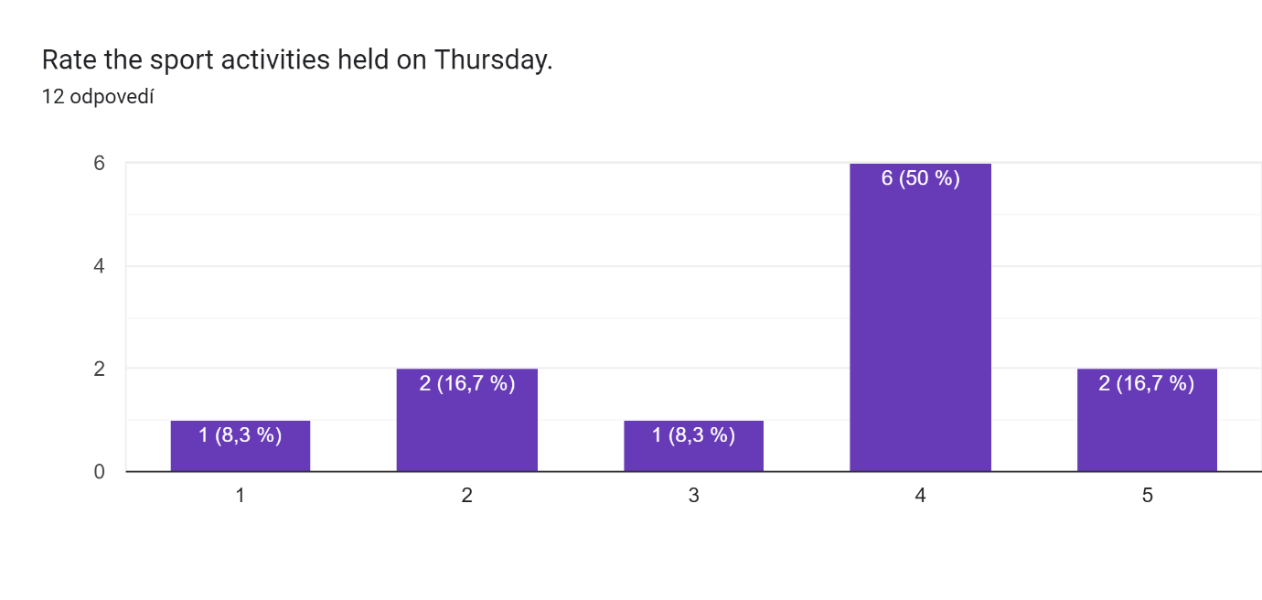
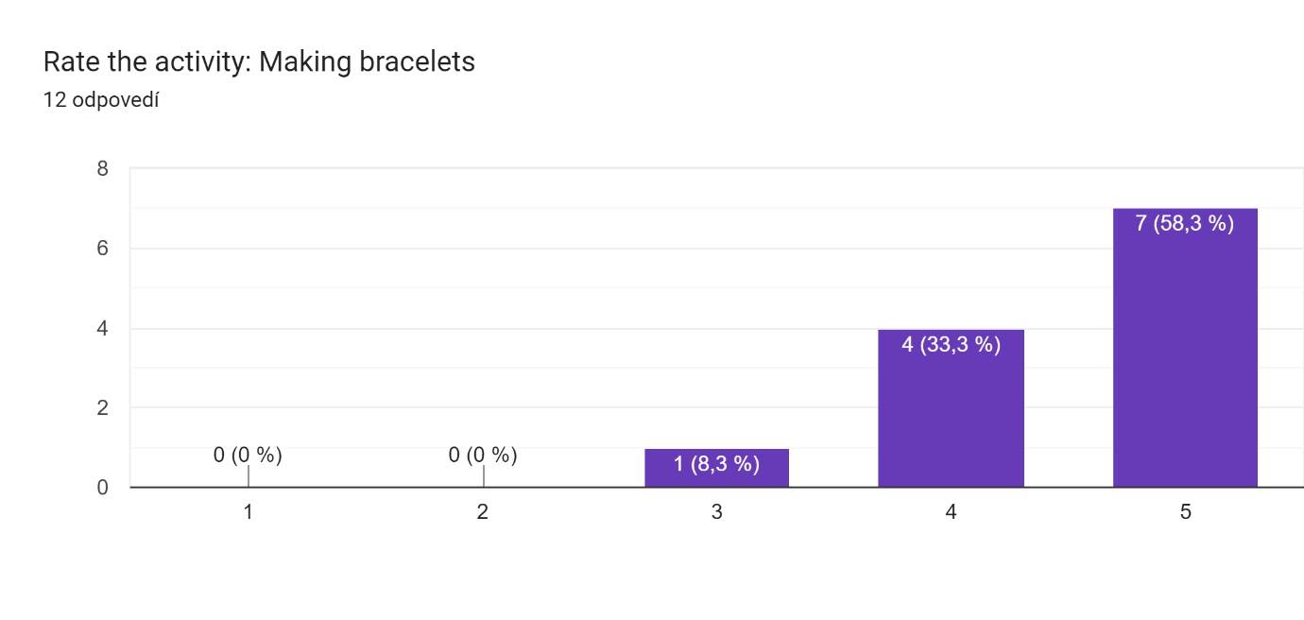
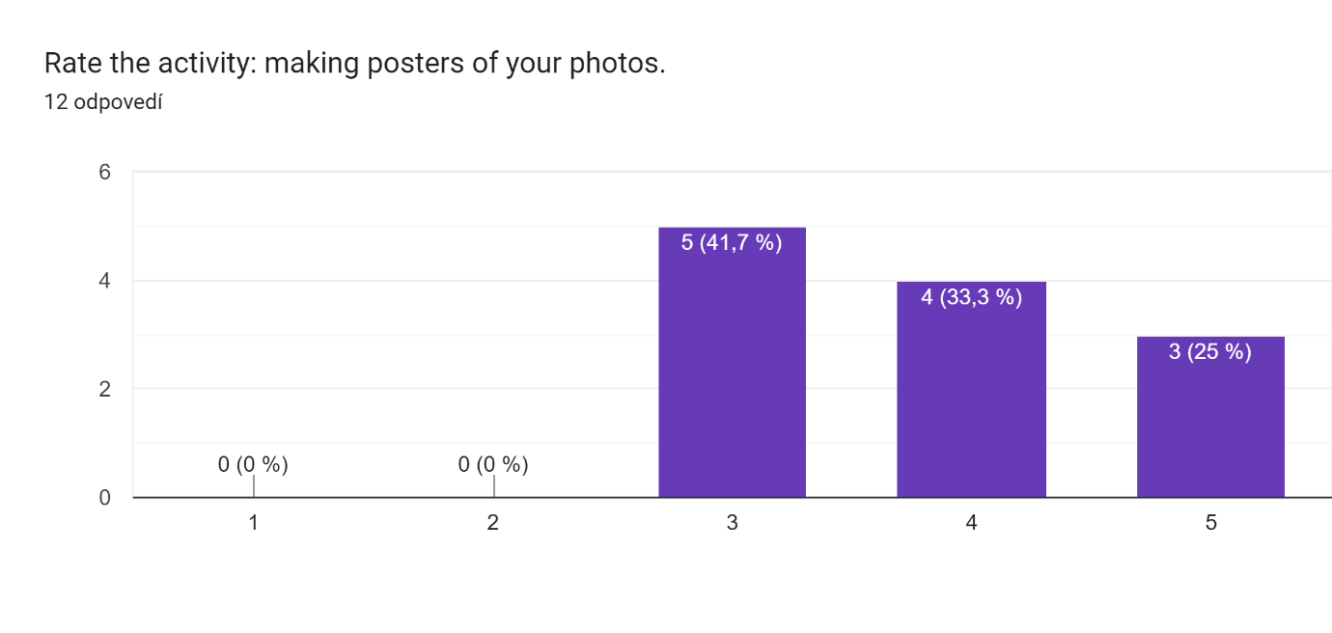
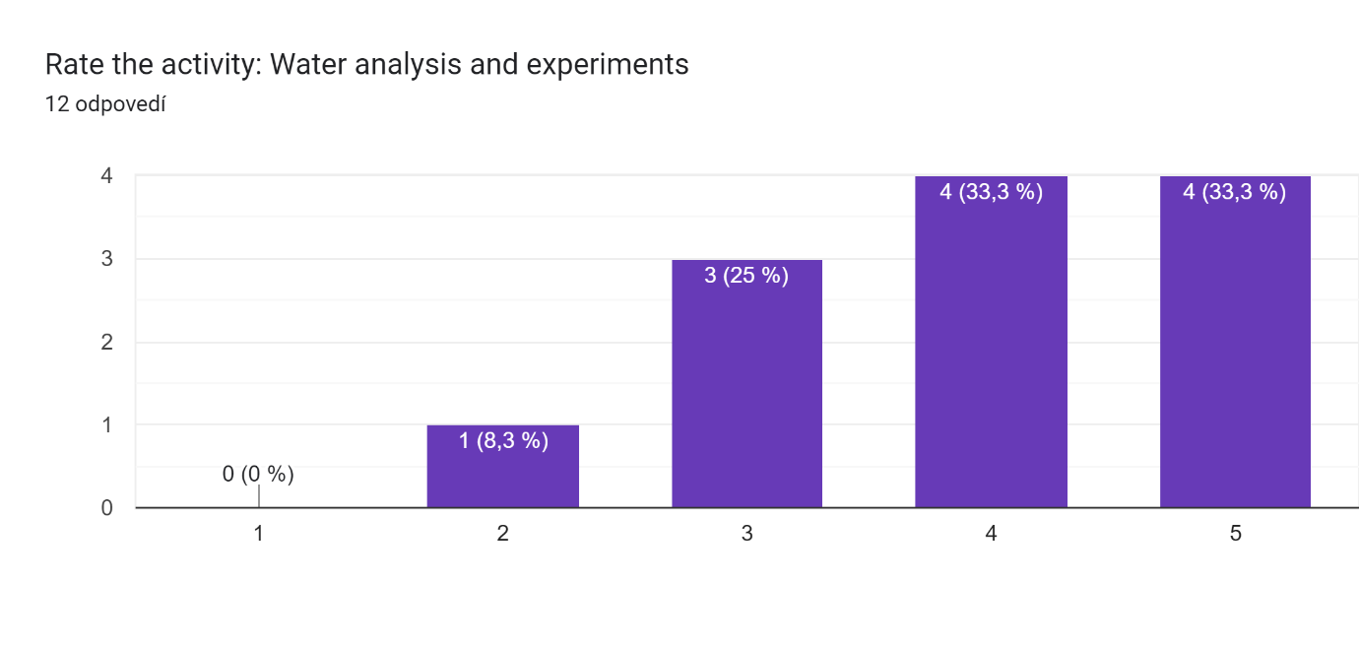
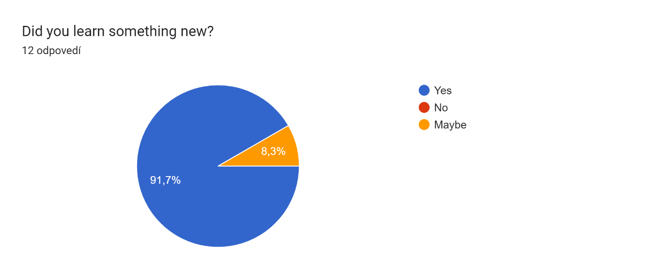
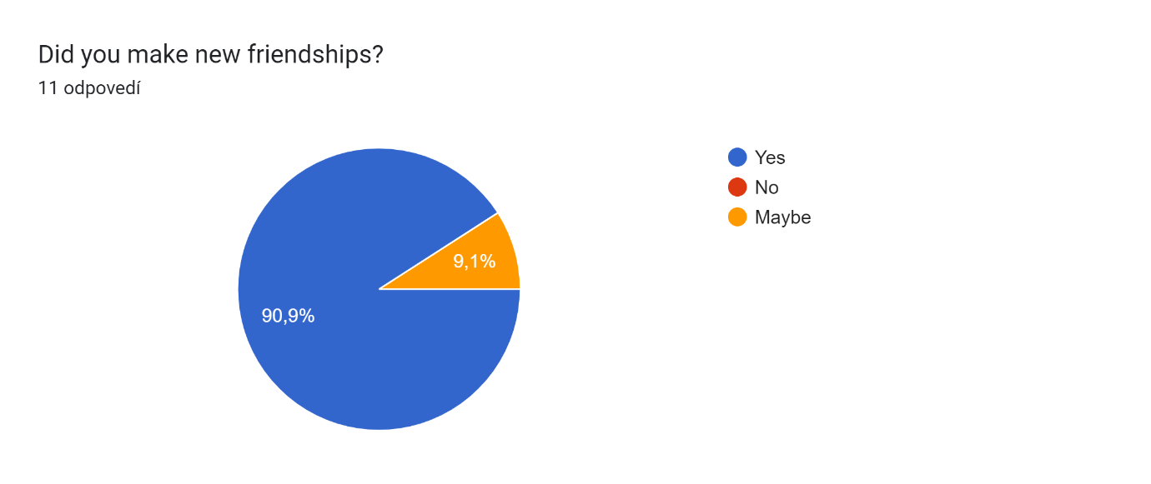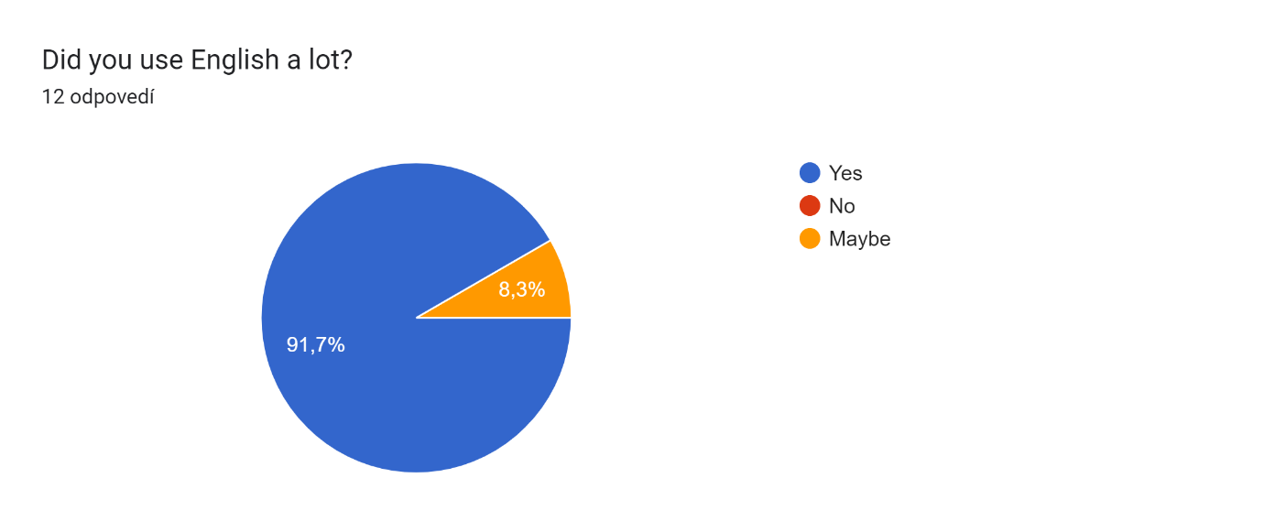
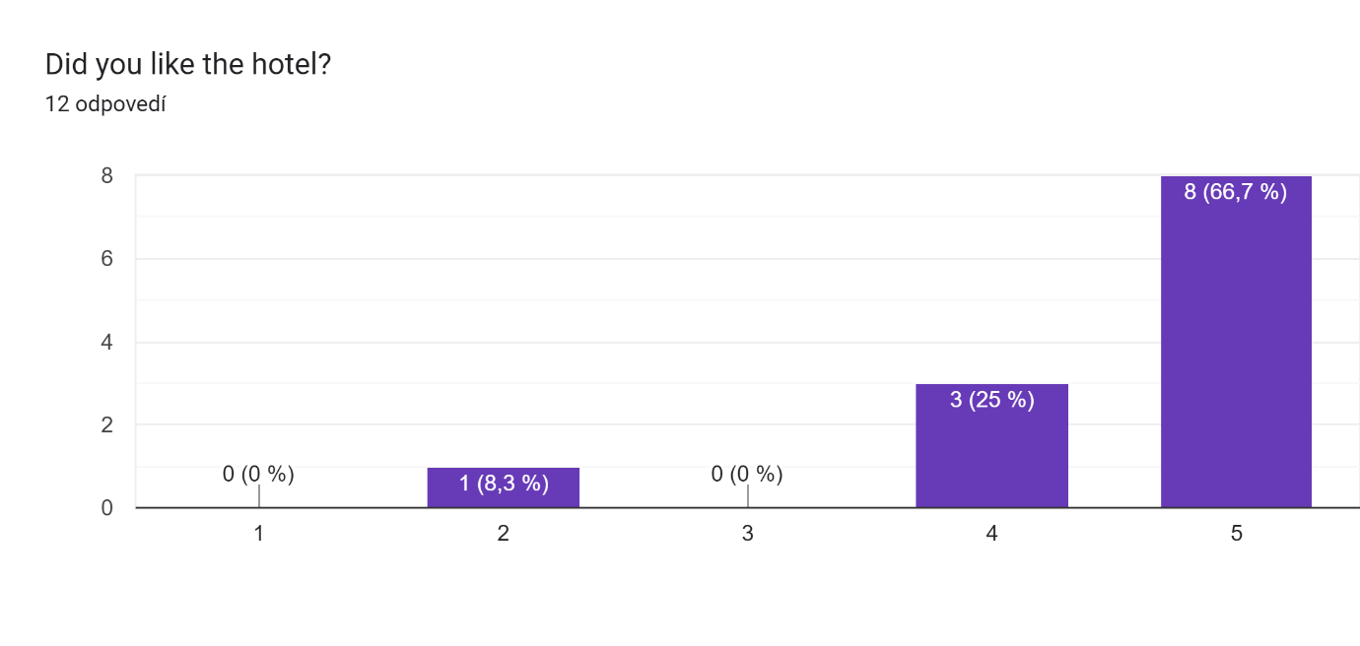

Add your comments about the mobility:6 odpovedí
The mobility was good.
It was very good and I'll be remembering the experience for a long time
The mobility was amazing, I met a lot of friendly people and visited places I will never visit again <3
Such a great experience! ty of this ;) <3
I would repeat the mobility because it helped me socialize and I had a great time
The hotel was very central in Bratislava, hence most spots we went during our freetime were within walking distance. Nevertheless traveling by bus with the other countries was a very confortable way of transportation.

