SIGHTSEEING MELFI in Basilicata
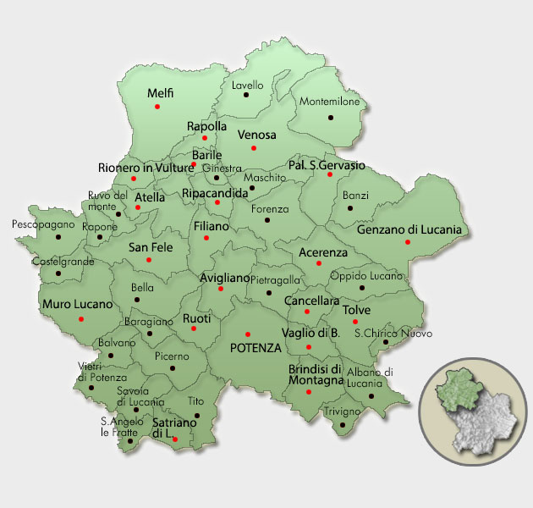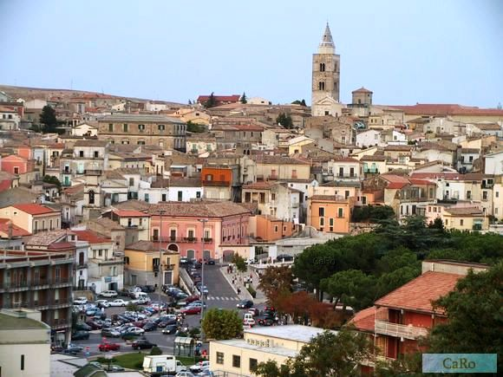
Melfi is a town and comune in the Vulture area of the province of Potenza, in the Southern Italian region of Basilicata. On a hill at the foot of Mount Vulture, Melfi is the most important town in Basilicata's Vulture, both as a tourist resort and economic centre.
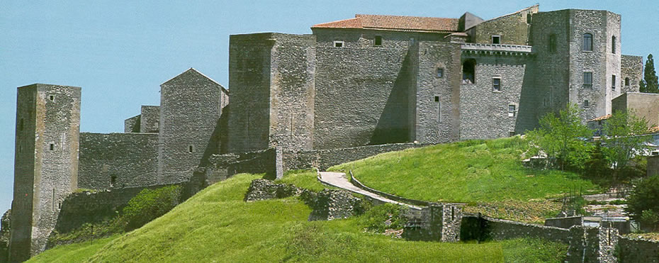

The Castle, dominates the whole town. It was probably constructed ex novo by the Normans (11th century), as no trace of pre-existing Byzantine or Lombard edifices has been found. Originally, it was probably a simple rectangle with square towers, with further towers defending the main gate. One of the main internal buildings was later (16th-18th centuries) turned into a baronial palace by enclosing the walls between the towers within new walls. Under the Angevine rule a new section was added on the slope descending to the Melfia stream, with several constructions rising at different altitudes. The Castle was chosen by King Charles II's wife, Mary of Hungary, as her residence. The Aragon kings gave it to the Caracciolo family, who rebuilt the side facing the city and dug a moat. Later it was a possession of the powerful House of Doria.
Today the castle is the seat of the National Archaeological Museum, which exhibits numerous archaeological finds from the surrounding areas. Among the exhibits you can see Byzantine jewellery and the famous “sarcophagus of Rampolla” (named after the village where it was found in 1856), one of the most important examples of the Asian art school and dating from the second century AD. On the sarcophagus a temple with some figures of gods and heroesis represented, with a cover depicting the deceased.

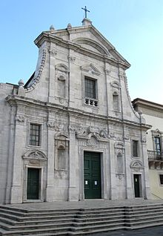
The Duomo (Cathedral), built in the 11th century for want of Robert Guiscard, it was also rehandled in the baroque style after the earthquakes, with exception of the original Norman bell tower. The interior contains a magnificent 13th-century fresco, the Madonna with Child and Angels.

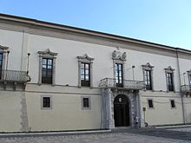
The Palazzo del Vescovado (Bishopric Palace), erected in the 11th century but rebuilt in the baroque style in the 18th century because of the earthquakes. It contains paintings by Nicholas of Tolentino and Cristiano Danona.

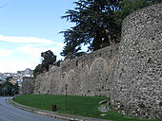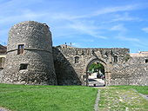

Norman Walls
The town winds along the Norman walls, with various gates, the most noteworthy being the Venosina gate (dating to the early 13th century), an ogival arch with two cylindrical towers on either side.

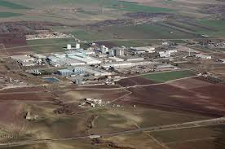
Melfi was mainly an agricultural center until the beginning of the nineties, since then the industrial sector received a boost in the frazione of San Nicola, with the building of an automobile factory owned by Fiat. The plant contributed to the economic recovery of the company in the mid-nineties and the growth of its market share in Europe. There are also about 30 companies linked to the implant, including Magneti Marelli, Tower Automotive, Benteler, Proma and Lear. The Fiat of Melfi has produced cars such as Grande Punto and Lancia Ypsilon and today is focused on the production of the Jeep Renegade and the Fiat 500X. The plant has produced 5.000.000 vehicles up to 2010. Melfi also hosts a Barilla factory, built in 1994, and the seat of Gaudianello's mineral water company, among the top 10 national companies in the sector and originally founded in Rionero in Vulture, where the extraction is carried out.

Food production
Melfi is one of the cities in the Vulture area involved in the production of the "Aglianico del Vulture", recognized as DOC, considered one of the greatest red wines of Italy, and the olive oil "Vulture". Another renowned product is the "marroncino", a type of chestnut used for many sweet and salty recipes and is precious for the industries specialized in the preparation of the marron glacé.

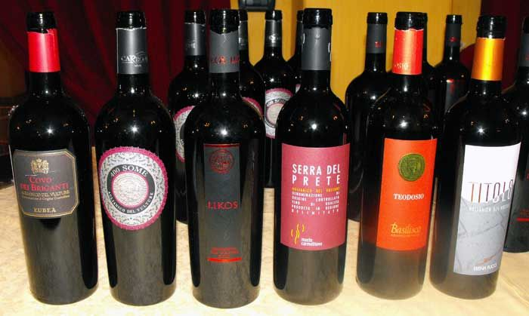

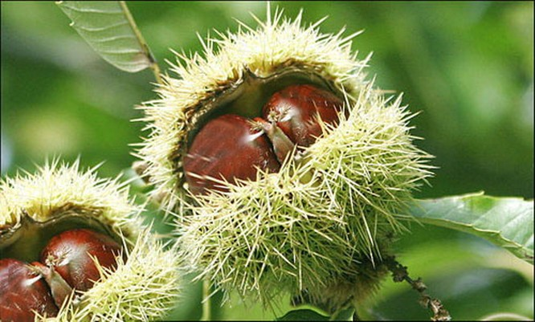

MONTICCHIO LAKES
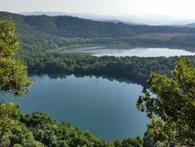
Rich vegetation, characterised by beech, pine, fir and chestnut woods, create an enchanting frame to the Monticchio Lakes. They formed on the crater of the extinguished volcano.
The Lago Piccolo (Small Lake) and the Lago Grande (Big Lake) are separated by a stream.
They look like two gems that, during the day, reflect the glows of the green nature moulding and confusing themselves in it and, during the night, create a very evocative landscape.
Those who love nature will find in this wonderful scenery the right environment for their explorations and will have a taste of the lightly sparkling water that naturally springs from the streams.

MATERA 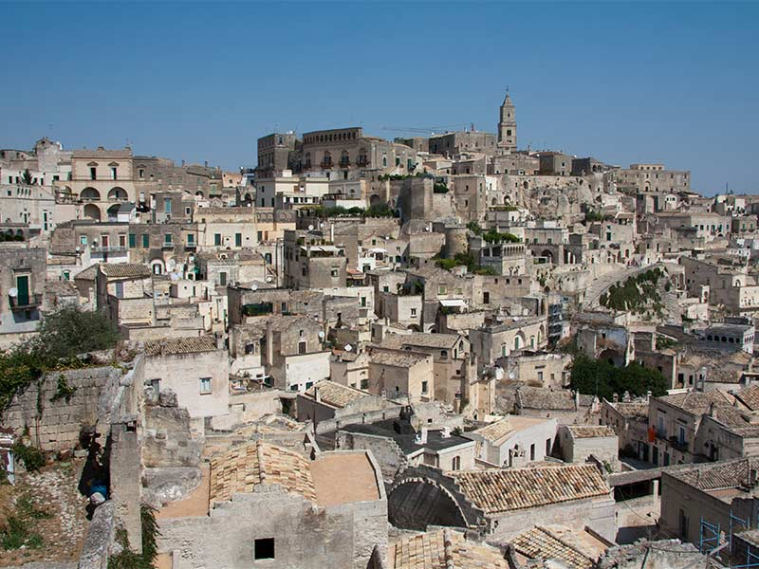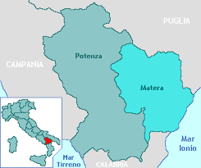
Matera is in the southern region of Basilicata. The World Heritage property includes the Sassi of Matera and the Park of the Rupestrian Churches.
A walk through Matera’s historic center will transport visitors back into a past long-forgotten. The zone was already inhabited during the Paleolithic Era, when the first settlements were established in these calcarenite grottoes.
Matera will be the European Culture Capital in 2019.

