Lemon cake (SPAIN)

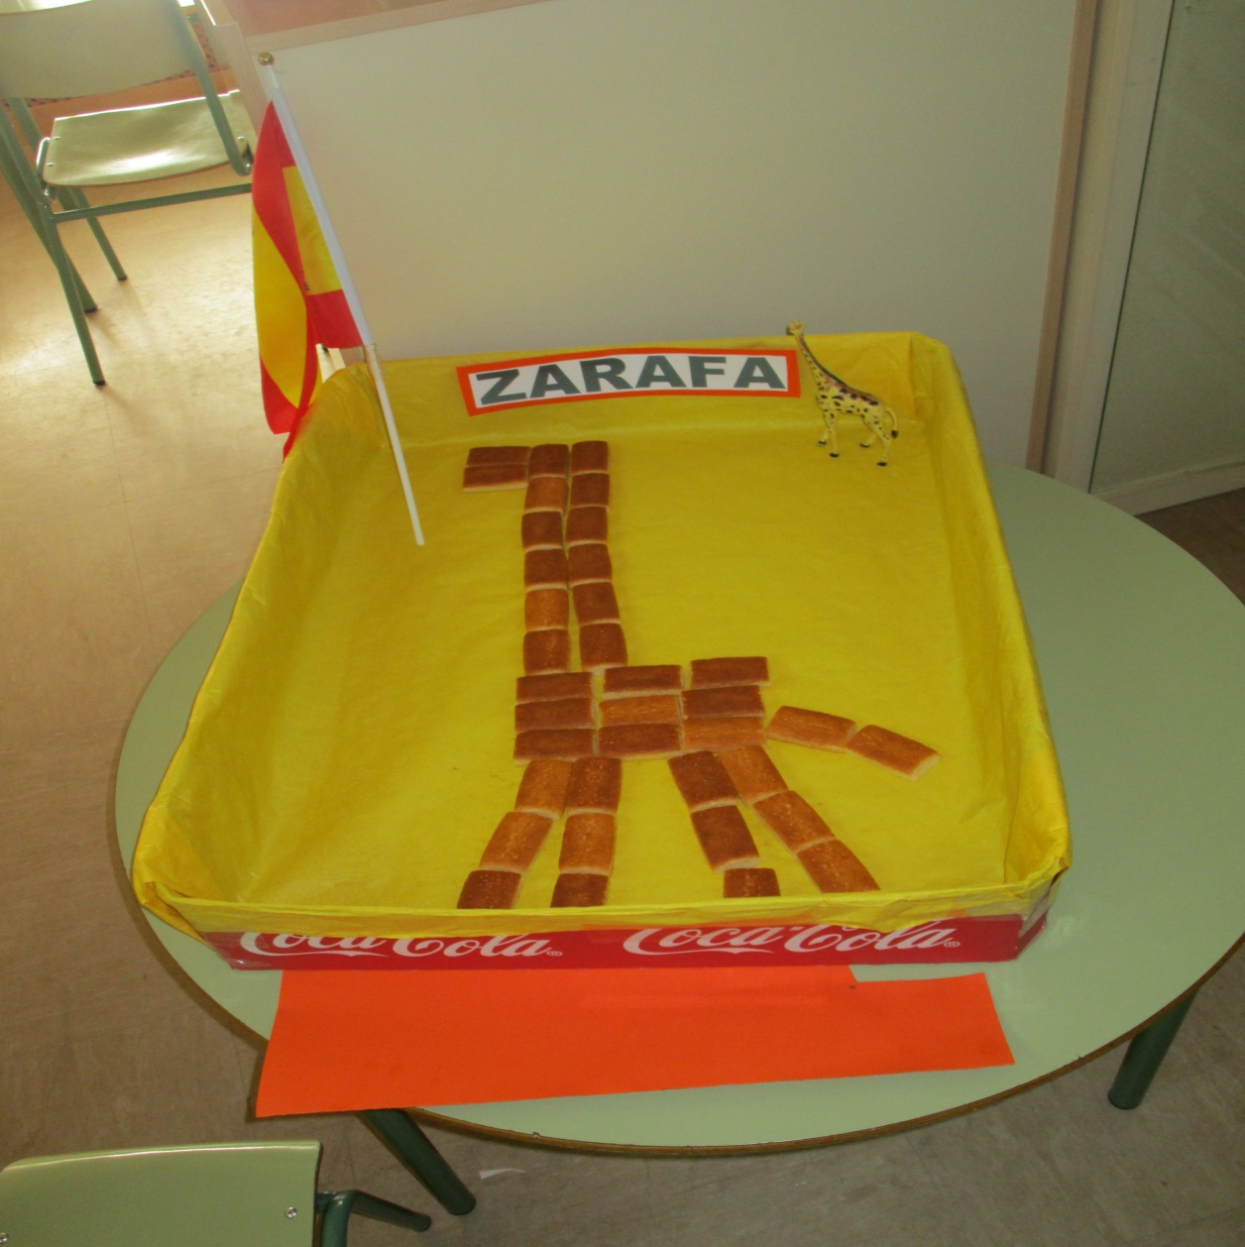

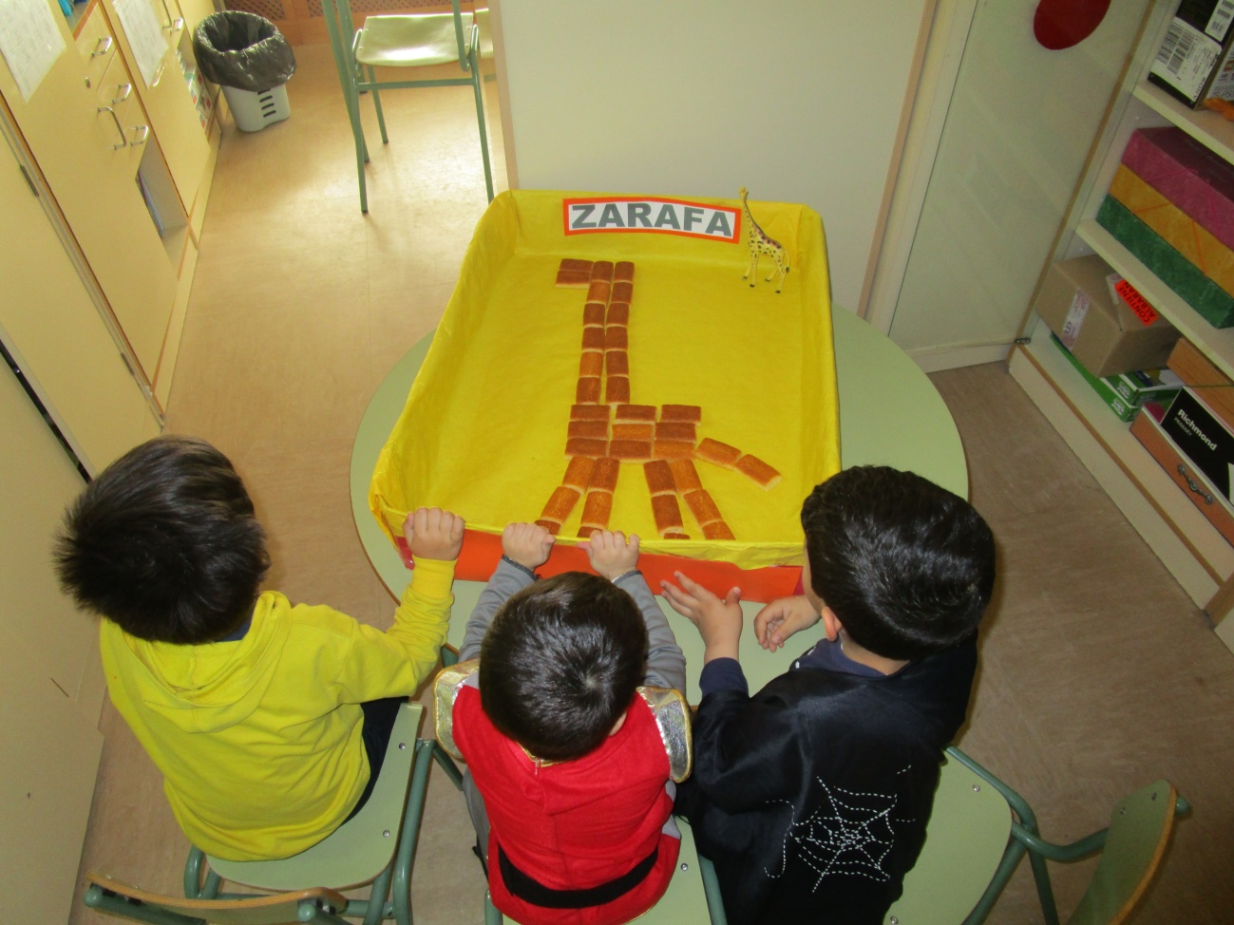

-INGREDIENTES:

-1 lemon yoghurt

- 2 recipients (yoghurt glass) of sugar

-1 recipients of olive oil

-3 recipients of flour

- 2 tsp baking powder

- 1/2 tsp vanilla

-3 eggs

- Heat oven to 180C/160C.
- Beat the eggs.
- Add sugar
- Add the lemon yoghurt and the olive oil and mix.
- Sieve the flour and the baking powder.
- Make the vanilla.
- Remove all the ingredients.
- Spread butter in the tray for the oven and sprinkle flour.
- Put the mix in the tray.
- Introduce it in the oven and bake during 40 minutes.
- Let it cool.
- Cut the cake into small pieces.
- Make the shape of a giraffe with the pieces.

